St Mary’s
C.E. Primary

Personal, Social, Health and Economic (PSHE) and
Relationships and
Sex Education Policy (RSE)

October 2022

St. Mary’s C.E. Primary School considers that Relationships & Sex Education (RSE) is an integral part of the Personal, Social and Health Education (PSHE) curriculum. Personal development underpins all aspects of school life as we aim to develop well-rounded pupils who develop socially, morally, spiritually and culturally and have opportunities to explore and develop their own values, whilst recognising that those of others may differ. Our curriculum includes development of pupils’ understanding of religious education, citizenship, equality and diversity, healthy living, British Values, career guidance and preparing our pupils for their next stage. We believe that the education of PSHE enables children to become healthier, more independent and more responsible members of society. We encourage our pupils to play a positive role in contributing to the life of the school and the wider community. In doing so, we help to develop their sense of self-worth. We teach them how society is organised and governed. We ensure that the children experience the process of democracy through participation of the School Council. We teach children about their rights and about their responsibilities.
Introduction

What is PHSE?
Personal, social and health education (PSHE) is a planned, developmental programme of learning opportunities and experiences through which children and young people acquire the knowledge, understanding and skills they need to manage their lives, now and in the future.
PSHE makes a significant contribution to pupil’s spiritual, moral, social and cultural (SMSC) development, their behaviour and safety and the school’s statutory responsibility to pupils’ well-being. In addition, the learning provided through this comprehensive PSHE provision is essential to safeguarding pupils, as Ofsted has set out.
We participate in and promote national events such as: Black History Month, Fairtrade Fortnight, Mental Health Awareness Week, Anti-Bullying Week and Internet Safety Week.
How is it taught at St Marys?

Personal, social and health education (PHSE) is taught through timetabled lessons, is threaded throughout the wider curriculum. As well as through assemblies, we have weekly Personal, Social and Health Education lessons. Sex and Relationships Education is included in Healthy Living and is taught in an age-appropriate manner. We aim to create a deepened understanding of pupils' responsibilities as citizens and to enable opportunities to demonstrate and reflect upon their own personal development. Eco Schools and School council assists in this process.

PHSE Curriculum.
The activities outlined above ensure that we meet the statutory requirements set out in the new 2020 curriculum; Relationships Education, Relationships and Sex Education and Health Education.
Our teaching reflects the needs shared by all children and specific needs of pupils in our school. There is a clear and progressive PSHE curriculum, which meets the statutory requirements to teach Relationships Education, Relationships and Sex Education (RSE) and Health Education . These are set into 7 different strands:
- Sex and relationship education (SRE)
- Drug, alcohol and tobacco education
- Physical health and well-being
- Mental health and emotional well-being
- Keeping safe and managing risk
- Financial capability & economic well-being
- Identity, society and equality
Within each strand, we have designed age appropriate topics for the different year groups. One topic per half term is taught to each year group and these topics are explored in more detail as children move through school.
Therefore our PSHE curriculum is as follows:
- Identity (their personal qualities, attitudes, skills, attributes and achievements and what influences these)
- Relationships (including different types and in different settings)
- A healthy (including physically, emotionally and socially) balanced lifestyle (including within relationships, work-life, exercise and rest, spending and saving and diet)
- Risk (identification, assessment and how to manage risk rather than simply the avoidance of risk for self and others) and safety (including behaviour and strategies to employ in different settings)
- Diversity and equality (in all its forms)
- Rights (including the notion of universal human rights), responsibilities (including fairness and justice) and consent (in different contexts)
- Change (as something to be managed) and resilience (the skills, strategies and ‘inner resources’ we can draw on when faced with challenging change or circumstance)
- Power (how it is used and encountered in a variety of contexts including persuasion, bullying, negotiation and ‘win-win’ outcomes)
- Career (including enterprise, employability and economic understanding)
PSHE Assessment
Verbal assessment from class and group discussion is supported by formal written assessment. At the beginning of the topic, pupils complete a written pre-topic assessment activity, which is then repeated at the end of the topic. This enables pupils and teachers to understand and demonstrate the progress made by individuals. In addition, this can identify any gaps in the pupils' knowledge that can be addressed in future lessons.
Legal Requirements.
This policy takes into account-
•Equality Act 2010
•Children and Social Work Act 2017
•DfE ‘Keeping Children Safe in Education’
•DfE ‘Relationships Education, Relationships and Sex Education (RSE) and Health Education’
•DfE ‘National curriculum in England: science programmes of study’
The fundamental building blocks and characteristics of positive relationships, with reference to friendships, family relationships, and relationships with other children and with adults needs to be .
Teaching about families requires sensitive and well-judged teaching based on knowledge of pupils and their circumstances. Families of many forms provide a nurturing environment for children. (Families can include for example, single parent families, LGBT parents, families headed by grandparents, adoptive parents, foster parents/carers amongst other structures.) Care needs to be taken to ensure that there is no stigmatisation of children based on their home circumstances and needs, to reflect sensitively that some children may have a different structure of support around them; e.g. looked after children or young carers.

Definition of Sex Education
The DfE continues to recommend that all primary schools should have a sex education programme tailored to the age and the physical and emotional maturity of the pupils…’
Where a maintained primary school chooses to teach aspects of sex education (which go beyond the national curriculum for science), the school must set this out in the policy and should consult with parents on what is to be covered.
Although it is not statutory to deliver sex education outside of the science curriculum (which is statutory) at primary level, the DfE recommends that all primary schools should have a sex education programme in place. At St. Mary’s, we do teach pupils sex education beyond what is required of the science curriculum – The content is tailored to the age, and physical and emotional maturity of pupils, and ensures that boys and girls are prepared for the changes that adolescence brings, drawing on knowledge of the human life cycle.

Aims of Relationship and Sex Education
Taking account of the age, maturity and needs of the pupils, Relationships and Sex Education aims to:
• To give children the confidence and self-esteem to value themselves and others
• To understand about the range of relationships, including the importance of family for the care and support of children
• To develop confidence in talking, listening, and thinking about feelings and relationships
• To be able to name parts of the body and describe how their bodies work
• To be prepared for puberty
• To understand the consequences of their actions and behave responsibly within relationships
• To be able to recognise unsafe situations and be able to protect themselves and ask for help and support
• To understand the role the media plays in forming attitudes
• To understand what a healthy relationship is both on and offline
• To ensure children know how and where to access appropriate support

See Appendix 1 for National curriculum requirements for RSE at primary school.
Safeguarding & Confidentiality
Everyone involved in the teaching RSE will be clear about the boundaries of their legal and professional roles and responsibilities. Teachers will be aware that effective RSE, which brings an understanding of what is and is not acceptable, may lead to disclosure of a child protection issue.
If a staff member has any concerns or a child discloses information giving cause for concern, this must be report to the DSL and the schools safeguarding policy must be followed.

Equality and Discrimination.
The school understands its responsibilities in relation to the Equality Act 2010, meaning that school cannot unlawfully discriminate against any pupil because of their sex, race, disability, religion or belief or sexual orientation. RSE will be taught to ensure quality of access for all pupils and avoiding discrimination.
We ensure our Relationships and Sex education programme is sensitive to the needs of all our pupils and their families by:
- Being aware of pupils’ individual characteristics, backgrounds, attitudes, and feelings.
- Differentiating teaching and learning from our planned scheme of work to allow access to Relationships and Sex education for all our pupils including those with SEND or EAL.
- The school understands that pupils with SEND or other needs (such as those with social, emotional or mental health needs) are entitled to learn about relationships, sex and health education, and the programme will be designed to be inclusive of all pupils.
- Ensuring freedom from all forms of bullying including homophobic, biphobia and transphobic bullying as is our duty within the Equalities Act (2010) through a zero-tolerance approach within all our policies and practice
Organisation of the Curriculum.
RSE will be delivered as part of the school’s PSHE curriculum which has been organised in line with the statutory requirements outlined in the ‘Relationships, Education, Relationships and Sex Education (RSE) and Health Education’ guidance.https://www.gov.uk/government/publications/relationships-education-relationships-and-sex-education-rse-and-health-education
At St. Mary’s, we have the flexibility to deliver the content in a way that is age and developmentally appropriate and sensitive to the needs and religious background of all our pupils.
At the point we consider it appropriate to teach pupils about LGBT, we will ensure that this content is fully integrated into the relationships, sex and health curriculum, rather than delivered as a standalone unit or lesson.
- All teachers will have responsibility for planning and delivering RSE.
- Everyone involved in the teaching of RSE will follow the school policy.
- A balanced and non-judgmental approach will be taken, and the personal beliefs and attitudes of teachers will not influence the teaching of RSE. .
At St. Mary’s, a number of teaching strategies will be used, to deliver an inclusive RSE curriculum, including:
- Establishing ground rules with pupils.
- Using ‘distancing’ techniques (e.g. Case studies)
- The provision of a ‘question box’ during each planned session
- Dealing with children’s questions in an appropriate manner
- Using discussion and age appropriate materials.
- Encourage reflection
At St. Mary’s we follow the PSHE Association scheme of work, which is split into 3 core themes.
The scheme of work maps out the lessons/units for each year group, which progresses and returns to themes as children move through the school
Core Theme 1: Health and wellbeing
Core Theme 2: Relationships
Core Theme 3: Living in the wider world – Economic wellbeing and being a responsible citizen
Right of withdrawal.
Relationships and Health Education are statutory at primary school and there is no right to withdraw from these subjects. It is important for all children to be taught the content on such essential matters like friendships and keeping safe both on and offline.
As sex education is not statutory at primary level (other than what is taught as part of the science curriculum), parents / carers have the right to request to withdraw their child from all or part of the sex education curriculum.
Before considering this option, we would always encourage parents to come and talk to us.
(For more information, please go to https://www.gov.uk/government/publications/relationships-sex-and-health-education-guides-for-schools)

The Role of external agencies.
The school may liaise with external agencies to support and compliment the schools PSHE/RSE programme of study. All agencies will be aware of the schools policies and procedures and their role within them.
Any matters reported by visitors will be dealt with in line with the our Safeguarding Policy
We ensure that the teaching delivered by visitors fits with the planned programme of study. The content of lessons provided by external agencies is age appropriate and accessible for all pupils and is approved by the school in advance of delivery.
Review
• The policy will be reviewed annually.
• The policy will be reviewed in light of any changes to statutory guidance, feedback from parents, staff or pupils, and issues in the school or local area that may need addressing.
• The governing board is responsible for approving this policy.
• Any changes made to this policy will be communicated to all staff, parents and, where necessary, pupils.

Headteacher:
Chair of Governors:
Policy Review Date:

Appendix 1: Relationships and Sex Education National Curriculum requirements

By the end of primary school children should know
Families and  people who  care for me | Pupils should know  • that families are important for children growing up because they can give love, security, and stability.  • the characteristics of healthy family life, commitment to each other, including in times of difficulty, protection and care for children and other family members, the importance of spending  time together and sharing each other’s lives.  • that others’ families, either in school or in the wider world, sometimes look different from their family, but that they should respect those differences and know that other children’s families  are also characterised by love and care.  • that stable, caring relationships, which may be of different types, are at the heart of happy families, and are important for children’s security as they grow up.  • that marriage represents a formal and legally recognised commitment of two people to each other which is intended to be lifelong.  • how to recognise if family relationships are making them feel unhappy
Caring  friendships | Pupils should know  • how important friendships are in making us feel happy and secure, and how people choose and make friends.  • the characteristics of friendships, including mutual respect, truthfulness, trustworthiness, loyalty, kindness, generosity, trust, sharing interests and experiences and support with problems and difficulties.  • that healthy friendships are positive and welcoming towards others, and do not make others feel lonely or excluded.  • that most friendships have ups and downs, and that these can often be worked through so that the friendship is repaired or even strengthened, and that resorting to violence is never right.  • how to recognise who to trust and who not to trust, how to judge when a friendship is making them feel unhappy or uncomfortable,  managing conflict, how to manage these situations and how to seek help or advice from others, if needed.
Respectful  relationships | Pupils should know  • the importance of respecting others, even when they are very  different from them (for example, physically, in character, personality or backgrounds), or make different choices or have different preferences or beliefs.  • practical steps they can take in a range of different contexts to improve or support respectful relationships.  • the conventions of courtesy and manners.  • the importance of self-respect and how this links to their own happiness.  • that in school and in wider society they can expect to be treated with respect by others, and that in turn they should show due respect to others, including those in positions of authority.  • about different types of bullying (including cyberbullying), the impact of bullying, responsibilities of bystanders (primarily  reporting bullying to an adult) and how to get help.  • what a stereotype is, and how stereotypes can be unfair, negative, or destructive.  • the importance of permission-seeking and giving in relationships with friends, peers and adults
Online  relationships | Pupils should know  • that people sometimes behave differently online, including by pretending to be someone they are not.  • that the same principles apply to online relationships as to face-to- face relationships, including the importance of respect for others  online including when we are anonymous.  • the rules and principles for keeping safe online, how to recognise risks, harmful content and contact, and how to report them.  • how to critically consider their online friendships and sources of information including awareness of the risks associated with people they have never met.  • how information and data is shared and used online
Being safe | Pupils should know  • what sorts of boundaries are appropriate in friendships with peers and others (including in a digital context).  • about the concept of privacy and the implications of it for both children and adults; including that it is not always right to keep secrets if they relate to being safe.  • that each person’s body belongs to them, and the differences between appropriate and inappropriate or unsafe physical, and  other, contact.  • how to respond safely and appropriately to adults they may encounter (in all contexts, including online) whom they do not  know.  • how to recognise and report feelings of being unsafe or feeling bad about any adult.  • how to ask for advice or help for themselves or others, and to keep trying until they are heard.  • how to report concerns or abuse, and the vocabulary and confidence needed to do so.  • where to get advice e.g. family, school and/or other sources.

Appendix 2: PSHE and RSE Whole school overview

PSHE and RSE Overview EYFS – Year 6
 | EYFS linked to ELGs Personal, Social and Emotional Development and Understanding the World
Reception (Red) | Relationships (feelings and emotions/healthy relationships/Valuing Difference)  ELG: Self-regulation, Managing Self and Building Relationships  All about me: To explore who I am, where I live, who is in my family. (Autumn 1/2)  Emotions: What are emotions? Exploring the emotions of anger, sadness, happiness and fear/anxiety. (Autumn 1/2)  Friendship: To explore what makes a good friend. How friendships are important. Understanding that friendships can make us feel happy. Know some ways that we can make new friends feel welcome. RSE L1 (Autumn 1/2)  Sharing: To understand what sharing and being fair means. Exploring how we can share with others and the impact of sharing on our emotions. (Autumn 1/2)  Falling out: To recognise the importance of saying sorry and forgiveness. RSE L2 (Autumn 1/2)  Families: To recognise that all families are different RSE L3 (Autumn 1/2) |  | Living in the wider world (Rights and Responsibilities; Taking Care of the Environment; Money Matters  ELG: People, Culture and Communities and the Natural World  Charities: Understanding that people do not live in the same way – exploring homelessness, disabilities and charities that can help.  (Autumn 2)  Celebrations around the world: To explore the celebrations of Diwali, Hanukkah, Christmas, Holi, Easter and Eid-al-Fitr. To talk about the similarities and differences in the cultures.  (Throughout the year)  Forest School: Looking at animals in the environment and how we can help/protect them. (Throughout the year)  Endangered animals, pollution and recyling: To understand how pollution can impact upon animals in the environment and how we can help. (Summmer 1/2)  Money: Can I think about where money comes from and what it is used for? (Summmer 1/2) |  | Health and Well Being (Healthy lifestyles; Growing and changing; Keeping safe)  ELG: Managing Self  Sleep: To explore why we need sleep and what can help us get a good nights sleep. (Spring 1/2)  Hygiene: To understand why we need to clean our bodies/hands and how this can impact on our health (Spring 1/2)  Teeth: To understand how we brush our teeth properly and different ways we can look after our teeth. (Spring 1/2)  Healthy eating: To understand the need for a varied diet and why some foods are good/bad for us. (Spring 1/2, Summer 2)  Medicines: To understand the items that we should not touch/eat in school and at home (medicines/cleaning products etc) (Spring 1/2)  Road safety: To understand how to stay safe when crossing the road. (Spring 1/2)  Esafety: To understand how to stay safe when using an electronic device and who to ask for help. (Spring 1/2)  Strangers: To understand who we can trust and what do we do if we are lost. (Spring 1/2)  People who help us: To explore different occupations and how those people can help to keep us healthy and safe. (Spring 1/2)
 | Autumn 1 | Autumn 2 | Spring 1 | Spring 2 | Summer 1 | Summer 2
Year 1 (Orange) | RELATIONSHIPS (feelings and emotions/healthy relationships/Valuing Difference)  Can I understand that we are all different?  To identify feelings experienced in and out of school / What happens inside and outside of our body when we feel different emotions.  To identify how right and wrong feels/ To identify how fair and unfair feels. (WORSHIP)  How peoples bodies and feelings can be hurt  To identify appropriate and inappropriate touch.  ACROSS THE CURRICULUM  To listen and work cooperatively  To offer feedback and support  To share opinions and views through peer and class discussion  To recognise acts of kindness (Pupil of the week)  LINKS TO OTHER SUBJECTS  RE – Linking Jesus to our own special people |  | Living in the wider world (Rights and Responsibilities; Taking Care of the Environment; Money Matters  Can I appreciate the needs of people and other living things?  Can I think of groups and communities that I belong to? (WORSHIP)  Can I think about what improves and harms their local, natural and built environments?  Can I think about where money comes from and what it is used for?  ACROSS THE CURRICULUM  How to contribute to the life of the classroom  To follow group and class rules  To recognise acts of kindness (Pupil of the week)  LINKS TO OTHER SUBJECTS  RE – Linking Jesus to our own special people  Maths – work with money |  | Health and Well Being (Healthy lifestyles; Growing and changing; Keeping safe)  Can we think of things we like to do that makes us feel good?  Can I understand how to keep myself healthy? DATE L1  Can I understand that children grow and change? RSE L2  Can I describe basic hygiene routines? DATE L1  Can I recognise and use the correct names for main parts of the body including external genitalia? RSE L2  Can I understand that I have the right to feel safe on the outside and safe on the inside? RSE L3  Can I understand how to take medicine safely? DATE L2  Can I understand who can give us medicine? DATE L3  Can I understand who I can ask for help?  Can I understand that we are all different? RSE L1  Can I understand that there are different types of families? RSE L3  Can I think about different kinds of loss (CIRCLE TIME)  ACROSS THE CURRICULUM  How do we keep safe across the school?  How can we keep safe online  How to take care of our belongings  To actively listen to each other  LINKS TO OTHER SUBJECTS
Year 2 (Yellow) | RELATIONSHIPS (feelings and emotions/healthy relationships/Valuing Difference)  To learn the difference between secrets and surprises  To identify appropriate and inappropriate touch  What makes us feel good and bad about ourselves / How do other people make us feel?  Describe the various groups and communities that they are part of and think of the special people that are also a part of these.  Identify and name a wider range of feelings and how we can communicate these positively / To describe intensity of feelings (WORSHIP)  ACROSS THE CURRICULUM  To work and play cooperatively  To offer constructive feedback and support  To share opinions and views through peer and class discussion  To recognise acts of kindness (Pupil of the week)  LINKS TO OTHER SUBJECTS |  | Living in the wider world (Rights and Responsibilities; Taking Care of the Environment; Money Matters  Can I think about what improves and harms their local, natural and harms their local, natural and built environments (WORSHIP)  Can I think about how to cooperate when we work in a group, and how we can deal with disagreements?  Can I understand that not everyone has money through work?  Can I think about the role money has in our lives?  ACROSS THE CURRICULUM  To think about the skills necessary to contribute to the life of the classroom  To think about how group and class rules help us  To recognise acts of kindness (Pupil of the week)  LINKS TO OTHER SUBJECTS  Maths – work with money |  | Health and Well Being (Healthy lifestyles; Growing and changing; Keeping safe)  Can I explain what the benefits (short-term and long-term) are of being active, taking rest, eating healthily and looking after their teeth?  How do we feel if we lose something or someone leaves our family? (WORSHIP – link to Jesus)  Identify the biological differences between boys and girls. Identify that boys and girls can do the same tasks and enjoy them RSE L1, 2 and 3  Can I identify the harmful aspects of some household products and medicines? DATE L1, 2  Can I describe different ways of keeping safe in familiar and unfamiliar situations DATE L1  Can I consider safety rules at home and at school? DATE L3  ACROSS THE CURRICULUM  How do we keep safe across the school?  How can we keep safe online  How to take care of our belongings  To actively listen to each other  LINKS TO OTHER SUBJECTS
Year 3 (Green) | Relationships (feelings and emotions/healthy relationships/Valuing Difference)  To think about the reasons why people would keep things a secret and where to go if they are concerned.  How to recognise and manage dares  To identify appropriate personal space (PANTS)  RSE L2  To think about stereotypes (link to aspirations)  To understand the impact of derogatory or discriminatory language  ACROSS THE CURRICULUM  To listen and respond respectively  To offer feedback and support  To manage conflict through negotiation and appropriate compromise  To recognise acts of kindness (Pupil of the week)  LINKS TO OTHER SUBJECTS |  | Living in the wider world (Rights and Responsibilities; Taking Care of the Environment; Money Matters  Can I discuss and debate issues concerning health and well being?  Can I understand that everyone has human rights?  Can I understand the ways in which rules and laws keep us safe? (WORSHIP)  Can I grasp concepts relating to money?  Can I appreciate the range of national, regional, religious and ethnic identities in the UK?  ACROSS THE CURRICULUM  To think about resolving differences  To think about our own rights, responsibilities and duties we have  To know about being part of a community  To recognise acts of kindness (Pupil of the week)  LINKS TO OTHER SUBJECTS |  | Health and Well Being (Healthy lifestyles; Growing and changing; Keeping safe)  Can I identify that people are unique and respect those differences. Explore the differences between male and female bodies. RSE L1  Can I explore different types of families and who to go for help and support? RSE L3  Can I make informed choices in relation to my health? Explore opportunities they have to make choices about food.  Can I identify safe, risky and dangerous places? What factors can change these places?  Can I reflect on family changes? (circletime)  Can I identify ways of staying emotionally and physically safe online?  Can I consider smoking and its effects? DATE L1  Do I understand the impact of smoking and passive smoking? DATE L2  Do I know some strategies to prevent starting smoking? DATE L3  ACROSS THE CURRICULUM  LINKS TO OTHER SUBJECTS
Year 4 (Blue) | Relationships (feelings and emotions/healthy relationships/Valuing Difference)  How do we celebrate different kinds of relationships? (WORSHIP)  Why do people live different lifestyles and why do we need to value these choices?  To focus challenging stereotypes in the media  To compare offline and online bullying  How to recognise and manage dares  Can I explore respect in a range of relationships? RSE L3  Can I discuss the characteristics of healthy relationships? RSE L3  ACROSS THE CURRICULUM  About recognising and caring about other peoples’ feelings  How to work collaboratively towards shared goals  About solving disputes and conflict through negotiation and appropriate compromise  About respecting the views of others’ and knowing when/how to challenge points of view when appropriate  To recognise acts of kindness (Pupil of the week)  LINKS TO OTHER SUBJECTS  ICT – E Safety |  | Living in the wider world (Rights and Responsibilities; Taking Care of the Environment; Money Matters  Can I understand that everyone has human rights and that some are specifically for children? (WORSHIP)  Can I identify some cultural practises which are illegal and against human rights?  Can I identify people and organisations that help uis take care of the environment?  Can I understand how I, and others, manage our money?  Can I appreciate what it means to be enterprising?  ACROSS THE CURRICULUM  How to take part in making, and changing, rules  To know about the consequences of anti-social behaviours  To resolve differences  To fulfil our responsibilities  To recognise acts of kindness (Pupil of the week)  LINKS TO OTHER SUBJECTS  Maths - money |  | Health and Well Being (Healthy lifestyles; Growing and changing; Keeping safe)  Can we identify positive changes we could make to our eating habits? Link to the impact of the media, both positive and negative.  Can I explain how bacteria and viruses affect humans and how we can reduce the spread of these?  Can I explain the different roles that people in school and the wider community have to help them stay healthy and safe.  Can I compare how I keep myself online and in the real world?  Can I explore the human lifecycle? RSE L1  Can I identify some basic facts about puberty? RSE L1  Can I explore how puberty is linked to reproduction? RSE L2  Can I understand the effect alcohol has on the body? DATE L1  Can I understand the risks related to drinking alcohol? DATE L2  Can I consider how society limits the drinking of alcohol? DATE L3  ACROSS THE CURRICULUM  Talk about what they are proud of and what they can improve on  Focus on how it feels when we do something difficult.  Identify when feelings can overwhelm us and how we can manage them.  LINKS TO OTHER SUBJECTS
Year 5 (Indigo) | Relationships (feelings and emotions/healthy relationships/Valuing Difference)  To reflect on how we are becoming more independent and how our relationships help this.  To think about people who have challenged stereotypes  About discrimination, teasing, bullying and aggressive behaviour and its effect on others  About what constitutes a positive, healthy relationship  About different types of relationships (friends, families, couples, marriage, civil partnership) (WORSHIP)  ACROSS THE CURRICULUM  How to negotiate and compromise  About different ways to work collaboratively  About how our actions can affect ourselves and others  How to respond appropriately to a wider range of feelings in others  LINKS TO OTHER SUBJECTS |  | Living in the wider world (Rights and Responsibilities; Taking Care of the Environment; Money Matters  Can I recognise that health and wellbeing includes mental and emotional health?  Can I understand who is responsible for ensuring a child’s human rights are met?  Can I justify why prejudice-based behaviour is always wrong? (WORSHIP)  Can I think about how finance plays an important part in people’s lives?  Can I learn to be a critical consumer?  ACROSS THE CURRICULUM  To learn about different kinds of responsibilities, rights and duties  About how to resolve differences, make decisions and explain choices  LINKS TO OTHER SUBJECTS |  | Health and Well Being (Healthy lifestyles; Growing and changing; Keeping safe)  Can I describe ways I can support and comfort people who are sad or bereaved?  Can I handle an emergency in a calm and effective manner?  Can I demonstrate steps I need to take to protect my personal information online?  Can I explore a range of legal and illegal drugs, their risks, and effects? DATE L1  Can I consider my beliefs about drug use and drug users? DATE L2  Can I consider strategies to resist drug use? DATE L3  Can I explore the emotional changes during puberty? RSE L1  Can I understand that our bodies will change as we progress through puberty? RSE L1, 2  Can I understand that puberty brings about changes that increase the need for good personal hygiene? RSE L3  Can I explore ways to get support during puberty RSE L3  ACROSS THE CURRICULUM  Identify the responsibilities that they have now they are older  Identify pressures on their behaviour and where they come from  How does it feel when we lose control of our feelings  LINKS TO OTHER SUBJECTS
Year 6 (Violet) | Relationships (feelings and emotions/healthy relationships/Valuing Difference)  To explore the importance of communication and respect in relationships RSE L2  To identify the signs of a risky, negative of unhealthy relationship RSE L4  How to respond appropriately to a changing range of feelings (link to puberty)  To think about why keeping a secret might compromise personal safety/safety of others (link to online relationships)  About the difference between acceptable/unacceptable physical contact (social media / portrayal in the media)  To think about the consequences of our own actions (WORSHIP)  ACROSS THE CURRICULUM  About managing and maintaining relationships and improving communication and negotiation  Better communication and negotiation skills  About the importance of shared goals and how this can mean reliance on others  LINKS TO OTHER SUBJECTS  ICT – E Safety  HISTORY - About discrimination and how we can respond to it |  | Living in the wider world (Rights and Responsibilities; Taking Care of the Environment; Money Matters  Can I learn about democracy and the British parliament?  Can I identify some organisations that work to help people whose human rights are not being met?  Can I understand that different cultures can have different practises and traditions and that these may be illegal and against a person’s human rights?  Can I think about what are the common values that different religious and ethnic groups share? (WORSHIP)  Can I understand how money is deducted from earnings to provide things that we all need?  ACROSS THE CURRICULUM  To know about the consequences of anti-social and aggressive behaviour  Different kinds of responsibilities, rights and duties  How to resolve differences, make decisions and explain choices  LINKS TO OTHER SUBJECTS  ICT – E Safety  HISTORY – Human rights |  | Health and Well Being (Healthy lifestyles; Growing and changing; Keeping safe)  Can I recognise and respond to a variety of emotions, fears and worries?  Can I increase my understanding about sexual intercourse and how babies can be made? Link to the issue of consent. RSE L1,3  Can I identify positive role models of healthy lifestyles in the media and explain why? Can I explain the influence of the media?  Can I identify rules and procedures for keeping safe online and explain why they are important  Can I learn about the effects of legal and illegal substances and drugs (including alcohol and tobacco) and be aware of the options for getting help, advice and support DATE L1, 2, 3  ACROSS THE CURRICULUM  Can I identify how I feel about my transition to secondary school?  Can I deal with increased responsibility?  LINKS TO OTHER SUBJECTS
Overarching Concepts
1. Identity (their personal qualities, attitudes, skills, attributes and achievements and what influences these)
2. Relationships (including different types and in different settings)
3. A healthy (including physically, emotionally and socially) balanced lifestyle (including within relationships, work-life, exercise and rest, spending and saving and diet)
4. Risk (identification, assessment and how to manage risk rather than simply the avoidance of risk for self and others) and safety (including behaviour and strategies to employ in different settings)
5. Diversity and equality (in all its forms)
6. Rights (including the notion of universal human rights), responsibilities (including fairness and justice) and consent (in different contexts)
7. Change (as something to be managed) and resilience (the skills, strategies and ‘inner resources’ we can draw on when faced with challenging change or circumstance)
8. Power (how it is used and encountered in a variety of contexts including persuasion, bullying, negotiation and ‘win-win’ outcomes)
9. Career (including enterprise, employability and economic understanding)

Highlighted yellow = Planning and resources from Christopher Winter RSE Lessons
Highlighted Green = Planning and resources from Christopher Winter Drugs and Alcohol Lessons

Appendix 3 Overview RSE and DATE of scheme of work

Relationships and Sex Education
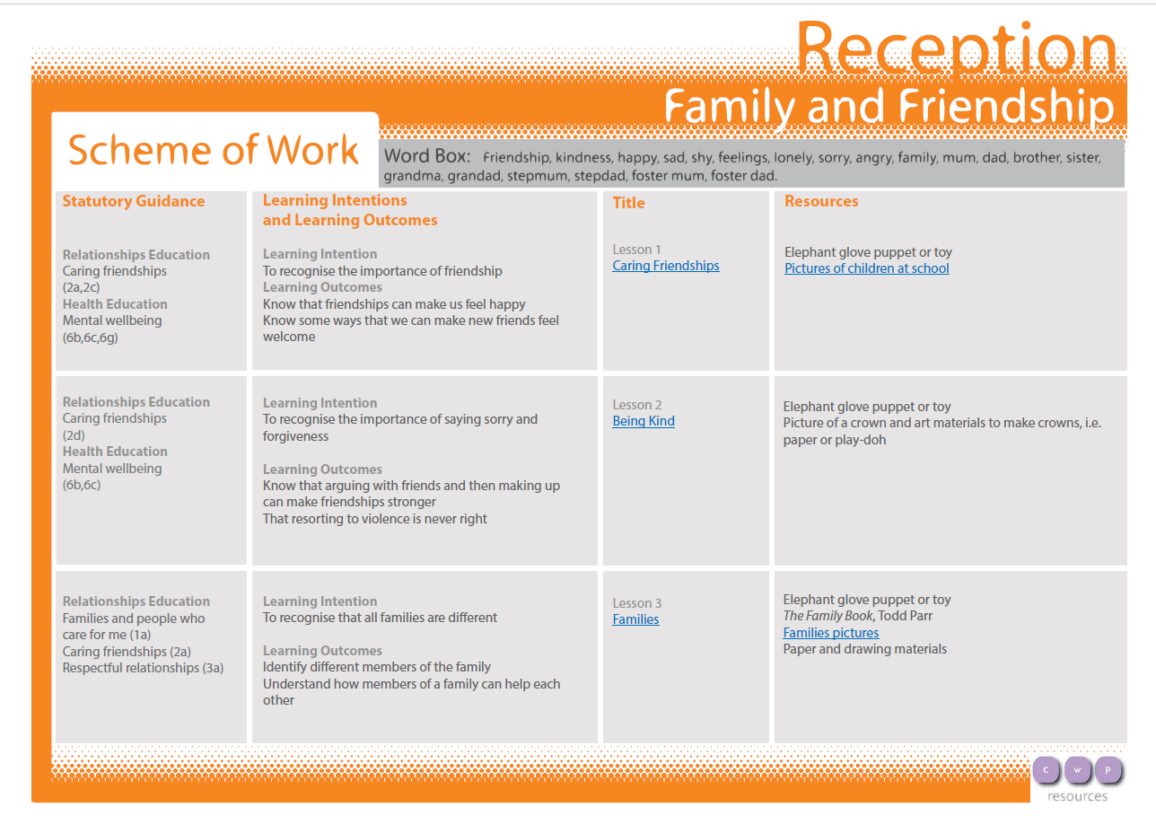

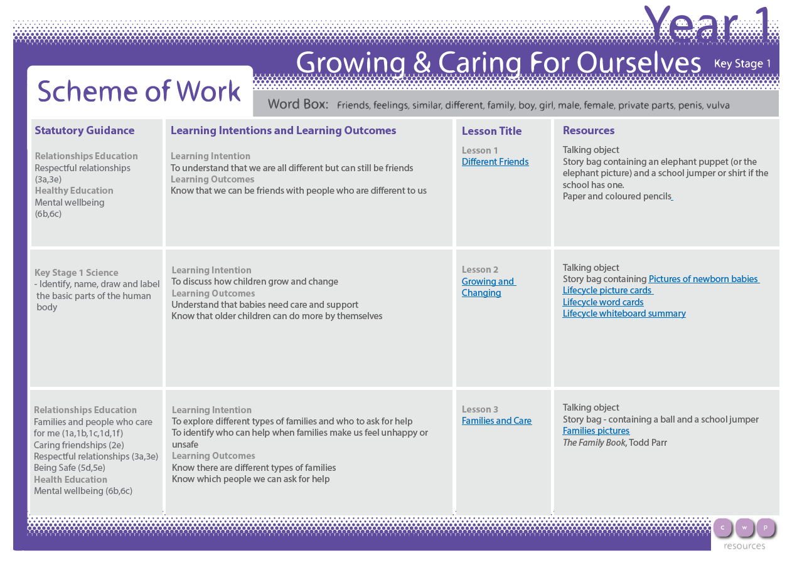

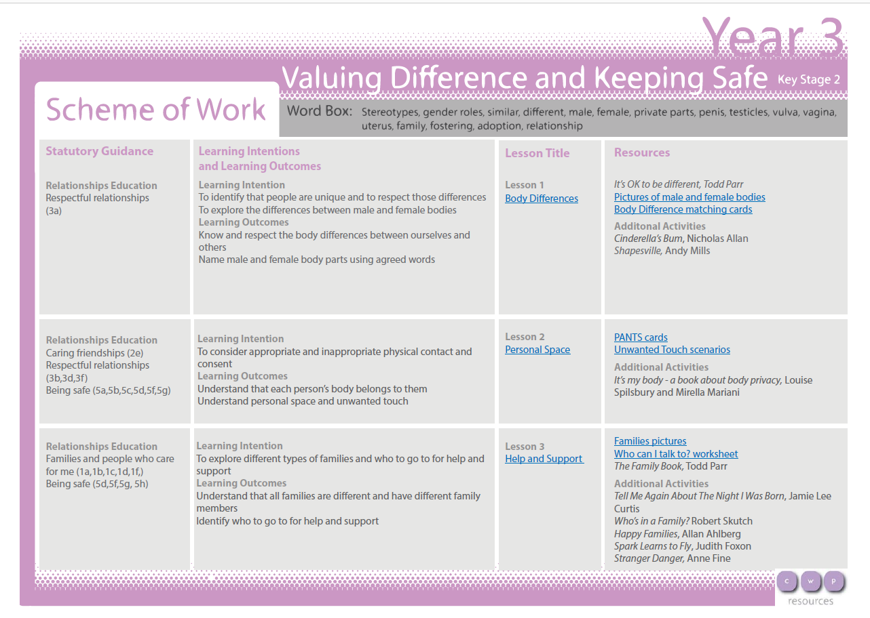

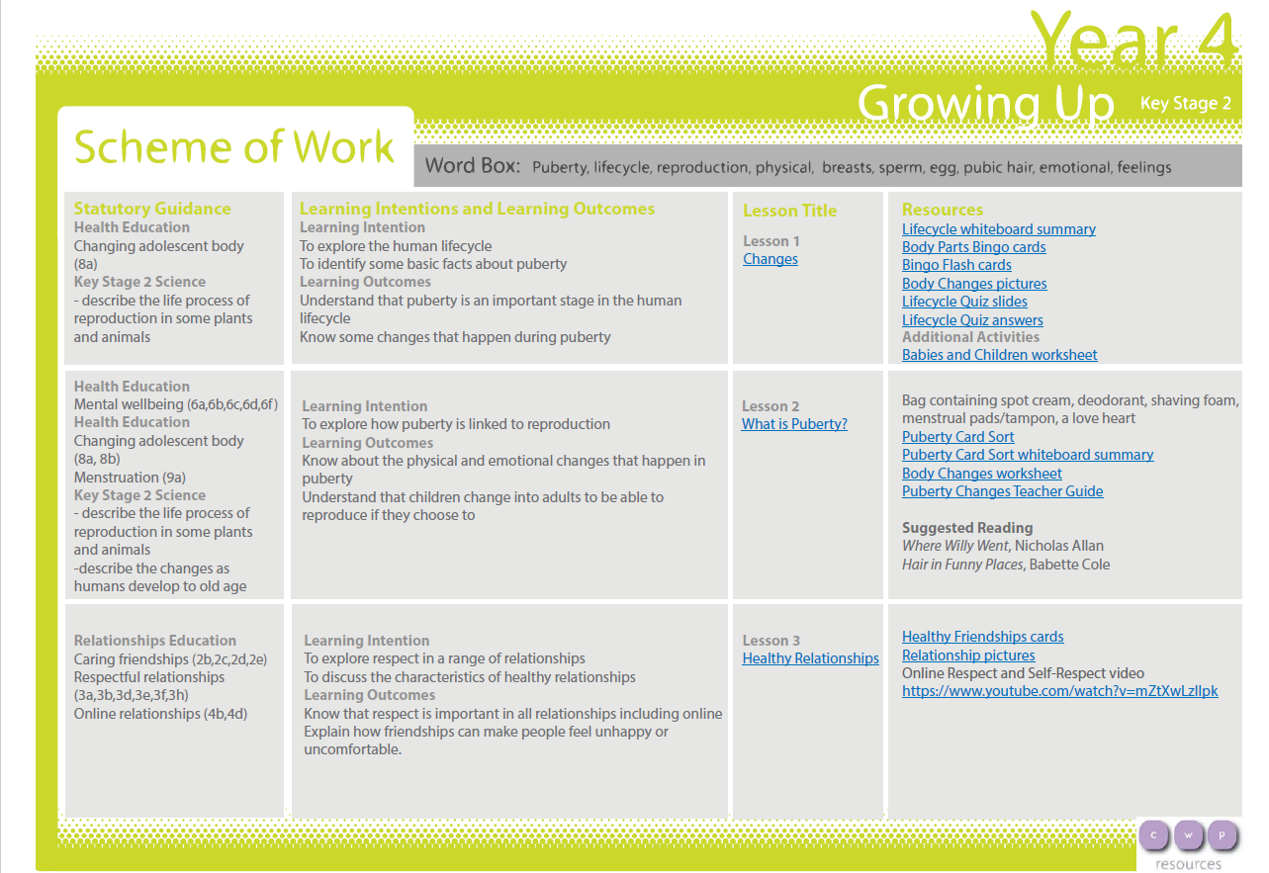

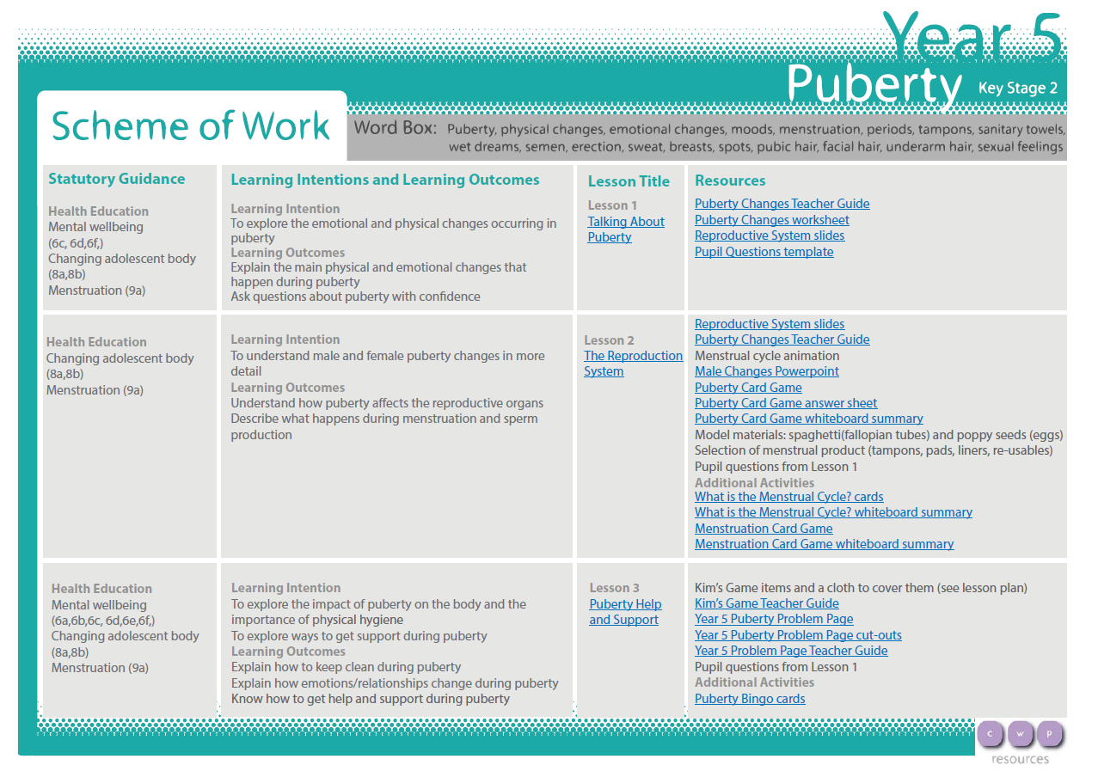

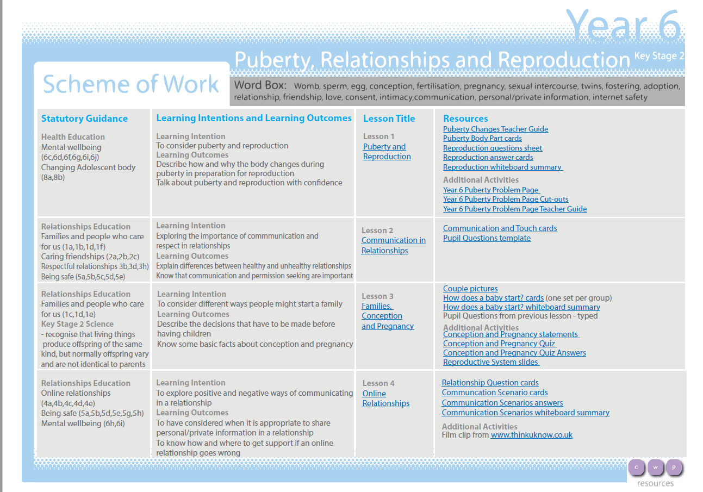
Drugs, Alcohol and Tobacco Education
