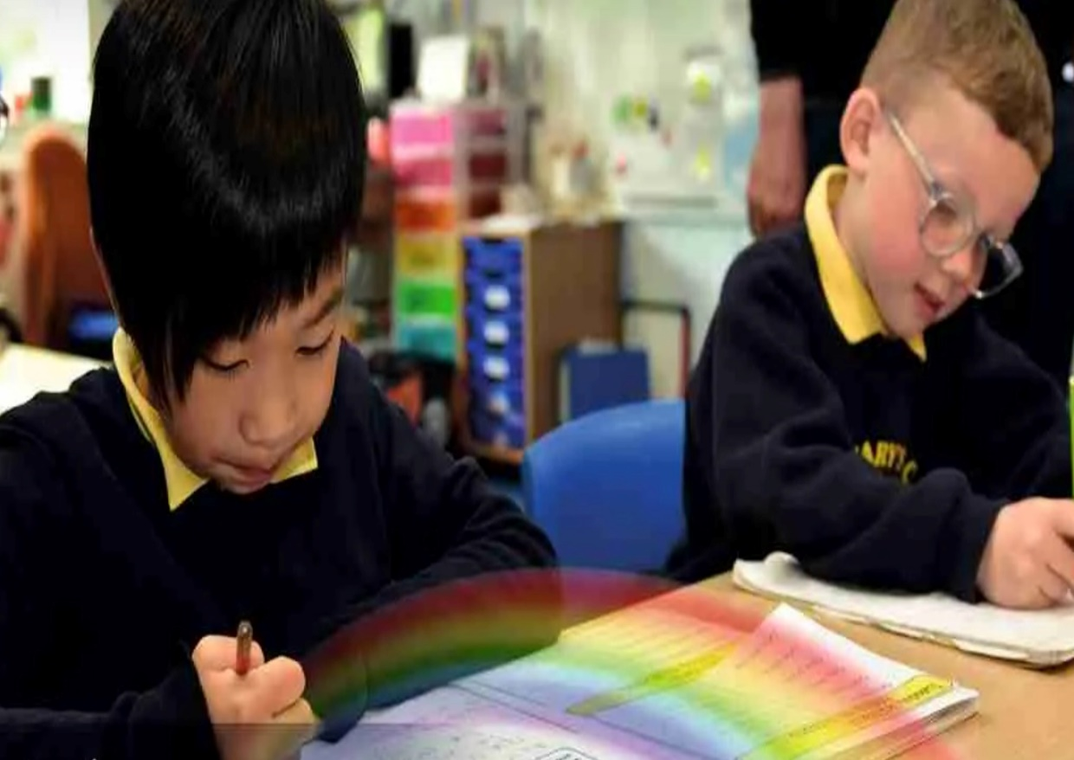

Music Curriculum Overview

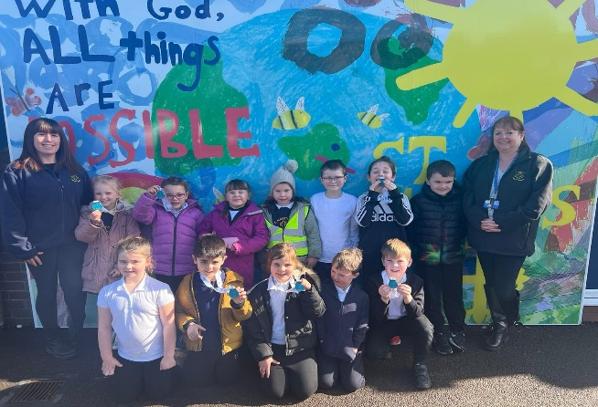
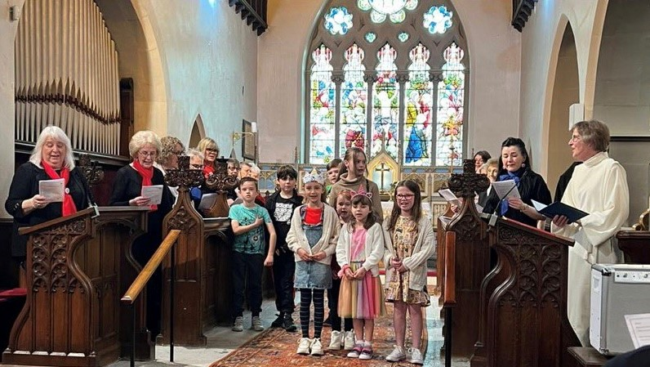
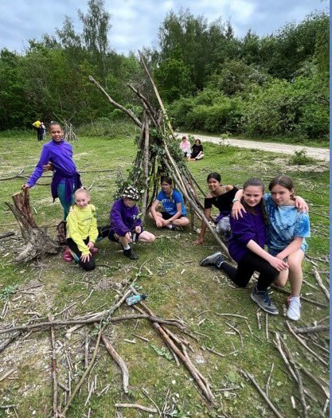
“With God, All Things are Possible.”

Our Approach

We have based our curriculum on the BBC Ten Pieces and Sing Up schemes of work. Our cyclical curriculum weaves the inter related dimensions of music through the 4 aspects below and our pupils revisit these aspects throughout their time in our school from EYFS to Y6 as highlighted in the overviews within this document. The dimensions of Inter related dimensions of music are: pulse, pitch, duration, dynamics, tempo, timbre, texture, structure and notation. Each time they revisit an aspect, it is with increasing complexity to build on their prior knowledge. Music is taught weekly as a 30-40 minute session and in addition, pupils come together through collective worship opportunities across each week to sing. Wider Opportunities are provided weekly through a school based choir and additional instrumental tuition.

YR | Autumn |  |  | Spring |  |  | Summer
Knowledge & Skills | BBC Ten Pieces ‘No Place Like’  - Pupils listen to a new piece of music and describe what they hear.  - Listen to the environment around them and find new sounds.  - Practise start and stop.  - Conduct the class in starting and stopping.  - Make their own ‘Home’ piece.  - Think of new words for songs.  - Link their topic or book to this piece of music.  - Help write a story with sound effects. |  | Sing up: Witch, witch and Row, row, row your boat.  - Make up a simple accompaniment using percussion instruments.  - Use the voice to adopt different roles and characters.  - Match the pitch of a four-note (la-so-mi-do) call-and-response song.  - Make up new lyrics and vocal sounds for different kinds of transport.  - Sing a tune with ‘stepping’ and ‘leaping’ notes.  - Play a steady beat on percussion instruments. | Sing up: Bird spotting cuckoo polka and Shake my Sillies out.  - Explore the range and capabilities of voices through vocal play.  - Develop a sense of beat by performing actions to music.  - Develop active listening skills by recognising the ‘cuckoo call’ in a piece of music (so-mi).  - Enjoy moving freely and expressively to music.  - Create a sound story using instruments to represent different animal sounds/ movements.  - Sing an action song with changes in speed.  - Play along with percussion instruments.  - Perform the story as a class.  - Listen to music and show the beat with actions. | Sing up: Up and Down and Five fine bumblebees.  - Make up new lyrics and accompanying actions.  - Sing and play a rising and falling melody, following the shape with voices and on tuned percussion.  - Use appropriate hand actions to mark a changing pitch.  - Improvise a vocal/physical soundscape about minibeasts.  - Sing in call-and-response and change voices to make a buzzing sound.  - Play an accompaniment using tuned and untuned percussion, and recognise a change in tempo.  - Listen to a piece of classical music and respond through dance. |  | Sing up: Down there under the sea and It’s oh so quiet.  - Develop a song by composing new words and adding movements and props.  - Sing a song using a call-and-response structure.  - Play sea sound effects on percussion instruments.  - With some support, play a call-and-response phrase comprising a short, stepping tune (C-D-E).  - Listen to a range of sea-related pieces of music and respond with movement.  - Improvise music with different instruments, following a conductor.  - Compose music based on characters and stories developed through listening to Beethoven’s 5th symphony.  - Play different instruments.  - Explore dynamics with voices and instruments.  - Develop listening skills, identifying dynamics (forte, piano, crescendo, and diminuendo) across a range of different musical styles. |  | Sing up: Slap Clap Clap and Bow, bow, bow Belinda.  - Compose a three-beat body percussion pattern and perform it to a steady beat.  - Sing a melody in waltz time and perform the actions.  - Transfer actions to sounds played on percussion instruments.  - Listen actively to music in 3/4 time.  - Find the beat and perform a clapping game with a partner.  - Invent and perform actions for new verses.  - Sing a song while performing a sequence of dance steps.  - Play a two-note accompaniment, playing the beat, on tuned or untuned percussion.  - Listen to and talk about folk songs from North America.
Vocab | Sounds, percussion, dynamics (Loud/Quiet), tempo (Fast/Slow), composer, conductor, timbre |  | High/low, call and response, phrase, strong beat, sounds, tone, percussion, solo, together, beat, pulse, rhythm, loud, quiet, stepping/leaping notes, songwriting and improvise | Beat, cuckoo interval, so-mi, echo singing, syncopation, rests, louder, quieter, higher/lower sounds, verse, chorus, faster/slower | Louder/quieter, up, down, higher/lower, melody, interval, stepping notes, scale, pulse, beat, faster, slower, glockenspiel, chime bars, xylophone, dotted rhythms, rest, stepping notes, jumping notes, fast, slow and soundscape |  | Stepping note, leap, call and response, slower/faster, louder/quieter, shaker, scraper, chime tree, chime bars, glockenspiel, xylophone, ocean drum, rain stick, soundscape, forte, piano, crescendo and diminuendo |  | Longer/shorter sound, waltz time, ring, shake, scrape, tap, strike, drum, body percussion, dotted notes, rhythm, higher/lower, phrase, steady beat, tuned and untuned
Continuous Provision Enhancements
- Seasonal instruments, instruments related to particular cultures, instruments used in different festivals, instruments created by children, CD’s or other listening material related to a topic of & costumes related to a topic of significance.
Y1 | Autumn |  |  | Spring |  |  | Summer
, , , Knowledge & Skills | Sing Up: Menu Song  (Progression snapshot)  - Participate in creating a dramatic group performance using kitchen-themed props.  - Sing a cumulative song from memory, remembering the order of the verses.  - Play classroom instruments on the beat.  - Copy a leader in a call-and-response song, show the shape of the pitch moving with actions, and sing using mi-re-do.  - Listen and move in time to the song. | BBC Ten Pieces Mars (Holst)  - Listen to a new piece of music  - Explore spikey and smooth in the context of music  - Learn a new song and sing it in different styles Play simple patterns on the drum, and repeat simple patterns back  - Write new lyrics to a familiar tune about all the things you might find on your way to Mars!  - Pupils make own space map with lots of different sounds  - Pupils will play some classroom instruments. |  | Sing Up: Football  (Progression snapshot)  - Compose word patterns in groups and melodies in pairs using mi-re-do (E-D-C).  - Chant together rhythmically, marking rests accurately.  - Play a simple ostinato on untuned percussion.  - Sing an echo song while tapping the beat, and clap the rhythm of the words, understanding there is one beat for each syllable.  - Recognise the difference between a pattern with notes (pitched) and without (unpitched). |  | Sing Up: ‘Dawn’ from Sea Interludes and Musical Conversations.  - Sing a simple singing game, adding actions to show a developing sense of beat.  - Listen actively by responding to musical signals and musical themes using appropriate movement.  - Create a musical movement picture.  - Compose musical sound effects and short sequences of sounds in response to a stimulus.  - Improvise question-and-answer conversations using percussion instruments.  - Create, interpret, and perform from simple graphic scores.  - Recognise how graphic symbols can represent sound. | Dancing and drawing to Nautilus and Cat and Mouse.  - Perform actions to music, reinforcing a sense of beat.  - Respond to musical signals and musical themes using movement, matching movements to musical gestures in the piece.  - Develop awareness of duration and the ability to move slowly to music.  - Create art work, drawing freely and imaginatively in response to a piece of music.  - Create rhythm patterns, sequencing them, and ‘fixing’ them as compositions using simple notation.  - Attempt to record compositions with stick and other notations.  - Sing and chant songs and rhymes expressively.  - Listen and copy rhythm patterns. | Come Dance with me (Progression snapshot)  - Create musical phrases from new word rhythms that children invent.  - Sing either part of a call-and-response song.  - Play the response sections on tuned percussion using the correct beater hold.  - Echo sing a line independently with teacher leading, then move on to pair singing in echo format.  - Copy call-and-response patterns with voices and instruments.
Vocab | Rhythm, rest, march on the beat, echo, call and response, cumulative, beat and talking bass | b, repeat. Motif, staccato, loud, quiet, high and low |  | Beat, rhythm, rest, untuned/tuned instruments, unpitched/pitched patterns, ostinato, echo, call and response, steady beat. |  | High/low, musical theme, beat, pulse, flute, harp, violin, viola, clarinet, orchestra, perform, tuned/untuned, improvise, compose, graphic symbol and graphic score. | Highness/lowness, beat and duration, rhythm, loud/quiet, high/low, notes in a tune and improvising | Beat, rhythm, stepping notes, tuned/untuned percussion, call-and-response, verse, chorus and solo
Y2 | Autumn |  |  | Spring |  |  | Summer
Knowledge & Skills | Sing Up: Tony Chestnut (Progression snapshot)  - Improvise rhythms along to a backing track using the note C or G.  - Compose call-and-response music.  - Play the melody on a tuned percussion instrument.  - Sing with good diction.  - Recognise and play echoing phrases by ear. |  | Sing Up: Carnival of the animals and Composing music inspired by birdsong.  - Select instruments and compose music to reflect an animal’s character.  - Listen with increased concentration to sounds/music and respond by talking about them using music vocabulary, or physically with movement and dance.  - Identify different qualities of sound (timbre) e.g. smooth, scratchy, clicking, ringing, and how they are made.  - Recognise and respond to changes of speed (tempo), the length of notes (duration – long/ short), short/detached/smooth (articulation), and pitch (high/low) using music vocabulary, and/ or movement. | Sing Up: Grandma Rap (Progression snapshot)  - Compose 4-beat patterns to create a new rhythmic accompaniment, using a looping app.  - Chant Grandma rap rhythmically, and perform to an accompaniment children create.  - Chant and play rhythms using the durations of ‘walk’ (crotchet), ‘jogging’ (quavers), and ‘shh’ (crotchet rest) from stick notation.  - Learn a clapping game to Hi lo chicka lo that shows the rhythm.  - Show the following durations with actions ‘walk’ (crotchet) and ‘jogging’ (quavers). |  | Sing Up: Orawa and Trains  - Improvise and compose, structuring short musical ideas to form a larger piece.  - Sing and play, performing composed pieces for an audience.  - Listen and appraise, with focus and attention to detail, recalling sounds and patterns.  - Begin to understand duration and rhythm notation.  - Structure musical ideas into a whole-class composition.  - Learn a simple rhythm pattern and perform it with tempo and volume changes.  - Learn about the musical terms crescendo, diminuendo, accelerando, ritenuto.  - Follow signals from a conductor.  - Listen to and analyse four pieces of music inspired by travel/vehicles. | Ten Pieces Finlandia (Sibelius)  - Listen to a new piece of music  - Explore loud and quiet sounds  - Made sounds on their body  - Make a graphic score, and new pieces of music  - Sing in different languages.  - Hear music from another country and compare.  - Move to a given pulse .  - Move to music.  - Play classroom instruments. | Sing Up: Tanczymy Labada (Progression snapshot)  - Demonstrate an internalised sense of pulse through singing games.  - Sing confidently in Polish, and play a cumulative game with spoken call-and-response sections.  - Play an accompaniment on tuned percussion and invent a 4-beat body percussion pattern.  - Listen and match the beat of others and recorded music, adapting speed accordingly.  - Listen to traditional and composed music from Poland. Begin to understand how music helps people share tradition and culture.
Vocab | Cuckoo call interval, melody, echo, call-and-response, beat, steady beat, tuned/untuned percussion, diction and improvise |  | Strings, long/short notes, glissando, legato, staccato, high, motif, conductor, orchestrate and improvise | Beat, crotchet, quavers, rhythm, pitch shape, 4-beat rhythm, steady beat and round |  | Beat, pulse, chant, coda, repetition, call-and-response, volume, crescendo, diminuendo, speed, accelerando, ritenuto and conductor | Pulse, beat, quiet, loud, graphic score, tunes/untuned percussion, compose and volume | Beat, 4-beats per bar, accompaniment, tuned/untuned percussion

Y3 | Autumn |  |  | Spring |  | Summer
, , , , Knowledge & Skills | Sing Up: I’ve been to Harlem (Progression snapshot)  - Compose a pentatonic ostinato.  - Sing a call-and-response song in groups, holding long notes confidently.  - Play melodic and rhythmic accompaniments to a song.  - Listen and identify where notes in the melody of the song go down and up. |  | Sing Up: Nao Chariya de/Mingulay boat song & Sound Symmetry  - Begin to develop an understanding and appreciation of music from different musical traditions.  - Identify that the songs are from different places in the world, use different instruments, have a different beat, and are different speeds. Pupils can use some musical vocabulary to describe these things.  - Understand that a folk song is music that belongs to the people of a particular place.  - Compose a simple song using symmetry to develop a melody, structure, and rhythmic accompaniment.  - Sing by improvising simple melodies and rhythms.  - Identify how the pitch and melody of a song has been developed using symmetry. | Sing Up: Latin Dance  (classroom percussion)  PROGRESSION SNAPSHOT  - Compose a 4-beat rhythm pattern to play during instrumental sections.  - Working in small groups, sing a call-and-response song with an invented drone accompaniment.  - Sing the syncopated rhythms in Latin dance and recognise a verse/chorus structure.  - Play a one-note part contributing to the chords accompanying the verses.  - Listen to a range of Cuban pieces, understanding influences on the music and recognising some of its musical features. | BBC Ten Pieces  Steve Reich Music for 18 musicians  - Listen and reflect on a piece of orchestral music.  - Create their own piece of music using instruments and voice.  - Perform as an ensemble using voices and playing musical instruments.  - Improvise and compose music for a range of purposes using the interrelated dimensions of music.  - Listen with attention to detail and recall sounds with increasing aural memory. | Sing Up: Just 3 notes & Samba with Sergio  - Invent simple patterns using rhythms and notes C-D-E.  - Compose music, structuring short ideas into a bigger piece.  - Notate, read, follow and create a ‘score’.  - Recognise and copy rhythms and pitches C-D-E.  - Perform call-and-response rhythms vocally, by ear, using word rhythms, then transfer rhythms to body percussion/instruments.  - Perform vocal percussion as part of a group.  - Move in time with the beat of the music.  - Talk about what they have learnt about Brazil and Carnival (e.g. samba batucada instruments, playing in call-and-response, samba schools, that in Brazil music helps communities thrive, that word rhythms are an important way to learn rhythm patterns that you can freely express yourself at Carnival). |  | Sing Up: Fly with the stars (Classroom Percussion)  PROGRESSION SNAPSHOT  - Play the chords of Fly with the stars on tuned percussion as part of a whole-class performance.  - Sing solo or in a pair in call-and-response style.  - Respond to and recognise crotchets and quavers, and make up rhythms using these durations to create accompaniment ideas for the song.
Vocab | Pentatonic scale, note clusters, chords, ostinato, echo, phrase, call-and-response, beat, unison, round, accompaniment, improvise, compose, ensemble |  | Time signature, faster/slower, verse, chorus, melody, harmony, acoustic/electric, traditional/ modern, guitar, bass, keyboard, flute, hand drum, ektara, composed song, folk music, rhythm, melody, accompaniment, symmetry, pattern, phrase, ABA ternary form | Beat, syncopation, rhythm pattern, melody, chords, song, verse, chorus, instrumental, call-and-response, accompaniment, claves, timbale, trumpet, congo, bongos, Latin, salsa and Latin America | Crescendo, diminuendo, dynamics, ostinato, pitched, percussion, unpitched, percussion | Duration, rhythm, pitch, ostinato, score, genre, beat, rhythm, call-and-response, repinique, samba, carnival, fanfarra and Escolas de samba |  | Beat, pulse, crotchet, quavers, rest, bar, chords, major, minor, drone, intro, verse, chorus and chord pattern
Y4 | Autumn |  |  | Spring |  | Summer
, , , , , Knowledge & Skills | Sing Up: This Little Light of Mine  PROGRESSION SNAPSHOT  - Improvise with the voice on the notes of the pentatonic scale D-E-G-A-B (and B flat if you have one).  - Sing in a Gospel style with expression and dynamics.  - Play a bass part and rhythm ostinato along with This little light of mine.  - Sing Part 1 of a partner song rhythmically.  - Listen and move in tme to songs in a Gospel style. |  | BBC Ten Pieces: Wagner – Ride of the Valkyries.  - Listen and reflect on a piece of orchestral music.  - Invent their own musical motifs and structure them into a piece.  - Perform as an ensemble  - Learn musical language appropriate to the task  - Play and perform in ensemble contexts, using voices and playing musical instruments  - Improvise and compose music for a range of purposes using the interrelated dimensions of music  - Listen with attention to detail and recall sounds with increasing aural memory. | Sing Up: The Doot Doot Song (Classroom Percussion)  PROGRESSION SNAPSHOT  - ‘Doodle’ with voices over the chords in the song.  - Sing swung rhythms lightly and accurately.  - Learn a part on tuned percussion and play as part of a whole-class performance.  - Sing Part 2 of a partner song rhythmically. Adopt a rhythmic accompaniment while singing.  - Listen and identify similarities and differences between acoustic guitar styles. | Sing Up: Fanfare for the Common Man & Spain  - Improvise and compose, exploring how timbre, dynamics, and texture can be used for impact in a fanfare.  - Compose a fanfare using a small set of notes, and short, repeated rhythms.  - Listen and appraise, recognising and talking about the musical characteristics of a fanfare using music vocabulary.  - Invent a melody.  - Fit two patterns together.  - Structure musical ideas into compositions.  - Play repeating rhythmic patterns.  - Count musically. | Sing Up: Global Pentatonics & The Horse in Motion  - Compose a pentatonic melody.  - Improvise and create pentatonic patterns.  - Use notation to represent musical ideas.  - Compare music extracts and understand that the pentatonic scale features in lots of music traditions and cultures.  - Create ostinatos.  - Layer up different rhythms.  - Create and follow a score.  - Watch a film and analyse it in a musical context. |  | Sing Up: Favourite Song (Classroom Percussion)  PROGRESSION SNAPSHOT  - Sing with expression and a sense of the style of the music.  - Understand triads and play C, F, G major, and A minor.  - Play an instrumental part as part of a whole-class performance.  - Sing a part in a partner song, rhythmically and from memory.  - Identify similarities and differences between pieces of music in a folk/folk-rock style.
Vocab | Pentatonic, blue note, verse, chorus, call-and-response, echo, phrase, off-beat, articulation, legato, staccato, melody, accompaniment, unison, solo, ensemble and improvise. |  | Timbre, tempo, rhythm, dynamics, atmosphere, structure, graphic Score, leitmotif, pitched percussion, rondo, tempo, triad, trill, unpitched percussion | Beat, pulse, chords, melody, part, intro, verse, chorus, middle8, 2-bar phrases, acoustic pop, country, folk, pop, improvise and patsch | Long/short sounds, rhythm patterns, contrasts, melody, fanfare, phrases, harmony, chord, unison, homophonic, musical commission, brass instruments, triplets, Habanera, dynamics and forte | Pentatonic, scale, melody, phrase, shape, ascending, descending, drone, raga, pitch matching, traditional. Electric, solo, accompaniment, ostinato, volume, louds, softs, orchestration and graphic score |  | Steady, beat, pulse, time signature, triads, chords, major, minor, introduction, verse, chorus, instrumental, folk, rock, acoustic and electric
Y5 | Autumn |  |  | Spring |  | Summer
Knowledge & Skills | Sing Up: What Shall we do with the Drunken Sailor?  PROGRESSION SNAPSHOT  - Compose body percussion patterns to accompany a sea shanty. Write these out using rhythm grids.  - Sing a sea shanty expressively, with accurate pitch and a strong beat.  - Play bass notes, chords, or rhythms to accompany singing.  - Sing in unison while playing an instrumental beat (untuned).  - Keep the beat playing a ‘cup’ game.  - Talk about the purpose of sea shanties and describe some of the features using music vocabulary. | Sing Up: Why we Sing & Introduction to Songwriting  - Develop and practise techniques for singing and performing in a Gospel style.  - Recognise individual instruments and voices by ear.  - Listen to a selection of Gospel music and spirituals and identify key elements that give the music its unique sound.  - Talk about music using appropriate music vocabulary (e.g. the ways the voices are used, the contrasting texture of solo voice and choir, singing in harmony, the lyrics etc.).  - Improvise and compose, ‘doodling’ with sound, playing around with pitch and rhythm to create a strong hook.  - Create fragments of songs that can develop into fully fledged songs.  - Listen and appraise, identifying the structure of songs and analysing them to appreciate the role of metaphor.  - Understand techniques for creating a song and develop a greater understanding of the songwriting process. |  | Sing Up: Madina Tun Nabi  PROGRESSION SNAPSHOT  - Improvise freely over a drone.  - Sing a song in two parts with expression and an understanding of its origins.  - Sing a round and accompany themselves with a beat.  - Play a drone and chords to accompany singing.  - Listen and copy back simple rhythmic and melodic patterns. | Sing Up: Building a Groove &  Epoca  - Show understanding of how a drum pattern, bass line and riff fit together to create a memorable and catchy groove.  - Identify drum patterns, basslines, and riffs and play them using body percussion and voices.  - Engage the imagination, work creatively in movement in small groups, learning to share and develop ideas.  - Develop listening skills and an understanding of how different instrumental parts interact (texture) by responding to each part through movement.  - Demonstrate an understanding of the history of Argentine Tango. | BBC Ten Pieces: Mozart – Horn Concerto No. 4  - Listen and reflect on a piece of orchestral music  - Invent their own musical motifs and structure them into a piece  - Perform as an ensemble  - Learn musical language appropriate to the task  - Play and perform in ensemble contexts, using voices and playing musical instruments  - Improvise and compose music for a range of purposes using the interrelated dimensions of music  - Listen with attention to detail and recall sounds with increasing aural memory. | Sing Up: Kisne Banaaya  PROGRESSION SNAPSHOT  - Compose a simple accompaniment using tuned instruments.  - Create and perform their own class arrangement.  - Sing and play the melody of Kisne banaaya.  - Sing in a 4-part round accompanied with a pitched ostinato.
Vocab | Time signature, crotchet, quavers, semiquavers, melody, chords, bass note, major, minor, beat, sea shanty, work song, rhythm grid, accompany, body percussion | Quiet, louder, crescendo, melody, harmony, high/low voices, call-and-response, spoken interludes, phrase, unison, homophonic, choir, congregation, gospel, note bend, decoration, diction, articulation, legato, glissando, bridge, lyrics, rhyme, metaphor |  | Melody, octave, major, minor, microtone, vocal decoration, introduction, verse, chorus, call-and-response, a cappella, accompaniment, improvisation, Nasheed and Arabic | Pentatonic scale, bass line, backbeat, riff, legato, staccato, head, jazz, beat, semitone, ostinato, tango, neotango, fusion, staccato, legato and texture | Cadenza, coda, concert, movement, musicologist, pitched percussion, rondo, trill, unpitched percussion | Swar notes, melody, harmony, chords, ostinato, unaccompanied, a cappella, accompaniment, unison, two part round, Riyaz and Indian Classical music
Y6 | Autumn |  |  | Spring |  | Summer
, , , , Knowledge & Skills | Sing Up: Hey, Mr Miller  PROGRESSION SNAPSHOT  - Compose a syncopated melody using the notes of the C major scale.  - Sing a syncopated melody accurately and in tune.  - Sing and play a class arrangement of the song with a good sense of ensemble.  - Listen to historical recordings of big band swing and describe features of the music using music vocabulary. | Sing Up: Shadows & Composing for Protest!  - Explore the influences on an artist by comparing pieces of music from different genres.  - Identify features of timbre, instrumentation, and expression in an extract of recorded music.  - Use musical knowledge and vocabulary to discuss similarities and differences in pieces of music.  - Create a shadow movement piece in response to music.  - Create their own song lyrics.  - Fit their lyrics to a pulse, creating a chant.  - Write a melody and sing it.  - Structure their ideas into a complete song. |  | Sing Up: Dona nobis pacem  PROGRESSION SNAPSHOT  - Compose an 8-bar piece on percussion, in 3-time and using chords F and C major.  - Sing a round accurately and in a legato style.  - Sing a chorus in two-part harmony with dancing on the beat.  - Identify changes in texture between parts moving together (homophonic texture) and parts moving independently (polyphonic texture). | BBC Ten Pieces: Leonard Bernstein ‘Mambo’ from West Side Story.  - Listen and reflect on a piece of orchestral music.  - Create their own Latin inspired rhythmic ostinatos.  - Learn rhythms from Bernstein’s ‘Mambo’ and structure them into a piece.  - Play and perform in ensemble contexts, using voices and playing musical instruments.  - Improvise and compose music for a range of purposes using the interrelated dimensions of music.  - Listen with attention to detail and recall sounds with increasing aural memory. | Sing Up: Race & Exploring Identity through Song  - Create an accompaniment.  - Create an extended melody with four distinct phrases.  - Experiment with harmony.  - Structure ideas into a full soundtrack.  - Identify ways songwriters convey meaning: through lyrics, the music, and the performance.  - Understand different ways that rhymes work in songs.  - Identify different elements of a song’s structure.  - Understand the concept of identity and how you can express that in songs. |  | Sing Up: Ame Sau Vala Tara Bal PROGRESSION SNAPSHOT  - Create a rhythmic piece for drums and percussion instruments.  - Sing the chorus of Throw, catch in three-part harmony with dancing.  - Develop knowledge and understanding of a variety of musical styles from India, talking about them using music vocabulary.  - Demonstrate coordination and keeping a steady beat by dancing to bhangra music.
Vocab | Beat, pulse, count-in, swing rhythm, syncopation, arpeggio, chromatic, major scale, layers, rhythm section, scat singing, improvisation, big band and swing music | Distortion, genre, style, fusion, rock, country, electronic/dance music, DJ, impressionism, drum/bass, legato, off beat rhythms, classical, tempo, ostinato, coda, protest song, lyrics, chant and melody |  | Time signature, dotted crotchet, dotted minim, crotchet, quavers, crotchet rest, major, minor, round, phrase, polyphonic, homophonic, monophonic, a cappella, sacred vocal music and Latin | Rhythm, tempo, timbre, structure, instruments, glissando, jam, pitched percussion, pulse, unpitched percussion | Steady beat, rhythm, motif, harmony, ostinato, melody, accompaniment, Pop, R&B, Hip hop, high voices, low voices, intro, verse, chorus, outro, instrumental, internal rhyme, anthem and voice change |  | Chaal rhythm, bols, Bhairavi raga, astayi, antara, echo, pulse, beat, solo, unison voices, bhangra, Bollywood, Indian classical music

