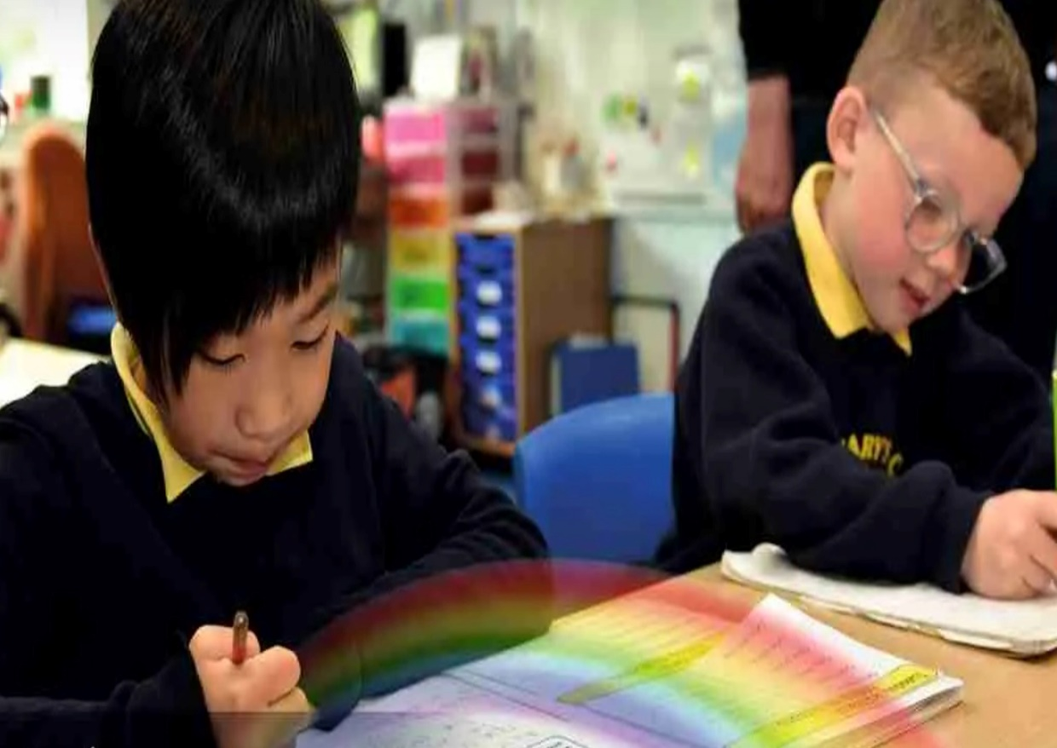

RE Curriculum Overview
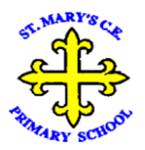
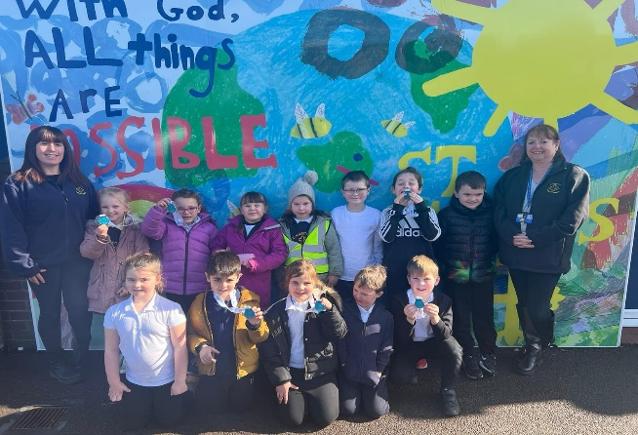
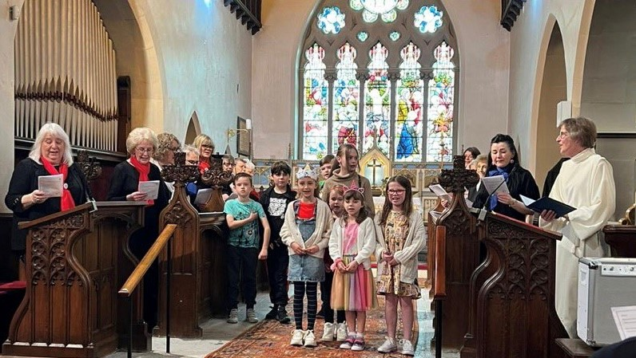
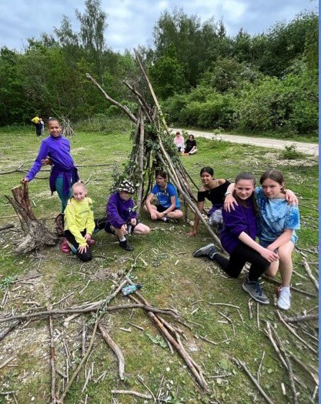
“With God, All Things are Possible.”

Our Approach

We follow the Manchester Syllabus Agreed Syllabus 2022-2027 and recognise that RE explores big questions about life, in order to find out what people believe and what difference this makes to how they live, so that pupils can make sense of religion and worldviews, and reflect on their own ideas and ways of living. Our cyclical curriculum focuses on the 3 aspects below and our pupils develop their knowledge and understanding through key questions, where they go on a quest to find the answers. Each time they revisit an aspect within a theme, it is with increasing complexity and deeper reflection to build on their prior knowledge. During the EYFS, children will encounter Christianity and other faiths, as part of their growing sense of self, their own community and their place within it. In KS1, children explore Christianity with links and comparisons to Islam and Judaism. As children move into KS2 they further build on this knowledge and also learn about Hinduism. RE is taught as an hour lesson each week and we record our pupils learning in class floor books. As a CofE school we have daily worship and all classrooms have a prominent reflection display and prayer area.

Across the agreed syllabus there are 3 aspects that knowledge and skills are built upon:

A. Know about and understand a range of religious and non-religious worldviews. | B. Express ideas and insights about the nature, significance and impact of religious and non-religious worldviews. | C. Gain and deploy the skills needed to engage seriously with religious and non-religious worldviews.

YR | Autumn |  |  | Spring |  |  | Summer
Knowledge & Skills | Expressing-Which places are special and why?  - Talk about somewhere that is special to themselves, saying why.  - Know some similarities and differences between religious communities in Britain.  - Be aware that some religious people have places which have special meaning for them.  - Hold conversations about the things that are special and valued in a place of worship.  - Identify some significant features of sacred places using recently acquired vocabulary.  - Recognise two different places of worship using new vocabulary.  - Get to know and use appropriate words to talk imaginatively and expressively about their thought and feelings when visiting a church. |  | Expressing-Which times are special and why?  - Give examples of special occasions and suggest features of a good celebration.  - Recall simple stories connected with Christmas / Easter and a festival from another faith.  - Say why Christmas / Easter and a festival from another faith is a special time for Christians / members of the other faith.  - Use new vocabulary t identify some similarities and differences between religious communities in Britain.  - Respond imaginatively and expressively to what happens at their favourite times. | Believing-Which people are special and why?  - Talk about people who are special to them.  - Hold conversations about what makes their family and friends special to them.  - Identify some of the qualities of a good friend.  - Reflect on the question ‘Am I a good friend?  - Recall and talk about stories of Jesus as a friend to others using new vocabulary.  - Recall stories about special people in other religions and talk about what we can learn from them.  - Know some similarities and differences between religious communities in Britain. | Believing-Which stories are special and why?  - Talk about some religious stories using new vocabulary.  - Recognise some religious words, e.g. about God, holy books or places of worship. Identify some of their own feelings in the stories they hear.  - Identify a sacred text e.g. Bible, Qur’an.  - Talk about what Jesus teaches about keeping promises and say why keeping promises is a good thing to do.  - old conversations about what Jesus teaches about saying ‘thank you’, and why it is good to thank and be thanked.  - Know some similarities and differences between religious communities in Britain. |  | Living-Where do we belong?  - Re-tell religious stories making connections with personal experiences.  - Share and record occasions when things have happened in their lives that made them feel special.  - Use new vocabulary to recall and name simply what happens at a traditional Christian infant baptism and dedication.  - Respond imaginatively and expressively to stories about new babies.  - Take additional opportunities for learning if you have children from religions other than Christianity in your setting so that children can use new vocabulary to describe ceremonies that welcome new babies.  - Recall simply what happens when a baby is welcomed into a religion other than Christianity. |  | Living-What is special about our world?  - Talk about things they find interesting, puzzling or wonderful and also about their own experiences and feelings about the world.  - Re-tell stories about creation and nature, talking about what they say about the world, God, human beings.  - Respond imaginatively and expressively to the beauty and delight of the natural world.  - Think about the wonders of the natural world, expressing ideas and feelings.  - Express ideas about how to look after animals and plants.  - Talk about what people do to mess up the world and what they do to look after it.
Vocab | Special places, church, mosque, synagogue |  | Christmas Bible Church | Jesus, bible, stories | Religion Special books, bible, Qu’ran, Torah |  | Christian, baptism, font, sacred |  | God, world, religion, prayer
Continuous Provision Enhancements
- Relevant books for each aspect, within different areas or dedicated RE/reflection space, puppets, small world figures, relevant costumes for the nativity characters/festivals at different times and imagery of places of worship within the construction area.
Y1 | Autumn |  |  | Spring |  |  | Summer
, , , Knowledge & Skills | Believing-Who is a Christian and what do they believe?  - Talk about the fact that Christians believe in God and follow the example of Jesus (A1).  - Recognise some Christian symbols and images used to express ideas about God (A3).  - Talk about some simple ideas about Christian beliefs about God and Jesus (A1).  - Re-tell a story that shows what Christians might think about God, in words, drama and pictures, suggesting what it means (A2).  - Talk about issues of good and bad, right and wrong arising from the stories (C3).  - Ask some questions about believing in God and offer some ideas of their own (C1).  - Make links between what Jesus taught and what Christians believe and do (A2).  - Respond thoughtfully to a piece of Christian music and a Bible text that inspired it (B1). | Living-What does it mean to belong to a faith community?  - Talk about what is special and of value about belonging to a group that is important to them (B2).  - Show an awareness that some people belong to different religions (B1).  - Recognise and name some symbols of belonging from their own experience, for Christians and at least one other religion, suggesting what these might mean and why they matter to believers (A3).  - Give an account of what happens at a traditional Christian infant baptism /dedication and suggest what the actions and symbols mean (A1).  - Identify two ways people show they belong to each other when they get married (A1).  - Respond to examples of co-operation between different people (C2).  - Give examples of ways in which believers express their identity and belonging within faith communities, responding sensitively to differences (B2).  - Identify some similarities and differences between the ceremonies studied (B3).  Christmas |  | Believing-Who is Jewish and what do they believe?  - Talk about the fact that Jewish people believe in God (A1).  - Recognise that some Jewish people remember God in different ways (e.g. mezuzah, on Shabbat) (A3).  - Talk about how the mezuzah in the home reminds Jewish people about God (A3).  - Talk about how Shabbat is a special day of the week for Jewish people, and give some examples of what they might do to celebrate Shabbat (B1).  - Re-tell a story that shows what Jewish people at the festivals of Sukkot, Chanukah or Pesach might think about God, suggesting what it means (A2).  - Ask some questions about believing in God and offer some ideas of their own (C1).  - Make links between some Jewish teachings and how Jewish people live (A2).  - Express their own ideas about the value of times of reflection, thanksgiving, praise and remembrance, in the light of their learning about why Jewish people choose to celebrate in these ways (C1). |  | Believing-What do we know about the Easter story?  - Give children an understanding that symbols are pictures or objects with a deeper meaning and a story to tell. (A3)  - Extend pupils knowledge of the details of the Easter story. (A2)  - Develop pupils’ understanding of the importance of Easter and the concept of salvation. | Expressing-What makes some places sacred?  - Recognise that there are special places where people go to worship, and talk about what people do there (A1).  - Identify at least three objects used in worship in two religions (A3).  - Identify special objects and symbols found in a place where people worship and be able to say something about what they mean and how they are used (A3).  - Talk about ways in which stories, objects, symbols and actions used in churches, mosques and/or synagogues show what people believe (B2).  - Describe some of the ways in which people use music in worship, and talk about how different kinds of music make them feel (C1).  - Ask good questions during a school visit about what happens in a church, synagogue or mosque (B1).  - Suggest meanings to religious songs, responding sensitively to ideas about thanking and praising (A2).  - Show that they have begun to be aware that some people regularly worship God in different ways and in different places (B3).  Place of Worship Visit
Vocab | Christian, God, Creator, Jesus,  symbol, thankful, faith, belief, wise sayings | Christian, God, Creator, Jesus, church, altar, font, Bible, gospel, Islam, Muslim, Allah, Muhammad, Mosque, Judaism, Jewish, Shabbat, Synagogue, |  | Jewish, Synagogue, Torah, bimah, Hanukkah, Ark, Judaism, Shabbat, mezuzah |  | Christian, God, Creator, Christmas, Easter, Jesus, church, Bible, gospel | Christianity, Church, Islam, Mosque, Judaism, Synagogue, worship, holy, artefacts, cross, font, altar, lectern, pulpit, pews, stained glass windows, Ner Tamid, Ark, Torah, Menorah, Bimah, tallit, tefillin, Kippah, wuzu / wudu, calligraphy, prayer mat, prayer beads, minbar, mihrab, muezzin
Y2 | Autumn |  |  | Spring |  |  | Summer
Knowledge & Skills | Believing-What can we learn from sacred books?  - Talk about some of the stories that are used in religion and why people still read them (A2).  - Recognise some ways in which Christians, Muslims and Jewish people treat their sacred books (B3).  - Recognise that sacred texts contain stories which are special to many people and should be treated with respect (B3).  - Re-tell stories from the Christian Bible and stories from another faith; suggest the meaning of these stories (A2).  - Ask and suggest answers to questions arising from stories Jesus told and from another religion (C1).  - Talk about issues of good and bad, right and wrong arising from the stories (C3).  - Suggest their own ideas about stories from sacred texts and give reasons for their significance (C1).  - Make links between the messages within sacred texts and the way people live (A2). |  | Expressing-How do we celebrate special and sacred times? (Christmas)  - Identify a special time they celebrate and explain simply what celebration means (A1).  - Talk about ways in which Jesus was a special person who Christians believe is the Son of God (A2).  - Identify some ways Christians celebrate Christmas (A1).  - Re-tell stories connected with Christmas and say why these are important to believers (A2).  - Ask questions and suggest answers about stories to do with Christian festivals and a story from a festival in another religion (B1).  - Collect examples of what people do, give, sing, remember or think about at the religious celebrations studied, and say why they matter to believers (C1).  - Suggest meanings for some symbols and actions used in religious celebrations, including Christmas (A3).  - Identify some similarities and differences between the celebrations studied (B3). | Believing-Who is a Muslim and what do they believe? (Part 1)  - Talk about the fact that Muslims believe in God (Allah) and follow the example of the Prophet Muhammad (A1).  - Recognise that Muslims do not draw Allah or the Prophet but use calligraphy, for example, to say what God is like (A3).  - Talk about some simple ideas about Muslim beliefs about God, making links with some of the 99 Names of Allah (A1).  - Re-tell a story about the life of the Prophet Muhammad (A2).  - Recognise some objects used by Muslims and suggest why they are important (A2).  - Identify some ways Muslims mark Ramadan and celebrate Eid-ul-Fitr and how this might make them feel (B1).  - Make links between what the Holy Qur’an says and how Muslims behave (A2).  - Ask some questions about God that are hard to answer and offer some ideas of their own (C1). |  | Expressing-How do we celebrate special and sacred times? (Easter)  - Identify a special time they celebrate and explain simply what celebration means (A1).  - Talk about ways in which Jesus was a special person who Christians believe is the Son of God (A2).  - Identify some ways Christians celebrate Easter (A1).  - Re-tell stories connected with Easter and say why these are important to believers (A2).  - Ask questions and suggest answers about stories to do with Christian festivals and a story from a festival in another religion (B1).  - Collect examples of what people do, give, sing, remember or think about at the religious celebrations studied, and say why they matter to believers (C1).  - Suggest meanings for some symbols and actions used in religious celebrations, including Easter (A3).  - Identify some similarities and differences between the celebrations studied (B3). | Believing-Who is a Muslim and what do they believe? (Part 2 - Link to Ramadan and Eid)  - Recognise some objects used by Muslims and suggest why they are important (A2).  - Identify some ways Muslims mark Ramadan and celebrate Eid-ul-Fitr and how this might make them feel (B1).  - Make links between what the Holy Qur’an says and how Muslims behave (A2).  - Ask some questions about God that are hard to answer and offer some ideas of their own (C1).  - Re-tell stories connected with Ramadan and Eid and say why these are important to believers (A2).  - Ask questions and suggest answers about stories to do with Muslim festivals (B1).  - Collect examples of what people do, give, sing, remember or think about at the religious celebrations studied, and say why they matter to believers (C1).  - Suggest meanings for some symbols and actions used in religious celebrations, including Eid (A3). | Living-How should we care for others?  - Talk about how religions teach that people are valuable, giving simple examples (B1).  - Recognise that some people believe God created the world and so we should look after it (A2).  - Re-tell Bible stories and stories from another faith about caring for others and the world (A2).  - Identify ways that some people make a response to God by caring for others and the world (B1).  - Talk about issues of good and bad, right and wrong arising from the stories (C3).  - Talk about some texts from different religions that promote the ‘Golden Rule’, and think about what would happen if people followed this idea more (C2).  - Use creative ways to express their own ideas about the creation story and what it says about what God is like (C1).  - Give examples of ways in which believers put their beliefs about others and the world into action, making links with religious stories Answer the title question thoughtfully, in the light of their learning in this unit (C1).
Vocab | Bible, Torah, yad, Ark, Qur’an, holy, sacred, rules for living, Jesus, Muhammad, Moses |  | Christian, God, Creator, Christmas, Jesus, church, rules for living, co-operation, belonging, Eid, Ramadan | Muslim, Islam, Allah, Prophet Muhammad, mosque, Qur’an, star and crescent, Eid, Ramadan, calligraphy, prayer beads, Mecca, minbar, Imam, Five Pillars, Shahada, Salah, Zakat, Sawm, Hajj |  | Christian, God, Creator, Easter, Jesus, church, Bible, gospel, crucifixion, Maundy Thursday, Good Friday, Easter Sunday, Passover / Pesach, Eid, Ramadan | Muslim, Islam, Allah, Prophet Muhammad, mosque, Qur’an, star and crescent, Eid, Ramadan, fasting, Five Pillars, Shahada, Salah, Zakat, Sawn, Hajj | Religion, celebration, festival, symbol, creation story, faith, belief, wise sayings, rules for living, golden rule, Judaism, Jewish, Tzedakah, Sukkot

Y3 | Autumn |  |  | Spring |  | Summer
, , , , Knowledge & Skills | Believing-What do different people believe about God?  - Identify beliefs about God that are held by Christians, Hindus and/or Muslims (B1).  - Retell and suggest the meanings of stories from sacred texts about people who encountered God (A1).  - Describe some of the ways in which Christians Hindus and/or Muslims describe God (A1).  - Ask questions and suggest some of their own responses to ideas about God (C1).  - Suggest why having a faith or belief in something can be hard (B2).  - Identify how and say why it makes a difference in people’s lives to believe in God (B1).  - Identify some similarities and differences between ideas about what God is like in different religions (B3).  - Discuss and present their own ideas about why there are many ideas about God and express their own understanding of God through words, symbols and the arts (C1). |  | Living-What does it mean to be a Christian in Britain today?  - Identify and name examples of what Christians have and do in their families and at church to show their faith (A3).  - Ask good questions about what Christians do to show their faith (B1).  - Describe some examples of what Christians do to show their faith, and make connections with some Christian beliefs and teachings (A1).  - Describe some ways in which Christians express their faith through hymns and modern worship songs (A2).  - Suggest at least two reasons why being a Christian is a good thing in Britain today, and two reasons why it might be hard sometimes (B2).  - Discuss links between the actions of Christians in helping others and ways in which people of other faiths and beliefs, including pupils themselves, help others (C2).  - Explain similarities and differences between at least two different ways of worshipping in two different Christian churches (A3).  - Discuss and present ideas about what it means to be a Christian in Britain today, making links with their own experiences (C1). | Believing-Why is the Bible so important for Christians today?  - Recall and name some Bible stories that inspire Christians-the Lost Coin, Sheep and Son (A2).  - Identify at least two ways Christians use the Bible in everyday life (B1).  - Make connections between stories in the Bible and what Christians believe about creation, the Fall and salvation (A2).  - Give examples of how and suggest reasons why Christians use the Bible today (B1).  - Describe some ways Christians say what God is like, with examples from the Bible, using different forms of expression (A1).  - Discuss their own and others’ ideas about why humans do bad things and how people try to put things right (C3).  - Explain how the Bible uses different kinds of stories to tell a big story (A2).  - Suggest why Christians believe that God needs to rescue/save human beings (B2). | Expressing-Why do people pray?  - Describe what some believers say and do when they pray (A1).  - Respond thoughtfully to examples of how praying helps religious believers (B2).  - Describe the practice of prayer in the religions studied (A2).  - Make connections between what people believe about prayer and what they do when they pray (A3).  - Describe ways in which prayer can comfort and challenge believers (B2).  - Describe and comment on similarities and differences between how Christians, Muslims and Hindus pray (B3).  - Explain similarities and differences between how people pray (B3). Consider and evaluate the significance of prayer in the lives of people today (A1). | Expressing-Why are festivals important to religious communities?  - Recognise and identify some differences between religious festivals and other types of celebrations (B2).  - Retell some stories behind festivals (e.g. Christmas, Diwali, Pesach) (A2). Make connections between stories, symbols and beliefs with what happens in at least two festivals (A2).  - Ask questions and give ideas about what matters most to believers in festivals (e.g. Easter, Eid) (B2).  - Identify similarities and differences in the way festivals are celebrated within and between religions (A3).  - Explore and suggest ideas about what is worth celebrating and remembering in religious communities and in their own lives (C1).  - Discuss and present their own responses about the role of festivals in the life of Britain today, showing their understanding of the values and beliefs at the heart of each festival studied, using a variety of media (C2).  - Suggest how and why religious festivals are valuable to many people (B2). |  | Living-How do family life and festivals show what matters to Jewish people?  - Identify and name examples of what Jewish people have and do in their families to show their faith (A3).  - Retell some stories behind festivals e.g. Yom Kippur, Pesach (A2).  - Make links between the Exodus story and Jewish beliefs about God and his relationship with the Jewish people (A3).  - Describe how Jewish people show their beliefs through worship in festivals, both at home and in wider communities (B1).  - Explore and suggest ideas about what is worth celebrating and remembering for Jewish people, and in pupils’ own lives (C1).  - Suggest how and why family life and festivals are valuable to Jewish people (B2).  - Make links with the value of personal reflection, saying sorry, being forgiven, being grateful, seeking freedom and justice in the world today, including in pupils’ own lives, and giving good reasons for their ideas (C2).  Place of Worship Visit
Vocab | Christianity, God, Holy Trinity, creator, Judaism, Jewish, Islam, Muslim, Allah, Qur’an, Shahadah. Hinduism, Hindu, Brahman, Durga, deity, Trimurti – Brahma, Vishnu, Shiva |  | Christian, Holy Communion, Christmas, Harvest Festival, Messiah, liturgy, church, Gospel, Jesus, Holy Spirit, God the Creator, Holy Trinity, Heaven | Christian, Bible, Testaments, Messiah, liturgy, church, Gospel, Jesus, Holy Spirit, God the Creator, Holy Trinity, Heaven, Creation, Temptation, Fall, Salvation | Religion, spiritual, commitment, values, prayer, pilgrimage, ritual, symbol, community, worship, devotion, belief, life after death, Lord’s Prayer, Qu’ran, First Surah, Gayatri Mantra, Christianity, Islam, Hinduism, Puja, deity, murti, Mandir, offerings / presad | Holy week, Lent, Easter, Christmas, Harvest, Pentecost, Diwali, Holi, Pesach, Rosh Hashanah, Yom Kippur, Hanakkah, Sukkot, Ramadan, Eid |  | Jewish, Judaism, Moses, Exodus, Ten Commandments, Star of David, Torah, Talmud, Siddur prayer book, Pesach, Rosh Hashanah, Yom Kippur, Shabbat, Sukkot
Y4 | Autumn |  |  | Spring |  | Summer
, , , , , Knowledge & Skills | Believing-Why is Jesus inspiring to some people?  - Ask questions raised by the stories and life of Jesus and followers today; give examples of how Christians are inspired by Jesus (B1).  - Suggest some ideas about good ways to treat others, arising from their learning (C3).  - Make connections between some of Jesus’ teachings and the way Christians live today (A1).  - Describe how Christians celebrate Holy Week and Easter Sunday (A1).  - Identify the most important parts of Easter for Christians and say why they are important (B1).  - Give simple definitions of some key Christian terms (e.g. gospel, incarnation, salvation) and illustrate them with events from Holy Week and Easter (A2). |  | Expressing-How do people from religious and non-religious communities celebrate key festivals?  - Recognise and identify some differences between religious festivals and other types of celebrations (B2).  - Retell some stories behind festivals (e.g. Christmas, Chanukah) (A2).  - Describe how the way some people celebrate festivals might show something about their beliefs (A2).  - Identify some differences in the way festivals (e.g. Christmas) are celebrated within and between different religious and non-religious worldviews (A3).  - Identify why members of the same religious or non-religious worldview might celebrate festivals differently or for different reasons (B1).  - Raise important questions and suggest answers about how the celebrations studied might make a difference to how pupils think and live (C1).  - Describe two different answers to ‘How do people celebrate Christmas?’ by a religious studies expert and a sociologist (C2).  - Suggest how and why religious festivals are valuable to many people (B2). | Believing-Inspiring Christians  - Make connections between the Easter story of Jesus and the wider ‘big story’ of the Bible (creation, the Fall, incarnation, salvation) – see unit L2.2), reflecting on why this inspires Christians (A1).  - Present their own ideas about the most important attitudes and values to have today, making links with Christian values (C2). | Expressing-Why do some people think life is like a journey and what significant experiences mark this?  - Recall and name some of the ways religions mark milestones of commitment (including marriage) (A1).  - Identify at least two promises made by believers at these ceremonies and say why they are important (B1).  - Suggest why some people see life as a journey and identify some of the key milestones on this journey (A2).  - Describe what happens in Christian, Jewish, and/or Hindu ceremonies of commitment and say what these rituals mean (A3).  - Suggest reasons why marking the milestones of life are important to Christians, Hindus and/or Jewish people (B2).  - Link up some questions and answers about how believers show commitment with their own ideas about community, belonging and belief (C1).  - Explain similarities and differences between ceremonies of commitment (B3).  - Discuss and present their own ideas about the value and challenge of religious commitment in Britain today (C2). | Living-What does it mean to be a Hindu in Britain today?  - Identify and name examples of what Hindus have and do in their families and at mandir to show their faith (A3).  - Ask good questions about what Hindus do to show their faith (B1).  - Describe some examples of what Hindus do to show their faith, and make connections with some Hindu beliefs and teachings about aims and duties in life (A1).  - Describe some ways in which Hindus express their faith through puja, aarti and bhajans (A2).  - Suggest at least two reasons why being a Hindu is a good thing in Britain today, and two reasons why it might be hard sometimes (B2).  - Discuss links between the actions of Hindus in helping others and ways in which people of other faiths and beliefs, including pupils themselves, help others (C2).  - Explain similarities and differences between Hindu worship and worship in another religious tradition pupils have been taught (B3).  - Discuss and present ideas about what it means to be a Hindu in Britain today, making links with their own experiences (C1).  Place of Worship Visit |  | Living-What can we learn from religions about deciding what is right and wrong?  - Recall and talk about some rules for living in religious traditions (B2).  - Find out at least two teachings from religions about how to live a good life (C3).  - Give examples of rules for living from religions and suggest ways in which they might help believers with difficult decisions (B1).  - Make connections between stories of temptation and why people can find it difficult to be good (A2).  - Give examples of ways in which some inspirational people have been guided by their religion (B1).  - Discuss their own and others’ ideas about how people decide about right and wrong (C3).  - Explain some similarities and differences between the codes for living used by Christians and the followers of at least one other religion or non-religious belief system (B3).  - Express ideas about right and wrong, good and bad for themselves, including ideas about love, forgiveness, honesty, kindness and generosity (C3).
Vocab | Religion, spiritual, role model, saviour, inspiration commitment, values, gospels, Beatitudes, prayer, symbol, incarnation, resurrection, salvation, community, worship |  | Humanist, Golden Rule, religious non-religious, secular, spiritual, atheist, festivals, Easter, Christmas, Hannukah, Sukkot, Diwali | Easter, Jesus, spiritual, role model, saviour, inspiration commitment, values, gospels, Beatitudes, prayer, symbol, incarnation, resurrection, salvation, community, worship | Spiritual, commitment, milestones, values, prayer, ceremonies, ritual baptism, Bar / Bat Mitzvah, dharma, karma, reincarnation, moksha, sacred thread ceremony, communion, pilgrim, pilgrimage, wedding, ketubah, | Hindu, Mandir, puja, murtis, gods, goddesses, deity, prasad, aarti, bhajans, Trimurti, Tridevi, Diwali, Holi, Aum, dharma, karma, reincarnation, moksha, ahisma |  | Beatitudes, golden rule, ten commandments, Torah, Bible, Humanism, temptation
Y5 | Autumn |  |  | Spring |  | Summer
Knowledge & Skills | Expressing-If God is everywhere, why go to a place of worship?  - Recall and name some key features of places of worship studied (A1).  - Find out about what believers say about their places of worship (C2).  - Make connections between how believers feel about places of worship in different traditions (A3).  - Select and describe the most important functions of a place of worship for the community (B3).  - Give examples of how places of worship support believers in difficult times, explaining why this matters to believers (B2).  - Present ideas about the importance of people in a place of worship, rather than the place itself (C1).  - Outline how and why places of worship fulfil special functions in the lives of believers (A3).  - Comment thoughtfully on the value and purpose of places of worship in religious communities (B1). | Believing-What would Jesus do? (Can we live by the values of Jesus in the 21st century?)  - Make connections between some of Jesus’ teachings and the way Christians live today (A1).  - Discuss their own ideas about the importance of values to live by, comparing them to Christian ideas (C3).  - Outline Jesus’ teaching on how his followers should live (A2).  - Offer interpretations of two of Jesus’ parables and say what they might teach Christians about how to live (B3).  - Explain the impact Jesus’ example and teachings might have on Christians today (B1).  - Express their own understanding of what Jesus would do in relation to a moral dilemma from the world today (C3). Explain the links between Jesus’ death on the cross and Christian belief in love and forgiveness, giving reasons why Christians want to follow Jesus (A2).  - Investigate and explain the challenges of following Jesus’ teaching about love, forgiveness, justice and/or generosity, expressing their own ideas (C3). |  | Expressing-Is it better to express your beliefs in art and architecture or in charity and generosity?  - Respond with ideas of their own to the title question (B2).  - Find out about religious teachings, charities and ways of expressing generosity (C3).  - Describe and make connections between examples of religious creativity (buildings and art) (A1).  - Show understanding of the value of sacred buildings and art (B3).  - Suggest reasons why some believers see generosity and charity as more important than buildings and art (B2).  - Apply ideas about values from scriptures to the title question (C2).  - Outline how and why some Humanists criticise spending on religious buildings or art (A3).  - Examine the title question from different perspectives, including their own (C1). | Living-What matters most to Christians and Humanists?  - Identify the values found in stories and texts (A2).  - Suggest ideas about why humans can be both good and bad, making links with Christian ideas (B3).  - Describe what Christians mean about humans being made in the image of God and being ‘fallen’, giving examples (A2).  - Describe some Christian and Humanist values simply (B3).  - Express their own ideas about some big moral concepts, such as fairness, honesty etc., comparing them with the ideas of others they have studied (C3).  - Suggest reasons why it might be helpful to follow a moral code and why it might be difficult, offering different points of view (B2).  - Give examples of similarities and differences between Christian and Humanist values (B3).  - Apply ideas about what really matters in life for themselves, including ideas about fairness, freedom, truth, peace, in the light of their learning (C2). | Living-What difference does it make to believe in ahimsa (harmlessness), grace and ummah (community)?  - Describe what ahimsa, grace or ummah mean to religious people (A1).  - Respond sensitively to examples of religious practice with ideas of their own (B2).  - Make connections between beliefs and behaviour in different religions (A1).  - Outline the challenges of being a Hindu, Christian or Muslim in Britain today (B2).  - Make connections between belief in ahimsa, grace and ummah, teachings and sources of wisdom in the three religions (A1).  - Consider similarities and differences between beliefs and behaviour in different faiths (B3).  - Explain similarities in ways in which key beliefs make a difference to life in two or three religions (A1).  - Consider and evaluate the significance of the three key ideas studied, in relation to their own ideas (B3).
Vocab | Church, Anglican, Baptist, Mosque, Mandir, puja, murti, Synagogue, orthodox, reform, community, worship, pilgrimage, spiritual, golden rule, charity, , sacred text | Christian, Jesus, Bible, gospel, parables, agape, love, forgiveness, fairness, generosity, justice, moral dilemmas, charity |  | Sacred, creativity, architecture, generosity, charity, Humanism, Christianity, Islam, Bible, Qur’an, Churches, Mosques, beliefs, values, vision, symbol, spiritual | Atheist, agnostic, Humanist, rationalist, code or living, golden rule, values, peace, ‘spiritual but not religious’, moral dilemmas, the ‘fall’ | Hindu, ahimsa, karma, dharma, murtis, Brahman, mandir, gods, goddesses, shrines, Mahatma Ghandi, Sewa, Islam, Muslim, Ummah, Christinaity, grace, forgiveness
Y6 | Autumn |  |  | Spring |  | Summer
, , , , Knowledge & Skills | Believing-What do religions say to us when life gets hard?  - Raise thoughtful questions and suggest some answers about life, death, suffering, and what matters most in life (B1).  - Give simple definitions of some key terms to do with life after death, e.g. salvation, heaven, reincarnation (A3).  - Express ideas about how and why religion can help believers when times are hard, giving examples (B2).  - Outline Christian, Hindu and/or non-religious beliefs about life after death (A1).  - Explain some similarities and differences between beliefs about life after death (B2).  - Explain some reasons why Christians and Humanists have different ideas about an afterlife (B3).  - Explain what difference belief in judgement/heaven/karma/reincarnation might make to how someone lives, giving examples (B1).  - Interpret a range of artistic expressions of afterlife, offering and explaining different ways of understanding (B3). | Living-What does it mean to be a Muslim in Britain today?  - Describe the Five Pillars of Islam and give examples of how these affect the everyday lives of Muslims (A1).  - Identify three reasons why the Holy Qur’an is important to Muslims, and how it makes a difference to how they live (B1).  - Make connections between Muslim practice of the Five Pillars and their beliefs about God and the Prophet Muhammad (A2).  - Describe and reflect on the significance of the Holy Qur’an to Muslims (B1).  - Describe the forms of guidance a Muslim uses and compare them to forms of guidance experienced by the pupils (A2).  - Answer the title key question from different perspectives, including their own (C1). |  | Believing-Why do some people believe God exists?  - Define the terms theist, atheist and agnostic and give examples of statements that reflect these beliefs (B1).  - Give two reasons why a Christian believes in God and one why an atheist does not (A3).  - Outline clearly a Christian understanding of what God is like, using examples and evidence (A2).  - Give examples of ways in which believing in God is valuable in the lives of Christians, and ways in which it can be challenging (B2).  - Express thoughtful ideas about the impact of believing or not believing in God on someone’s life (B1).  - Present different views on why people believe in God or not, including their own ideas (C1).  - Explain how Christians sometimes disagree about what God is like, giving examples of how they interpret texts differently (B3).  - Enquire into what some atheists, agnostics and theists say about God, expressing their own ideas and arguments, using evidence and examples (C1). | Living-What does it mean to be a Muslim in Britain today?  - Recall the Five Pillars of Islam and give examples of how these affect the everyday lives of Muslims (A1).  - Recall three reasons why the Holy Qur’an is important to Muslims, and how it makes a difference to how they live (B1).  - Describe and reflect further on the significance of the Holy Qur’an to Muslims (B1).  - Make connections between the key functions of the mosque and the beliefs of Muslims (A1).  - Comment thoughtfully on the value and purpose of religious practices and rituals in a Muslim’s daily life (B1).  - Answer the title key question from different perspectives, including their own (C1).  Place of Worship Visit | Expressing-What can be done to reduce racism? Can religion help?  - Describe examples of what is unjust about racism, referring to teaching from different religions and worldviews (A1).  - Respond sensitively to religious engagements with racism with ideas of their own (B2).  - Find out about at least two examples of anti-racism that have been effective (C3).  - Describe examples of connections between anti-racism and religion (A1).  - Understand the challenges racism presents to human communities and consider different religious responses (B2).  - Discuss their own and others’ ideas about reducing racism and prejudice, informed by rich knowledge of case studies (C3).  - Explain how different religious leaders have responded to the challenges of racism in and beyond their own communities (A1).  - Consider and evaluate the significance of at least three key ideas about racism they have studied, in relation to their own ideas (B3).  - Express ideas about a religious question to do with reducing prejudice and racism, e.g. through the creative arts or in reasoned argument (C3). |  | Living-Green religion? How and why should religious communities do more to care for the Earth?  - Describe some key environmental problems and some key religious teachings about the Earth (A1).  - Respond sensitively to examples of green religious practice with ideas of their own (B2).  - Find out about two examples of religious projects seeking to have an environmental impact (C3).  - Make connections between beliefs about the earth and activist behaviour in different religions (A1).  - Understand the challenges facing the planet and responses from different religions (B2).  - Discuss their own and others’ ideas about the kinds of collaboration, activism and commitment needed to ‘save the Earth’ (C3).  - Explain similarities and differences between religious beliefs about the Earth (A1).  - Consider and evaluate the contributions religions can make to environmental protection (B3).  - Express ideas about key questions to do with the need for ‘greener religions’ (C3).
Vocab | salvation, judgement, dharma, karma, heaven, reincarnation, life after death, moksha, | Muslim, Allah, Mosque, Ummah, 5 Pillars, Ibadah, Shahada, salat, zakat, almsgiving, hajl, Mecca, Kaaba Prophet Muhammad, Iman (faith), akhlaq, Qur’an, Sunnah, Hadith |  | Christian, theist, atheist, agnostic, incarnation, resurrection, salvation | Muslim, Allah, Mosque, Ummah, 5 Pillars, Ibadah, Shahada, salat, zakat, almsgiving, hajl, Mecca, Kaaba Prophet Muhammad, Iman (faith), akhlaq, Qur’an, Sunnah, Hadith | Anti-racism, equality, prejudice, discrimination, stereotype, justice, slavery, community, beliefs, values, golden rule |  | environmental impact, climate, justice, human responsibility, respect, values, compassion, activism, collaboration, commitment, protection, sustainability, Khalifah, stewardship, Bhumi, Tu B’Shevat

