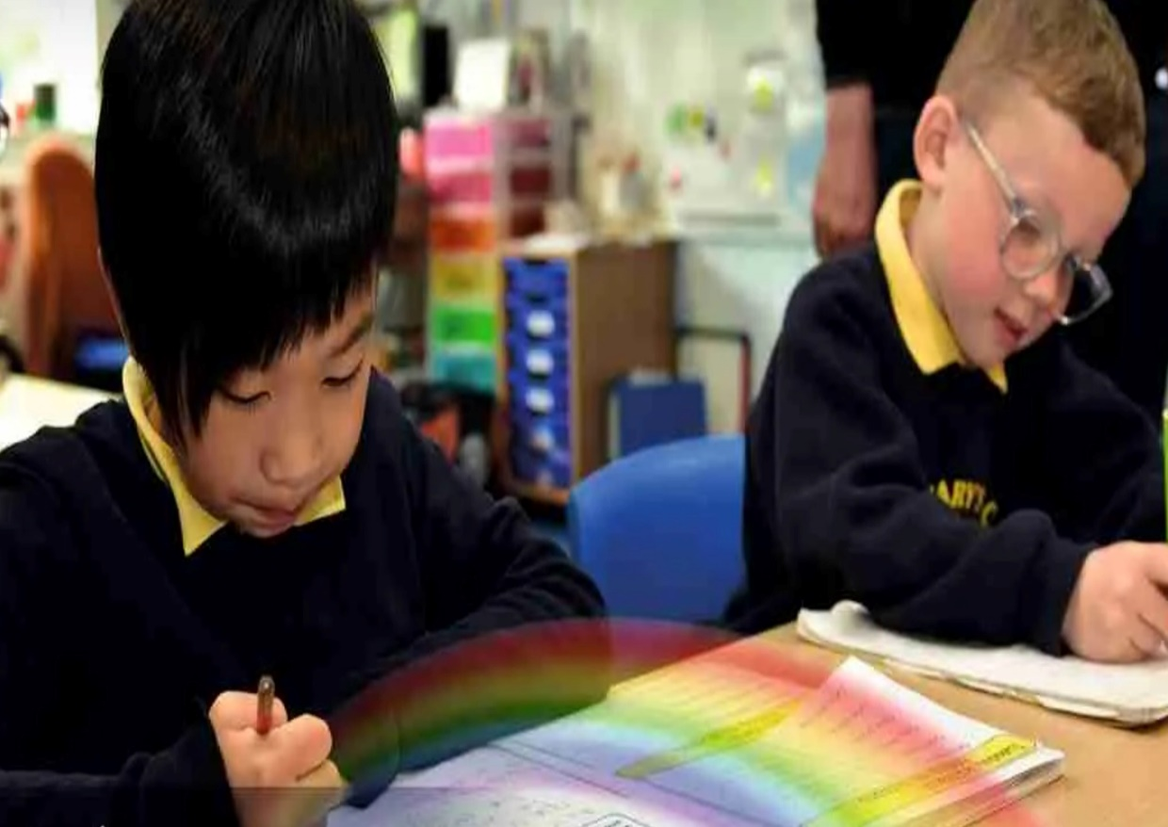

Science Curriculum Overview

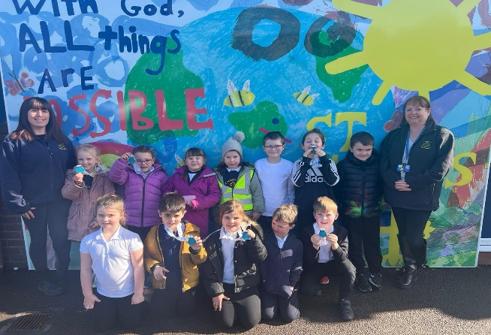
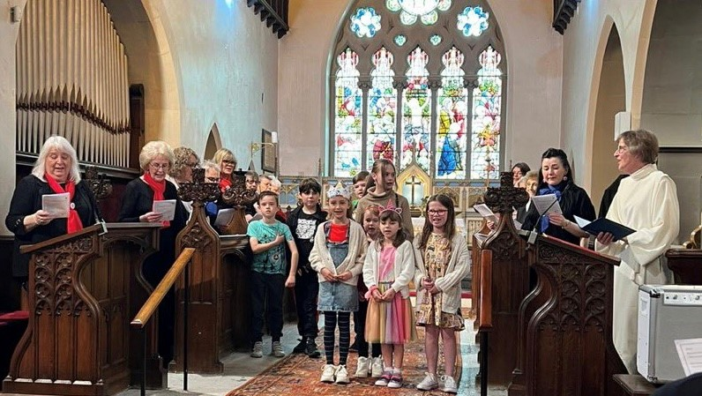
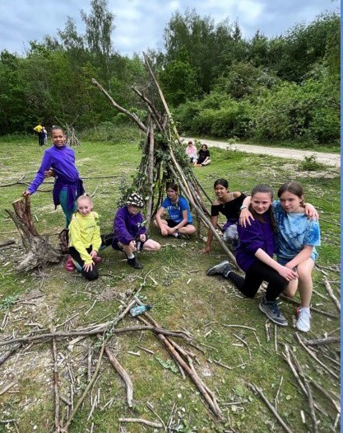
“With God, All Things are Possible.”

Our Approach

We have used Switched on Science as the base for our cyclical curriculum, which weaves working scientifically through the 3 branches of Natural Sciences below. Our pupils revisit these aspects throughout their time in our school. The elements of working scientifically are: observing over time, pattern seeking, identifying, classifying/grouping, comparative/fair testing and researching using secondary sources. Within each unit we have identified the working scientifically element that is the main focus. We have also ensured that working scientifically skills are embedded and built upon across each phase. Each time they revisit an aspect, it is with increasing complexity to build on their prior knowledge. In each year group starting in Y1, children learn about the work of 3 prominent scientists to build up an overview of different people and the impact of their work on society. Science is taught weekly for 1 hour from Y1-Y6. Across 5 half termly topics they complete an investigation to put into practice and apply their working scientifically skills in the context of the topic. In summer 2 they undertake a “Science in Action” project to secure their developing knowledge through real life applications of science. In EYFS children have an investigative focus question each half term, to start to build the foundations of science knowledge and working scientifically elements, alongside the continuous provision. From Reception to Y6 we have identified the key vocabulary that children will be introduced to.

Working Scientifically Progression

EYFS | KS1 |  | LOWER KS2 |  | UPPER KS2
- Name and Sort  - Find out information by reading books and from visitors  - Say and test own ideas  - Notice changes as well as similarities and differences  - Use their senses and look closely  - Use equipment and tools carefully  - Create simple representations of people and objects  - Talk about things like plants, animals, natural objects. I can use some simple science words  - Question why things happen | - Ask simple questions and recognise that they can be answered in different ways  - Use simple equipment to observe closely  - Perform simple comparative tests  - Identify, group and classify  - Use his/her observations and ideas to suggest answers to questions noticing similarities, differences and patterns  - Gather and record data to help in answering questions including from secondary sources of information |  | - Ask relevant questions and use different types of scientific enquiries to answer them  - Set up simple practical enquiries, comparative and fair tests  - Make systematic and careful observations and, where appropriate, take accurate measurements using standard units, using a range of equipment, including thermometers and data loggers  - Gather, record, classify and present data in a variety of ways to help in answering questions  - Record findings using simple scientific language, drawings, labelled diagrams, keys, bar charts, and tables  - Report on findings from enquiries, including oral and written explanations, displays or presentations of results and conclusions  - Use results to draw simple conclusions, make predictions for new values, suggest improvements and raise further questions  - Identify differences, similarities or changes related to simple scientific ideas and processes  - Use straightforward scientific evidence to answer questions or to support his/her findings |  | - Plan different types of scientific enquiries to answer their own or others' questions, including recognising and controlling variables where necessary  - Take measurements, using a range of scientific equipment, with increasing accuracy and precision, taking repeat readings when appropriate  - Record data and results of increasing complexity using scientific diagrams and labels, classification keys, tables, scatter graphs, bar and line graphs  - Use test results to make predictions to set up further comparative and fair tests  - Report and present findings from enquiries, including conclusions, causal relationships and explanations of and degree of trust in results, in oral and written forms such as displays and other presentations  - Report and present findings from enquiries, including conclusions, causal relationships and explanations of and degree of trust in results, in oral and written forms such as displays and other presentations  - Describe and evaluate their own and other people’s scientific ideas related to topics in the national curriculum (including ideas that have changed over time), using evidence from a range of sources
sort, same, different, hear, see, smell, touch, taste, change, big(ger/est), small(er/est)  Adult should also use:  Observe, question, answer, measure, compare | Questions, answers, equipment, explore, observe, similar, egg timers, ruler, tape measure, metre stick, beaker, collect, measures, record, group, test, compare, describe  Adult should also use: differences, similarities, results | Chart, table, pictogram, tally chart, block diagram/graph, gather, order, notice patterns, stop watch, pipette, syringe, results, differences, similarities  Adult should also use: gather, evidence, data, Venn diagram, Identify, classify, rank, notice relationships, comparatives | Scientific enquiry, observations, keys, bar chart, thermometer, data logger, changes over time, Identify, classify, evidence, conclusion, prediction, magnifying glass, microscope, comparative test, fair test, present, data, results, support, systematic, gather, evidence, rank  Adult should also use: accurate, disprove | Increase, decrease, accurate, appearance, disprove  Adult should also use: Notice relationships | Opinion, fact, variables, independent variable, dependent variable, controlled variable precision, classification keys, scatter graphs, line graphs, notice relationships  Adult should also use: Degree of trust, casual relationship, refute | Casual relationships, refute, degree of trust

YR | Autumn |  |  | Spring |  |  | Summer
Knowledge & Skills | Plants-Why do trees look different in Autumn?  - Name, describe and sort animals that live in different habitats  - Describe different habitats  - Know about similarities and differences in relation to living things and places  - Can talk about some of the things they have observed such as plants, animals, natural and found objects  - Shows care and concern for living things and the environment |  | Materials-How can we sort different materials?  - Explore a range of materials, including natural materials  - Make objects from different materials, including natural materials.  - Shape and join materials | States of Matter-Why does chocolate melt?  - Combine and mix ingredients  - Change materials by heating and cooling | Plants-Why won’t it grow?  - Help to grow and take care of plant  - Shows care and concern for living things and the environment  - Name common plants they see around school/in forest schools. Specific plants in our school to name:  - Daisy, buttercup, daffodils, sunflowers, apple tree, pear tree |  | Animals including humans-How does a chicken grow?  - Learn about the lifecycles of animals  - Observe how baby animals change over time  - Shows care and concern for living things and the environment  - Compare adult animals to babies  - Learn to take care of themselves  - Know the importance of good health of physical exercise, and a healthy diet, and talk about ways to keep healthy and safe  - Learn about their senses |  | Forces-How can I make a boat float?  - Explore how to change how things work  - Explore how the wind can move objects  - Feel forces  - Explores Shadows  - Explores rainbows
Vocab | animal names, land, water, jungle, desert, North Pole, South Pole, sea, hot, cold, wet, dry, snow, ice |  | Wood, paper, plastic, water, ice hard, soft, materials, dull, shiny, bendy, stiff | hot, cold, melt, wet, dry, change, change back, solid, liquid | Seed, plant, flower, soil, water, sun, leaf/leaves fruit, petal, bud, blossom, stem |  | Egg, chick, bird, caterpillar, cocoon, chrysalis, butterfly, grow, change, die |  | Wind, air, blow, fast, slow, turn, spin
Continuous Provision Enhancements
- Children will use their senses to explore the natural world around them, describing and understanding the effect of changing seasons. They will also be encouraged to be curious, question and to give explanations as they explore the different provision areas to think about “why” something behaves or works in a certain way.
- Play and explore outside in all seasons and in different weather
- Observe living things throughout the year.
Y1 | Autumn |  |  | Spring |  |  | Summer
, , , Knowledge & Skills | Who am I?  - Identify, name, draw and label the basic parts of the human body.  - Say which part of the body is associated with each sense . | Celebrations  - Distinguish between an object and the material from which it is made.  - Identify and name a variety of everyday materials, including wood, plastic, glass, metal, water and rock.  - Describe the simple physical properties of a variety of everyday materials.  - Identify and describe the basic structure of a variety of common plants, including trees |  | Polar Places  - Identify and name a variety of common animals including fish, amphibians, reptiles, birds and mammals  - Identify and name a variety of common animals that are carnivores, herbivores and omnivores  Specific animals in our locality:  - Pond – pond skater, backswimmer, dragonfly  - Forest school – ladybird, woodlouse, slug, snail, ant, spider, fox, caterpillar to butterfly  - Birds – Robin, blue tit, magpie, pigeon  - Pets – cat, dog, rabbit, hamster |  | Plants and animals  - Identify and name a variety of common wild and garden plants, including deciduous and evergreen trees  - Identify and describe the basic structure of a variety of common flowering plants, including trees  Specific plants in our school to name:  - Wild plants –clover, poppies, bluebells  - Garden plants –crocus, Water lily (pond)  - Deciduous trees – oak, rowan, willow, cherry + purple leaf sand cherry (outside yr 1), horse chestnut  - Evergreen - bamboo, cedar (2 varieties), Fir, Ivy (evergreen plants) | On Safari  - Identify and name a variety of common wild and garden plants, including deciduous and evergreen trees.  - Identify and name a variety of common animals including fish, amphibians, reptiles, birds and mammals. Identify and name a variety of common animals that are carnivores, herbivores and omnivores.  - Describe and compare the structure of a variety of common animals (fish, amphibians, reptiles, birds and mammals, including pets) | Holiday  - Identify and name a variety of common animals including fish, amphibians, reptiles, birds and mammals.  - Identify and name a variety of common animals that are carnivores, herbivores or omnivores. Describe and compare the structure of a variety of common animals (fish, amphibians, reptiles, birds and mammals, including pets).  - Distinguish between an object and the material from which it is made. Identify and name a variety of everyday materials including wood, plastic, glass, metal, water and rock.  - Describe the simple physical properties of a variety of everyday materials.
, , , Knowledge & Skills | Alfred Wegener |  |  | Carl Linnaeus |  |  | Maria Sibylla Merian
Vocab | sight, hearing, touch, smell, taste, skeleton, skull, skin, head, neck, arms, elbows, fingers, chest, torso, legs, feet, toes, brain, lung, heart, kidney, liver | Candle, dark, eat, food, light, light source, loud, music, opaque, plant, quiet, shadow, sound, translucent, transparent, vibrate |  | wing, claw, tail, beak, fur, feather, fin, scales, carnivore, habitat, herbivore, omnivore, pets, wild animals |  | Berry, blossom, bud, bulb, branch, deciduous, evergreen, fruit, habitat, identify, leaf/leaves, petal, root, stem, tree, trunk | fish, reptiles, mammals, birds, amphibians, herbivore, carnivore, omnivore, head, ear, eye, mouth, nose, leg, knee, arm, elbow, back wings, beak | Habitat, marine biologist, pollution, sun burn, Animals, banded wedge shell, beach, cockle, fish, habitat, limpet, mussel, periwinkle shell, protect, razor clam, recycle, rock pool, rubbish, sand, sea, shell, crab, Sun, sunglasses, sunscreen, turtles
WS | pattern seeking | identifying,  classifying/grouping |  | comparative/fair testing |  | researching using secondary sources | observing over time | observing over time
Y2 | Autumn |  |  | Spring |  |  | Summer
Knowledge & Skills | Healthy Me!  - Understand that animals, including humans, have offspring which grow into adults  - Describe the basic needs of animals, including humans, for survival (water, food and air)  - Describe the importance for humans of exercise, eating the right amounts of different types of food, and hygiene |  | Materials  - Distinguish between an object and the material from which it is made  - Identify and name a variety of everyday materials, including wood, plastic, glass, metal, water, and rock  - Describe the simple physical properties of a variety of everyday materials  - Compare and group together a variety of everyday materials on the basis of their simple physical properties | Squash, Bend Twist and Stretch  - Identify and compare the suitability of a variety of everyday materials, including wood, metal, plastic, glass, brick, rock, paper and cardboard for particular uses  - Describe how the shapes of solid objects made from some materials can be changed by squashing, bending, twisting and stretching |  | Our Local Environment  - Explore and compare the differences between things that are living, dead, and things that have never been alive  - Identify that most living things live in habitats to which they are suited and describe how different habitats provide for the basic needs of different kinds of animals and plants, and how they depend on each other  - Identify and name a variety of plants and animals in their habitats, including micro-habitats SEE YEAR 1 LIST  - Describe how animals obtain their food from plants and other animals, using the idea of a simple food chain, and identify and name different sources of food | Young Gardeners  - Observe and describe how seeds and bulbs grow into mature plants  - Find out and describe how plants need water, light and a suitable temperature to grow and stay healthy  - Revisit and extend names of plants found in local area. | Little Masterchefs  - Find out about and describe the basic needs of humans for survival (water, food and air).  - Describe the importance for humans of eating the right amounts of different types of food, and hygiene.  - Observe and describe how seeds and bulbs grow into mature plants.  - Identify and compare the suitability of a variety of everyday materials, including wood, metal, plastic, glass, brick, rock, paper and cardboard for particular uses
Knowledge & Skills | Steve Irwin |  |  | Al Jahiz |  |  | Barbara McClintock
Vocab | Adult, baby, basic needs (water, food, air), carbohydrate, child, dairy, exercise, fats, fruit, grow, hygiene, infection, offspring, oils, protein, sugar, survival, vegetables, teenager, toddler, unhealthy |  | Absorbent, bendy, dull, hard, gas, glass, liquid, material, metal, object, rock, rough, shiny, smooth, soft, solid, stiff, transparent, waterproof, properties, reflection | Changes, concrete, elastic, fabric, flexible, man-made, material, natural, opaque, properties, reflective, rigid, rubber, shape, squash, stretch, strong, suitable, translucent, transparent, twist, use/useful, weak, characteristics, suitability, purpose |  | Adaptation, alive, breathe, carnivore, conditions, characteristics, dead, excrete, feed, food chain, grow, heat, herbivore, living, micro-habitats, move, non-living, omnivore, reproduce, shelter, names of habitats, micro-habitats and describe conditions | Earth, fully grown, growth, healthy, light, nutrients, seedling, shoot | Air, bread, balanced diet, diet, food, fruit, healthy, hygiene, ingredients, vegetables, water, bones, change, chopping board, cook, dehydrate, digest, energy, fork fruit, frying pan, grow, heat, hot, knife, oven, saucepan, spoon, strong, temperature, utensils, whisk
WS | pattern seeking |  | identifying,  classifying/grouping | comparative/fair testing |  | researching using secondary sources | observing over time | observing over time

Y3 | Autumn |  |  | Spring |  | Summer
, , , , Knowledge & Skills | Rocks, Soils and Fossils  - Compare and group together different kinds of rocks on the basis of their appearance and simple physical properties  - Describe in simple terms how fossils are formed when things that have lived are trapped within rock  - Recognise that soils are made from rocks and organic matter | Food and our bodies  - Identify that animals, including humans, need the right types and amount of nutrition, and that they cannot make their own food; they get nutrition from what they eat  - Identify that humans and some other animals have skeletons and muscles for support, protection and movement |  | Light and Shadow  - Recognise that he/she needs light in order to see things and that dark is the absence of light  - Notice that light is reflected from surfaces  - Recognise that light from the sun can be dangerous and that there are ways to protect eyes  - Recognise that light from the sun can be dangerous and that there are ways to protect eyes  - Find patterns in the way that the size of shadows change | How does your garden grow?  - Identify and describe the functions of different parts of flowering plants: roots, stem/trunk, leaves and flowers  - Explore the requirements of plants for life and growth (air, light, water, nutrients from soil, and room to grow) and how they vary from plant to plant  - Investigate the way in which water is transported within plants  - Explore the part that flowers play in the life cycle of flowering plants, including pollination, seed formation and seed dispersal. | Forces and Magnets  - Compare how things move on different surfaces  - Notice that some forces need contact between two objects, but magnetic forces can act at a distance  - Compare and group together a variety of everyday materials on the basis of whether they are attracted to a magnet, and identify some magnetic materials  - Describe magnets as having two poles Predict whether two magnets will attract or repel each other, depending on which poles are facing | Environmental Challenge  - Gather, record, classify and present data in a variety of ways to help in answering questions.  - Ask relevant questions and use different types of scientific enquiries to answer them. Use results to draw simple conclusions, make predictions for new values, suggest improvements and raise further questions.  - Set up simple practical enquiries, comparative and fair tests.  - Use straightforward scientific evidence to answer questions or to support their findings.
, , , , Knowledge & Skills | James Hutton |  |  | Agnes Arber |  | James Clark Maxwell
Vocab | Absorb, extinct, crystals, fossils, granite, grains, humus, igneous, impermeable, layers, magma, metamorphic, mineral, molten, palaeontology/ palaeontologists, permeable, rock, sediment, sedimentary, soil, erosion, particles, physical properties, porous | Backbone, balanced diet, blood vessels, bones, brain, carbohydrate, dietary fibre, heart, invertebrates, joints, movement, minerals, muscles, nutrients, nutrition, protection, ribs, sockets, skeleton, skull, spine, support, tendons, vertebrates, vitamins, |  | Absorb, beam, block, direction of light, bright, dim, dull, light source, mirror, opaque, reflect, reflective, shadow, shiny, sun light, translucent, transparent. Names of light sources, speed of light, emit, light spectrum | Absorb, fertiliser, plant life cycle, pollination, seed dispersal, seed formation, temperature, transported | Air resistance, attract, bar magnet, button magnet, compass, contact, float, force, force-meter, friction, gravity, horse shoe magnet, iron, magnet, magnetic, magnetic North, non-contact, non-magnetic, North pole, poles, repel, ring magnet, sink, South pole, strength | Absorb, absorbent, cloth, cotton, disposable, elastic, faeces, liquid, material, nappy, plastic. Urine, Velcro, waterproof, wood pulp
WS | pattern seeking | researching using secondary sources |  | comparative/fair testing | observing over time | identifying,  classifying/grouping | observing over time
Y4 | Autumn |  |  | Spring |  | Summer
, , , , , Knowledge & Skills | What’s that sound?  - Identify how sounds are made, associating some of them with something vibrating  - Recognise that vibrations from sounds travel through a medium to the ear  - Find patterns between the pitch of a sound and features of the object that produced it  - Find patterns between the volume of a sound and the strength of the vibrations that produced it  - Recognise that sounds get fainter as the distance from the sound source increases | Living things  - Explore and use classification keys to help group, identify and name a variety of living things in their local and wider environment (refer back to names covered in KS1)  - Recognise that environments can change and that this can sometimes pose dangers and have an impact on living things |  | Looking at states  - Compare and group materials together, according to whether they are solids, liquids or gases  - Observe that some materials change state when they are heated or cooled, and measure or research the temperature at which this happens in degrees Celsius (°C)  - Identify the part played by evaporation and condensation in the water cycle and associate the rate of evaporation with temperature. | Teeth and eating  - Describe the simple functions of the basic parts of the digestive system in humans  - Identify the different types of teeth in humans and their simple functions  - Construct and interpret a variety of food chains, identifying producers, predators and prey | Power it up  - Identify common appliances that run on electricity  - Construct a simple series electrical circuit, identifying and naming its basic parts, including cells, wires, bulbs, switches and buzzers  - Identify whether or not a lamp will light in a simple series circuit, based on whether or not the lamp is part of a complete loop with a battery  - Recognise that a switch opens and closes a circuit and associate this with whether or not a lamp lights in a simple series circuit  - Recognise some common conductors and insulators, and associate metals with being good conductor | The Big Build  - Ask relevant questions and use different types of scientific enquiries to answer them.  - Make systematic and careful observations and, where appropriate, take accurate measurements using standard units, using a range of equipment, including thermometers and data loggers.  - Gather, record, classify and present data in a variety of ways to help in answering questions.  - Use results to draw simple conclusions, make predictions for new values, suggest improvements and raise further questions.
, , , , , Knowledge & Skills | Galileo Galilei |  |  | Albert Einstein |  | Michael Faraday
Vocab | Brass, echo, insulation, instrument, percussion, pitch, sound source, sound wave, string, travel, tune, tuning fork, vibration, volume, woodwind | fish, reptiles, mammals, birds, amphibians, snails, slugs, worms, spiders, insects, environment, habitat, vertebrate, invertebrate, exoskeleton, adaptation |  | Air, boiling point, boiling, condensation/condensing, degree Celsius, energy transfer, evaporation/evaporating, freezing, freezing point, gaseous, grain, matter, melting, melting point, oxygen, particles, powder, water cycle, water vapour | Absorb, anus, blood stream, canines, consumer, decay, dentine, digestion, enamel, energy, faeces, gums, incisors, large intestine, molars, nerves, oesophagus, plaque, predator, prey, producer, saliva, small intestines, stomach, swallowing | Battery, bulb, buzzer, cell, circuit, closed circuit, components, complete circuit, conductor, connection, crocodile clip, electricity, electrical device/appliance, insulator, mains, motor, negative, open circuit, plug, positive, rechargeable, simple circuit, symbol, switch, terminals, wires, series circuit and terminal | Build, construct, construction, structure, tower, bridge
WS | pattern seeking | identifying,  classifying/grouping |  | Observing over time | researching using secondary sources | comparative/fair testing | observing over time
Y5 | Autumn |  |  | Spring |  | Summer
Knowledge & Skills | Growing up and Growing old  - Describe the changes as humans develop to old age |  | Circle of Life  - Describe the differences in the life cycles of a mammal, an amphibian, an insect and a bird  - Describe the life process of reproduction in some plants and animals | Out of this World  - Describe the movement of the Earth, and other planets, relative to the Sun in the solar system  - Describe the movement of the Moon relative to the Earth  - Describe the Sun, Earth and Moon as approximately spherical bodies  - Use the idea of the Earth's rotation to explain day and night and the apparent movement of the sun across the sky | Let’s get moving  - Explain that unsupported objects fall towards the Earth because of the force of gravity acting between the Earth and the falling object  - Identify the effects of air resistance, water resistance and friction, that act between moving surfaces  - Recognise that some mechanisms, including levers, pulleys and gears, allow a smaller force to have a greater effect | Material World  - Compare and group together everyday materials on the basis of their properties, including their hardness, solubility, transparency, conductivity (electrical and thermal), and response to magnets  - Recognise that some materials will dissolve in liquid to form a solution, and describe how to recover a substance from a solution  - Use knowledge of solids, liquids and gases to decide how mixtures might be separated, including through filtering, sieving and evaporating  - Give reasons, based on evidence from comparative and fair tests, for the particular uses of everyday materials, including metals, wood and plastic  - Demonstrate that dissolving, mixing and changes of state are reversible changes  - Explain that some changes result in the formation of new materials, and that this kind of change is not usually reversible, including changes associated with burning and the action of acid on bicarbonate of soda. |  | Amazing Changes  - Demonstrate that dissolving, mixing and changes of state are reversible changes.  - Explain that some changes result in the formation of new materials, and that this kind of change is not usually reversible, including changes associated with burning and the action of acid on bicarbonate of soda.
Knowledge & Skills | Rachel Carson |  |  | Stephen Hawking & Mae Carol Jemison |  | Amedeo Avogadro
Vocab | Adolescence, adolescent, arthritis, gestation period, life expectancy, menstruation, pregnant, puberty |  | Anther, asexual reproduction, carpel, external fertilisation, fertilisation, filament, germination, gestation, internal fertilisation, larva, metamorphosis, pollen, pollination, seed dispersal, seed formation, sepal, sexual reproduction, sperm, stamen, style, stigma | Asteroids, axes/Axis, celestial body, comets, galaxy, light years, meteors, orbit, phases of the moon, planet, revolve, rotation, shadow clocks, spherical, spin, solar system, star, sun, sundials, time zone | Drag forces, gears, levers, mechanisms, Newton, non-contact force, pulleys, reliable, springs, transference of force and motion, water resistance, weight | Burning, dissolve, electrical conductor, filter, insoluble, irreversible change, mixture, reversible change, rust, sieving, soluble, solute, solution, solvent, thermal conductor, thermal insulator, combustion, oxidisation, chemical reaction, residue, filtrate |  | Burning, acid, irreversible, chemical change and rust
WS | pattern seeking |  | identifying,  classifying/grouping | comparative/fair testing | researching using secondary sources | observing over time |  | observing over time
Y6 | Autumn |  |  | Spring |  | Summer
, , , , Knowledge & Skills | Healthy Bodies  - Identify and name the main parts of the human circulatory system, and describe the functions of the heart, blood vessels and blood  - Recognise the impact of diet, exercise, drugs and lifestyle on the way their bodies function  - Describe the ways in which nutrients and water are transported within animals, including humans |  | Electricity  - Associate the brightness of a lamp or the volume of a buzzer with the number and voltage of cells used in the circuit  - Compare and give reasons for variations in how components function, including the brightness of bulbs, the loudness of buzzers and the on/off position of switches  - Use recognised symbols when representing a simple circuit in a diagram | Evolution and Inheritance  - Recognise that living things have changed over time and that fossils provide information about living things that inhabited the Earth millions of years ago  - Recognise that living things produce offspring of the same kind, but normally offspring vary and are not identical to their parents.  - Identify how animals and plants are adapted to suit their environment in different ways and that adaptation may lead to evolution. | Classifying living things  - Identify how animals and plants are adapted to suit their environment in different ways and that adaptation may lead to evolution (Extends y3 – requirements for life and growth)  - Classifying plants (Linked to Year 4 learning)  - Describe how living things are classified into broad groups according to common observable characteristics and based on similarities and differences, including micro-organisms, plants and animals  - Give reasons for classifying plants and animals based on specific characteristics. | Light  - Recognise that light appears to travel in straight lines  - Use the idea that light travels in straight lines to explain that objects are seen because they give out or reflect light into the eye  - Explain that we see things because light travels from light sources to our eyes or from light sources to objects and then to our eyes  - Use the idea that light travels in straight lines to explain why shadows have the same shape as the objects that cast them
, , , , Knowledge & Skills | Marie Maynard Daly |  |  | Charles Darwin & Rosalind Franklin |  | Ibn al-Haytham
Vocab | Addiction, aorta, artery, atrium, blood, bronchi, capillaries, carbon dioxide, circulatory system, de-oxygenated, diaphragm, lifestyle, lungs, nicotine, oxygen, oxygenated, plasma, pulmonary vein/artery, pulse, red blood cells, respiration, vein, ventricles, white blood cells |  | Current, electrons, filament, fuse, resistance series circuit, terminal, voltage volume, parallel circuit | Adaptation, chromosomes, competition, DNA, evolution, evolutionary change features, environmental conditions, environmental variations, fossil records, genes, natural selection, reproduction, survival of the fittest, variation | classification, mammals, birds, amphibians, fish, reptiles, insects vertebrates, invertebrates, micro-organisms, bacteria, fungi | Absorption, cornea, lenses, iris, light ray, optics, pupil, prism, rainbow, refraction, symmetry, spectrum, transmission
WS | pattern seeking |  | identifying,  classifying/grouping | comparative/fair testing | researching using secondary sources | observing over time |  | observing over time

