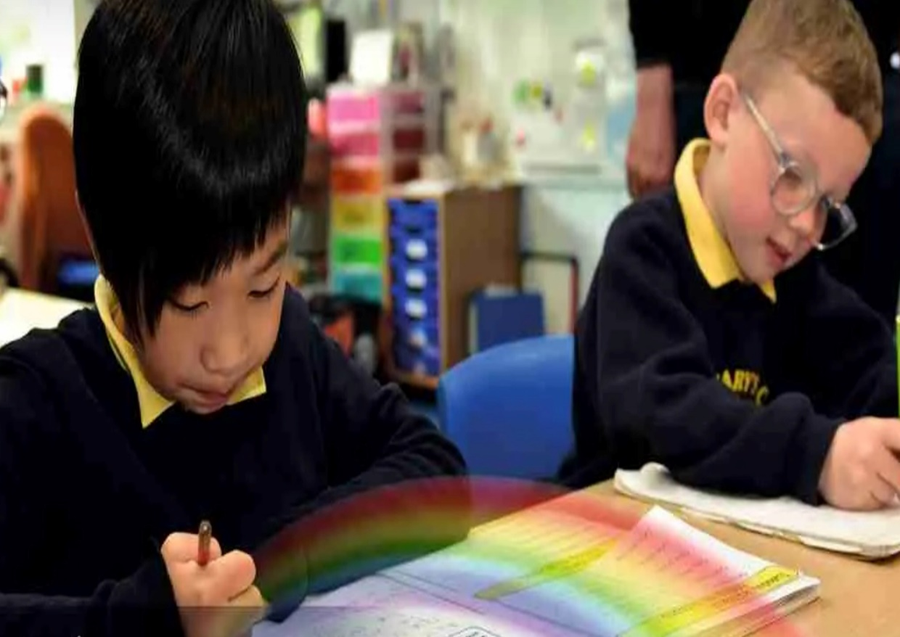

Geography Curriculum Overview
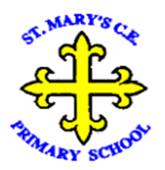
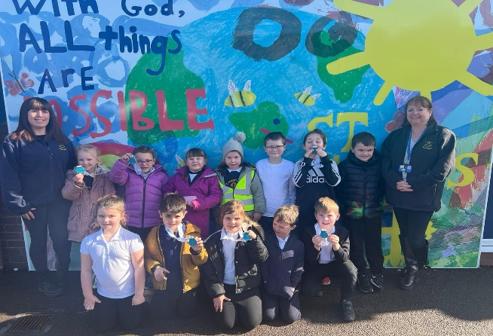
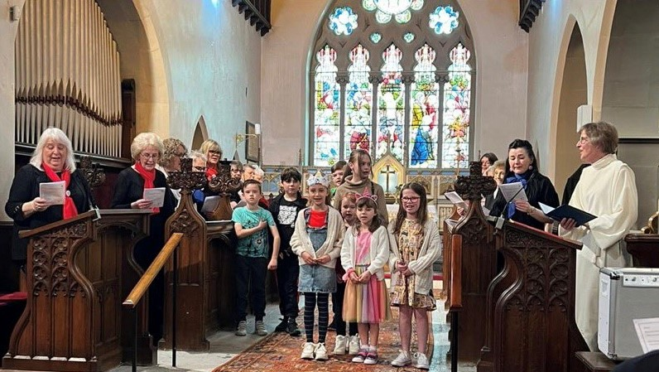
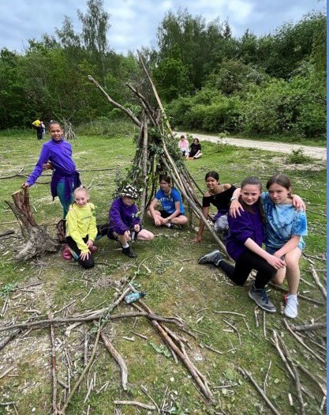
“With God, All Things are Possible.”

Our Approach

We have used the Plan Bee scheme as the main backbone of our curriculum. Our cyclical curriculum focuses on the 4 aspects below, which our pupils revisit throughout their time in our school. Each time they revisit a key piece of knowledge or a skill area this is with increasing complexity to build on their prior knowledge. Our scheme of work weaves the nine core concepts of place, space, scale, interdependence, physical & human processes, environmental impact, sustainable development, cultural awareness and cultural diversity across each phase so that pupils can comprehend each topic in its own right, but also where it fits into the bigger picture. We have identified specific fieldwork opportunities within each year group that draw on our school and local area so that our pupils can build confidence and proficiency in using a range of methods to observe, measure, record and present their findings. Each year group has 3 taught units that are taught as a half termly block with an hour each week.

Through our scheme of work our pupils will know and understand the big Ideas in Geography that we have identified for our pupils to have embedded by the end of KS2:

- The scale and size of places studied: Reddish is an area within Stockport. Stockport is an industrial town in Greater Manchester. Reddish is within the historic county of Lancashire. Greater Manchester is in the northwest of England.

- Manchester is an important city which connects people and goods to other destinations (within UK and abroad).

- Liverpool, is a significant coastal city in the North West and has transport links to N. Ireland (Historic trade links).

- The 7 continents are Asia, North America, South America, Europe, Africa, Australia (Oceania is a Region), Antarctica and the 5 oceans across the world are the Arctic Ocean, Atlantic Ocean, Indian Ocean, Pacific Ocean and Southern Ocean.

- Earth's climate zones consist of tropical, dry, temperate, continental, and polar zones.

- Biomes are classified according to the plants/animals that live there: aquatic, grassland, forests, desert, and tundra

- The major lines of latitude are The Arctic Circle, The Antarctic Circle, the Tropic of Cancer, the Tropic of Capricorn and the Equator, and an important line of longitude is the Prime Meridian.

- Local river systems are the River Goyt/River Tame which merge to create the River Mersey (major river) and flows out to the Irish Sea, as well as naming some other major world rivers.

- The physical processes on Earth create constant change; creating mountains, valleys, volcanoes, causing earthquakes and erosion (wind and water).

- We have trade links with countries around the world, accessing fossil fuel, raw materials, and food.

- Different types of maps can be used to identify aspects of physical and human geography.
YR | Autumn | Spring | Summer
Knowledge & Skills | Where is my home?  - Understand the difference between a path, road and street.  - Name the road or street where they live.  - Share photographs of where they live and discuss.  - Name the different types of buildings people live in.  - My house, family and local surroundings as Reddish  - Naming and describing people who are familiar.  - Draw simple plans of an area of the classroom compared to a an aerial photograph.  - Learn about special people in the community | Why do we need maps?  - Maps from imaginary story settings such as ‘We’re going on a Bear Hunt’,’ What the Ladybird heard’ , ‘Rosie’s walk’, ‘The Gruffalo’, ‘Little Red Riding Hood’  - Draw map of local area /roads / familiar journeys e.g. Journey to school  - Understand that some places are special to members of their community  - Recognise some similarities and differences between life in this country and other countries with a focus on France, Africa and North/South America. | How are places around the world different?  - Know some similarities and differences between different religious and cultural communities in this country, drawing on their experiences and what has been read in class  - Explain some similarities and differences between life in this country and life in other countries, drawing on knowledge from stories, nonfiction texts and – when appropriate – maps.  - Focus on Brazil looking at Mardi Gras celebrations and stories.
Fieldwork | Walk around the local community to identify topographical features documented by photographs to use as discussion prompts. | Children to use the school grounds to create story sticks and draw sketch maps within the provision. Creation of treasure maps and link to pirate theme. | Children to use globes and large maps of the world to talk about different places in stories and to start to develop a sense of place and space.
Vocab | House, local, street, Stockport, Reddish, Bury, map, community. | Map, Reddish, school, community, similarity, difference | Religion, culture, Hindu, Muslim, Sikh, Buddhist, Jew, country, England, globe, world map, countries
Continuous Provision Enhancements
- World Map on display in the classroom to regularly discuss places children have visited on holiday and to locate places of interest or places that arise in books and topics.
- A range of books linked to areas focus on different places, cultural identity/awareness and environmental impact.
- Small world enhancement focus to apply skill learnt such as map making, creating plans/buildings etc Beebots, and explore seasonal/daily weather patterns.
- Access to cameras, clipboards and recording media to capture observations of the natural world in and around the school grounds.
Y1 | Autumn | Spring | Summer
Knowledge & Skills | Where do I live?  - Name the seven continents of the world and locate the UK on a world map.  - Identify the four countries and capital cities of the UK, matching them on a simple outline map.  - Locate Stockport on a map and identify it as a town within Greater Manchester.  - Identify the difference between a village, town and city.  - Understand the difference between urban and rural.  - Locating where they live on an aerial photograph, children recognise local features.  - Name the road/town the school is situated in.  - Look at aerial maps of the school setting  - They create plans using classroom objects before drawing simple plans of the school grounds. | The Four Seasons  - Recall and match the seven continents.  - Know what seasons are and how they relate to the months of the year.  - Know the names of the months within each season.  - Describe the features of each of the seasons using appropriate vocabulary to describe weather patterns in the UK.  - Compare the four seasons through observations and looking at different pictures/watching clips, comparing this to their own experiences.  - Understand how the weather affects human behaviour, including the choice of different clothing.  - Know some of the changes in winter including that days get shorter.  - Identify that in spring some of the changes include warmer weather, longer days, new growth of plants and the birth of baby animals.  - Collect own data through observations to study the weather and seasons (this should be ongoing throughout the year to allow for retrieval/spaced learning and collection should start in the autumn term). | Map Makers-The Wonders of Reddish  - Recall the four countries of the UK and match them on a simple map.  - Identify Stockport on a map as a part of Greater Manchester.  - Identify the physical and human features within the local area, with a focus on Reddish Vale using aerial photographs and perspectives to recognise landmarks.  - Know what happened to Reddish Vale when it was nearly sold and how people came together to protect and preserve it as an area of local importance.  - Plan a simple route to the Vale on a map, considering the benefits of the route and what is the best way.  - Use simple compass directions and directional language to move around a map.  - Create an aerial view of the classroom.  - Know that maps use keys to help identify features.  - Use a map of our local area to identify features.  - Use fieldwork and observational skills to study the school and its surroundings.
Fieldwork | Use of the school grounds for orienteering to know compass directions and the location of features. | Children to keep a weather diary across the year and record their observations in words/pictures or a simple tally through establishing a weather station. | Visit Reddish Vale to locate human/physical features after planning a route. Children uses tally charts to document the plants, flowers and birds.
Vocab | Aerial view, land, location, village, city, aerial photograph, sea, country, continent, town, map, globe, place, features, atlas, distance, country, key, locate, urban, rural, settlement, UK, England, Scotland, Wales, Northern Ireland, Europe, Asia, Africa, Australia, North/South America, Antarctica | Autumn, winter, spring, summer, month, climate, continent, country, direction, land, locate, location, map, rain gauge, season, temperature, thermometer, weather, weather vane, Europe, Asia, Africa, Australia, North/South America, Antarctica | Key, map, UK, England, Scotland, Wales, Northern Ireland, aerial, route, compass, direction, north, east, south and west
Y2 | Autumn | Spring | Summer
Knowledge & Skills | Let’s Go to Liverpool on the Coast*  - Recall the names of the four countries of the UK, their capital cities and locate confidently on a map.  - Locate and name the 5 main oceans of the world and know that the UK lies between the North Atlantic Ocean and North Sea.  - Know that the River Mersey begins in Stockport, is formed by the river Goyt/Tame and flows 70 miles to the Irish Sea.  - Locate Liverpool on a map of the UK and understand that it is a coastal city.  - Understand what a port is and how goods are imported/exported through coastal city ports.  - Know that Liverpool was once the busiest and wealthiest port in the world.  - Know that Liverpool imports grain and exports recycled materials as well as being the main port between Ireland and Britain.  - Identify why people visit the coast and the significant physical features such as the beach, cliff, bay, cove, dune, headland and estuary. | Let’s Go on Safari to Kenya  - Recall the 7 continents and 5 key oceans  - Know that Nairobi is the capital city of Kenya.  - Describe how the climate is different in Kenya to the UK.  - Compare and contrast the landscapes and settlements of Kenya and the UK.  - Know that countries near the equator are hot countries and countries near the poles are cold countries.  - Know that Kenya is near the equator so it is a hot country.  - Describe the physical features of Kenya, using vocabulary such as beach, volcano, mountains, savannah and valley.  - Know that there are lots of different groups of people in Kenya and that some live in traditional tribes and some live in modern cities.  - Describe some of the cultural features of Kenya.  - Describe which oceans surround the continent of Africa.  - Navigate around a map using a grid and compass directions. | Let’s Go to the Arctic  - Recall 7 continents and 5 key oceans.  - Locate the Arctic Circle on maps to learn about what it is and where it is.  - Know the seven countries that make up the Arctic Circle and that Sisimiut is the capital city.  - Use maps to identify Arctic cities and describe the physical features within the cities.  - Identify and describe images of towns found in the Arctic Circle and compare Sisimiut in Greenland to London in the UK.  - Learn new weather vocabulary and use it to describe weather patterns.  - Understand the differences about winter and summer in the Arctic and compare the seasons to the UK.  - Use senses to describe the landscapes in the Arctic.  - Identify the physical features found in the Arctic, including mountains, hills, icebergs, rivers and lakes.  - Look at animals in the Arctic and how they survive the cold, harsh winters.  - Use maps to locate and record animal distribution in the Arctic.
Fieldwork | Visit Liverpool docks to explore what a port is and cross the Mersey. | Use of the school grounds for orienteering to know compass directions and the location of features. | Use of digital fieldwork techniques to create notes on weather patterns and use mapping skills to investigate key features.
Vocab | Liverpool, port, city, Atlantic, Pacific, Indian, Southern, Arctic, ocean, North sea, Irish sea, beach, cliff, bay, cove, dune, headland, estuary, import, export, grain, | Nairobi, capital city, equator, settlement, hot, cold, volcano, beach, savannah, valley, landscape, continent, climate, temperature, tribe, Indian ocean, Atlantic ocean, read sea, Mediterranean sea, | Equator, polar region, season, arctic, arctic circle, Pacific, Indian, Atlantic, Southern, Arctic, city, mountains, hills, ice berg, river, lake, arctic air, anticyclone, arctic high,

Y3 | Autumn | Spring | Summer
Knowledge & Skills | The Northern Power House Manchester*  - Name and locate counties in the UK and key cities, recapping the capital cities and coastal cities in the 4 countries of the UK.  - Know how to use 4-figure grid references  - Identify key physical characteristics of the UK, using an atlas (including rivers, hills, mountains and coast)  - Identify key human characteristics of the UK, using a map or atlas (quarry, mines, farms, major cities)  - Undertake a detailed exploration of the county of Greater Manchester including physical and human features with a focus on the city of Manchester.  - Understand that Manchester is a landlocked county that has no coast.  - The rivers Mersey, Irwell and Tame are key rivers.  - The Pennine hills are to the east and the moors lie to the west.  - The Peak District National Park lies to the East and South East.  - The Manchester Ship Canal leads to the Irish sea via the Mersey. | Our European Neighbours  - Recall the names of the 7 continents and known human/physical features about them studied to date.  - Name and identify different countries in Europe and their capital cities.  - Locate these countries and their capital cities, including Russia on a map of Europe.  - Name the seas and oceans surrounding Europe.  - Compare the human and physical geography of London and Paris. (Naples/Liverpool as port cities on the Coast)  - Ask and answer questions to help compare and contrast London and Paris.  - Identify European countries based on human features, such as language, flag and currency.  - Use independent research to explore the human and physical features of France as a European country and as the MFL choice for the school. | Why do our Oceans matter?  - Recall the 5 key oceans and main seas studied to date.  - Understand that the main functions of the ocean are to regulate the climate, generate the majority of the oxygen humans breathe, absorb carbon dioxide and they are also a food source.  - Know that water in the oceans is moved around by currents.  - Understand that the ocean provides jobs and livelihoods for people, whilst also transporting goods and people all around the globe.  - Locate the Great Barrier Reef as part of the continent of Australia on a map.  - Know that a reef generates clean air, protects coast lines from erosions/flooding/storms and are home to a quarter of the oceans marine life.  - Explore how plastic and pollution is damaging these marine environments and impacting on the world.  - Identify positive environmental changes that have already been made and how they can contribute by making eco-friendly choices.
Fieldwork | Travel by coach to Manchester to gather information/data to be able to write a report using photographs and gathered field notes. | Undertake planned orienteering activities in the school grounds to further develop orienteering skills and map orientation with grid references. | Use digital sources to collect up data about ocean pollution and its effects.
Vocab | Map, atlas, locate, counties, describe, features, digital mapping, computer mapping, compass, four points, north, south, east, west, north east, north west, south east, south west, four figure grid reference, symbols, keys | Ordnance Survey Maps, symbols, tourism, economy, healthcare, leisure, education, points of a compass (8 points), continent names, France, Germany, Italy, Norway, Sweden, Finland, Russia, Arctic, Atlantic, North Sea, Mediterranean Sea, English Channel | atmosphere, biodegradable, buffer, coral bleaching, coral reef, decompose, digital map, disposable, ecology, ecosystem, erosion, geology, habitat, human footprint, marine, microplastics, natural disaster, ocean current, policy, renewable energy, single use plastic, species,
Y4 | Autumn | Spring | Summer
Knowledge & Skills | Water World  - Compare and contrast water availability and usage in the UK and Kenya using a water quality map.  - Name and describe the Earth’s bodies of water, including seas, oceans, lakes, reservoirs, bays, gulfs, straits, glaciers and fjords.  - Know that some of the Earth’s bodies of water have salt water and some have fresh water.  - Understand and explain the water cycle using appropriate vocabulary.  - Explain why the water cycle is important for our planet.  - Draw and label a diagram of the water cycle.  - Describe some of the ways in which people need water every day to live.  - Know that water is pumped into a water treatment plant, then pumped into houses for the water we use every day.  - Describe the six steps in the water treatment process.  - Know what the term ‘water conservation’ means and why this is important.  - Know that Kenya is a water-scarce country.  - Explain what hydropower is and how it can be used to contribute to a sustainable future.  - Identify the positive and negative aspects of using hydropower.  - Use a water quality map and an atlas to identify countries in the world where everyone has access to clean water, most people have access to clean water and most people do not have access to clean water.  - Identify local bodies of water on a map. | Biomes & Climate Belts*  - Locate and label the six biomes on a world map (desert, tundra, grassland, coniferous forest, deciduous forest and tropical forest).  - Describe and explain how people who live in a contrasting physical area may have different lives to people in the UK.  - Understand some of the causes of climate change.  - Find countries and features of countries in an atlas using contents and index.  - Mapping land use in a small local area using maps and plans.  - Make a plan for how to collect data to answer an enquiry-based question, with the support of a teacher.  - Ask and answer one-step and two-step geographical questions.  - Collecting quantitative data in charts and graphs.  - Suggest different ways that a locality can be changed and improved. | Volcanoes  - Know that the equator separates the Northern and Southern Hemispheres.  - Know that the capital of Hawaii is Honolulu.  - Identify similarities and differences between England and Hawaii (a non- volcanic and volcanic area).  - Describe what a volcano is and know some facts, such as the height and age of some of the world’s volcanoes, as well as locating on maps of the world.  - Explain why a volcano erupts and that ash, gas, lava and rocks are released when a volcano erupts.  - Explain how a volcano eruption affects the local people and environment.  - Know some of the strategies put in place to help people survive when they are near a volcano eruption.  - Explain the difference between a composite, shield and dome volcano.  - Understand the different between a dormant, active and extinct volcano.  - Know what tectonic plates are and that most world’s volcanoes are found at the boundaries of tectonic plates.  - Use a key to label the world’s tectonic plates on a map.  - Name countries and continents that sit on different tectonic plates.  - Know that the ‘ring’ of fire’ is an area around the Pacific Ocean where most of the world’s earthquakes and volcanoes occur.  - Know that minerals, fertile soil, geothermal energy and tourism are some of the reasons why people choose to live near volcanoes.  - Identify some of the animals and plants that live in volcanic areas.  - Describe some of the human and physical features of Hawaii, a volcanic area.
Fieldwork | Visit the river Tame (Reddish Vale) to capture data digitally and create sketch maps of the key features | Undertake digital fieldwork to map out the 6 biomes on a map of the world and use atlases to collect data to answer questions on land use. | Undertake own research about an identified volcano collecting data and identifying the impact of the volcano on the landscape and human settlement.
Vocab | condensation, delta, estuary, evaporation, flooding, floodplain, groundwater, irrigation, leisure, meander, oxbow lake, percolation, precipitation, river mouth, source, transpiration, tributary, valley, water cycle, waterfall, precipitation, infiltration, transpiration, transportation, water conservation | Tundra, desert, grassland, coniferous forest, deciduous forest, tropical forest, biome, atlas, vegetation belts, climate zone, climate, temperature, climate change, humidity, rainfall, maps, atlas, globe, natural resources, suggest, reasoned opinions, locate, explain, distribution | inner core, outer core, mantle, crust, magma, tectonic plate, plate boundary, fold mountain, fault-block mountain, volcanic mountain, atlas, composite volcano, shield volcano, magma chamber, vent, pyroclastic flow, active volcano, dormant volcano, extinct volcano, negative effects, positive effects, fertile soil, climate change, volcanic springs, geothermal energy, index, earthquake, tsunami
Y5 | Autumn | Spring | Summer
Knowledge & Skills | Mountains*  - A mountain is a natural elevation of the Earth's surface, rising to a summit and has an elevation greater than that of a hill, usually greater than 610m.  - Know how mountains are formed and the different types of mountain: fold, fault-block, volcanic, dome and plateau.  - Understand there are different climates and types of wildlife at different altitudes on mountains.  - Understand that there are more than 200 mountain peaks in England and name the 3 biggest mountains in the UK as Snowdon, Scarfell Pike and Ben Nevis.  - Locate the Alps on a world map and identify and label the eight countries they spread through.  - Locate three physical and three human characteristics in the Alps.  - Research and describe the physical and human features of Innsbruck as a mountain city in the Alps.  - Understand the different reasons people visit mountains.  - Use a variety of data collection methods including completing a questionnaire, mapping their route and recording their findings in sketches or photographs.  - Compare the human and physical geography of their local area and Innsbruck.  - Describe at least four of the key aspects of the human and physical geography of the Alps to answer the enquiry question, ‘What is life like in the Alps? | Extreme Earth  - Know where some places of extreme temperature are located.  - Know that the first layer of the Earth’s atmosphere is called the troposphere and that it is here that weather occurs.  - Use data to create a graph showing the hottest and coldest inhabited places on Earth, before comparing them.  - Explain what a drought is and some of the causes and effects.  - Explain why some areas get more rain than others in relation to the water cycle.  - Describe some extreme weather phenomena around the world, including tornados, tropical storms, hail storms and blizzards.  - Describe the effects of extreme weather phenomena on the environment and people affected.  - Use plate tectonics to describe what earthquakes are and why they happen.  - Know what the Richter scale is.  - Describe the effects of earthquakes on the environment and people affected.  - Know that tsunamis occur when there are earthquakes on the ocean floor. | Brazilian Rainforests in South America  - Know what the equator, Tropic of Cancer and Tropic of Capricorn are, and can place them on a world map.  - Name continents and countries that have areas of rainforest.  - Name the countries of South America.  - Use a variety of geographical sources, including maps, to compare an area of the UK with an area of South America.  - Define what a rainforest is and locate areas of rainforest on a world map.  - Know that the climate in rainforests is hot and humid, and that this climate is ideal for plant growth.  - Describe the four layers of the rainforest and name some animals that live in each layer.  - Know what the water cycle is.  - Explain the basic steps of the water cycle using appropriate vocabulary.  - Explain why rain falls more often in rainforests than in other parts of the world.  - Use line graphs and bar charts to explore the climate of rainforests.  - Know that lots of native tribes live in rainforests and that their way of life has remained unchanged for hundreds of years.  - Compare daily life for people living in rainforest tribes with that of people living in modern society.  - Know what deforestation is and why it is happening.  - Describe the impact deforestation has on local wildlife and the environment.  - Describe ways in which steps are being taken to protect rainforests from deforestation.
Fieldwork | Pupils undertake the river Tame Loop walk from Reddish Vale to gather data to compare to Innsbruck. | Pupils collect data on weather patterns around the world and examine natural disaster impact on communities. | Use the school forest school area to document nature findings and collect data. Compare to a rainforest environment experienced through digital media.
Vocab | atlas, climate, climate change, coniferous trees, data, deciduous trees, enquiry, fold mountain, glacier, hemisphere, human feature, land height, latitude, leisure, longitude, method, mountain climate, mountain range, OS map, physical feature, population, questionnaire, sea level, recreational land use, risk, route, scale | Richter, tectonic, earthquake, tsunami, climate change, cyclone, drought, extreme temperature, flood, heatwave, hurricane, landslide, sandstorm, severe storm, typhoon, wildfire, Global Climate Risk, Index, , fossil fuel, carbon dioxide, climate zone, deforestation, export, farming, economy, troposphere | biome, Equator, Tropic of Capricorn, Tropic of Cancer, lines of latitude, buttress roots, lianas, vegetation, vegetation belts, forest floor, understory layer, canopy layer, emergent layer, deforestation, community, indigenous peoples, drought, greenhouse gas, global warming, logging, mining, method, risk, route, questionnaire, enquiry, data, analyse
Y6 | Autumn | Spring | Summer
Knowledge & Skills | Natural Resources & Renewable Energy*  - To recall the names of countries and major cities in Europe and North and South America.  - To recall the names of cities in the UK.  - To know the Prime/Greenwich Meridian is a line of longitude which goes through 0°and determines the start of the world’s time zones.  - Using longitude and latitude when referencing location in an atlas or on a globe.  - To know that natural resources can be used to make energy.  - To know some positive/negative impacts of humans on the environment.  - Understanding how land use has changed over time using examples.  - Describing and explaining similarities between two environmental regions studied.  - Describing and explaining differences between two environmental regions studied.  - Understanding how climates impact on trade, land use and settlement.  - To know that contours on a map show height and slope.  - To know that qualitative data involves qualities, characteristics and is largely opinion based and subjective.  - To know how to use a range of data collection methods. | Polar Regions*  - Recap key human and physical features of the Arctic to compare with what is learnt about Antarctica.  - Understand that tundra is land where it is too cold for trees to grow.  - Know that Antarctica is a continent, located south of the Antarctic Circle. The South Pole is the most southern geographical point on Earth. The Antarctic has long, cold, dark winters and cool, light summers.  - Understand that Antarctica is the coldest, windiest and driest place on Earth – temp. range between -60°C and -20°C.  - Natural resources in the Arctic include food, minerals (aluminium, sandstone and oil) energy sources (water, coal and gas), wood and freshwater, compared to ice on Antarctica which represents 90% of the worlds fresh water.  - Understand that Climate change is caused by global warming. Human activity, such as burning fossil fuels, deforestation, habitat destruction, overpopulation and rearing livestock, all contribute.  - Know that the polar oceans are significantly colder than other world oceans.  - The polar regions experience near-constant daylight, known as polar day or Midnight Sun and near-constant darkness, known as polar night.  - Latitude/longitude are measured in degrees and identify locations on Earth | Food & Farming*  - Understand the he physical geography or human geography of an area and the impacts on the surrounding environment.  - Know what the key transport networks are eg. rails, roads or canals, and air and sea corridors and these link places together (allow for the movement of people and goods).  - The journey that food travels from producer to consumer is measured in food miles.  - Understand that climate influences the placement and success of agricultural land e.g. climate, topography, transport links, etc. - Jersey an ideal place to grow potatoes, California for growing citrus fruits, and coffee in Peru, tea in India.  - Know that agricultural land in the UK is divided into three main types, arable (growing crops), pastoral (livestock) and mixed (arable and pastoral).  - An allotment is a small piece of land used to grow fruit, vegetables and flowers.  - A variety of crops are farmed in the UK e.g. wheat, barley, potatoes, fruit, etc and a variety of livestock are reared on farms in the UK e.g. sheep, dairy cattle, beef cattle, poultry and pigs.  - Changes to the weather and climate (temperature, weather patterns and precipitation) can affect land use.  - Farming in developing countries is challenging due to poor soil, disease, drought and lack of markets.
Fieldwork | Pupils to complete a study on the carbon footprint of their school and potentially invite an energy provider into school to look at renewable energy. | Pupils investigate the impact of global warming on the polar regions and the implications for this unique ecosystem. | Pupils to undertake an investigation into the distribution of food around the world to understand how food is imported and exported through transportation.
Vocab | Biofuel, coal, consumption, contour line, crude oil, dam, emissions, energy source, hydropower, natural gas, non-renewable, nuclear power. Prime Meridian, producer, regenerate, renewable, replenish, sea level, solar power, time zone, urban planner, wind power, six-figure grid reference | Antarctic Circle, Arctic Circle, hemisphere, climate, tundra, boreal forest, precipitation, deforestation, vegetation, topography, indigenous, native, nomadic, settlement Horizon, North Pole, South Pole Polar night/polar day Longitude, latitude, Prime Meridian Climate change, deforestation, drought, carbon footprint, extinction, renewable, sustainable, reduce, reuse, global warming | Climate zones, climate, temperature, humidity, vegetation belts, national park, topography, agriculture, allotment, nutrients, soil, crops, vegetation, farm farming, farmed, plantations grid reference, compass, contour lines

