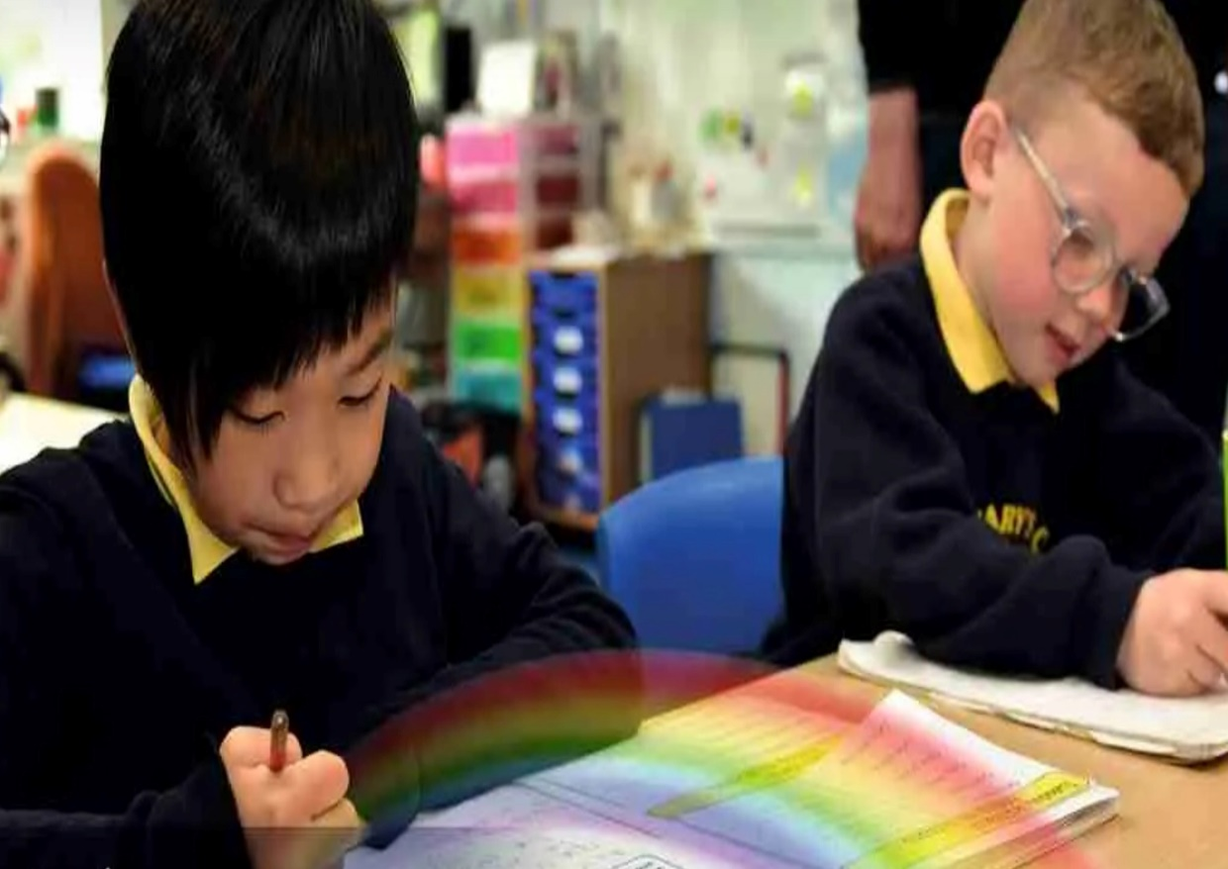

PE Curriculum Overview

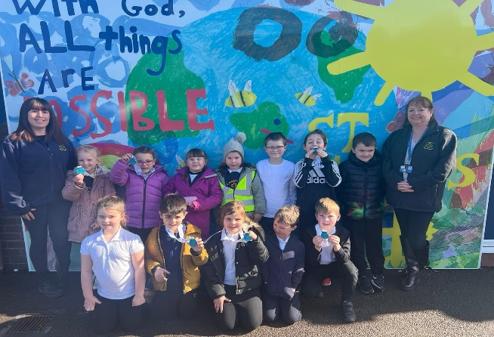
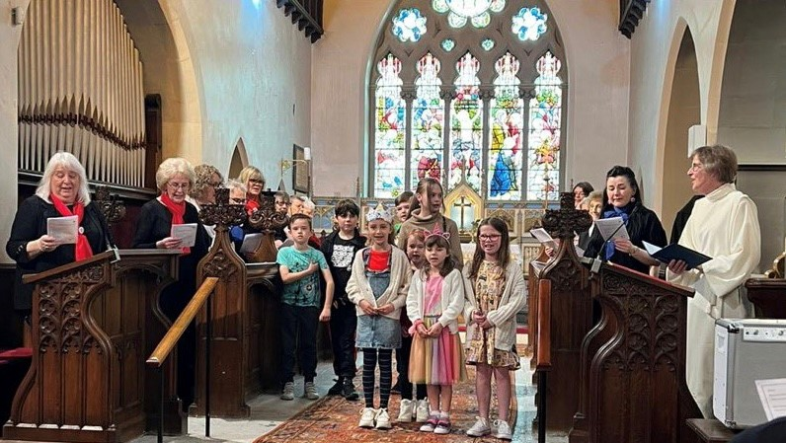
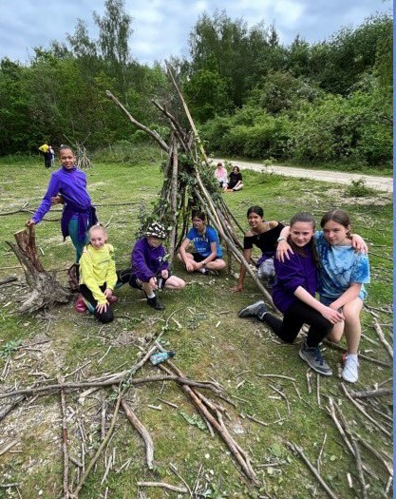
“With God, All Things are Possible.”

Our Approach

We follow the Get Set 4 PE Scheme from EYFS to Y6, which focuses on the 9 core aspects below to meet both the EYFS and National Curriculum expectations. In the EYFS our pupils experience movement, interaction and engagement through structured play, which builds into our National Curriculum content from Y1 onwards. In our cyclical curriculum pupils develop their declarative knowledge across movement, rules, tactics, strategies, health & participation and develop an understanding of what it means to lead a healthy and active lifestyle. Pupils have two taught PE sessions each week, have access to extra-curricular provision within and outside of the school day and each taught aspect has its own knowledge organiser and visual vocabulary pyramid for pupils. The school is part of “shapes” who run competitions and events to ensure pupils have further opportunities to take part in sport. In addition, a specialist PE teacher provides CPD for staff through modelling lessons, team teaching and providing developmental feedback.

YR | Autumn |  |  |  |  |  |  | Spring |  |  |  |  |  |  | Summer
Knowledge & Skills | Unit 1 – fundamentals  - To develop balancing whilst stationary and on the move  - To develop running and stopping.  - To develop changing direction.  - To develop jumping and landing.  - To develop hopping and landing with control.  - To explore different ways to travel.  Unit 1- Intro into PE 1  - To move around safely in space with consideration of others  - To develop moving safely and stopping with control.  - To use equipment safely and responsibly.  - To use different travelling actions whilst following a path.  - To work with others co-operatively and play as a group.  - To follow, copy and lead a partner. |  |  |  | Gymnastics unit 1  - To copy and create shapes with your body and whilst on apparatus.  - To develop balancing and taking weight on different body parts.  - To develop jumping and landing safely.  - To develop rocking and rolling.  - To copy and create short sequences by linking actions together.  Unit 1-Intro into PE 2  - To move around safely in space.  - To follow instructions and stop safely.  - To stop safely and develop control when using equipment.  - To follow instructions and play safely as a group.  - To follow a path and take turns.  - To work co-operatively with a partner. |  |  | Dance 1-6  - To explore different body parts and how they move, and remember and repeat actions.  - To express and communicate ideas through movement exploring directions and levels.  - To create movements and adapt and perform simple dance patterns.  - To copy and repeat actions showing confidence and imagination.  - To move with control and co-ordination, linking, copying and repeating actions.  Fundamentals 2  - To develop balancing  - To develop running and stopping.  - To develop changing direction.  - To develop jumping.  - To develop hopping.  - To explore different ways to travel using equipment. |  |  | Gymnastics unit 2  - To create short sequences using shapes, balances and travelling actions.  - To develop balancing and safely using apparatus.  - To develop jumping and landing safely from a height.  - To develop rocking and rolling.  - To explore travelling around, over and through apparatus.  - To create sequences using apparatus.  Games 1 unit 1  - To work safely and develop running and stopping.  - To develop throwing and learn how to keep score.  - To play games showing an understanding of the different roles within it.  - To follow instructions and move safely when playing tagging games.  - To work co-operatively and learn to take turns.  - To work with others to play team games. |  |  |  | Dance 7-12  - To copy, repeat and explore actions in response to a theme.  - To explore and remember actions considering level, shape and direction.  - To explore movement using a prop with control and co-ordination, expressing ideas through movement.  - To remember and repeat actions moving in time with the music.  - To explore actions in response to a theme and begin to use counts.  Unit 1-Ball Skills  - To develop rolling a ball to a target.  - To develop stopping a rolling ball.  - To develop accuracy when throwing to a target.  - To develop bouncing and catching a ball.  - To develop dribbling a ball with your feet.  - To develop kicking a ball. |  |  | Unit 2-Ball skills  - To develop accuracy when throwing to a target.  - To develop dribbling with hands.  - To develop throwing and catching with a partner.  - To develop dribbling a ball with your feet.  - To develop kicking a ball to a target.  Games 2  - To aim when throwing and practise keeping score.  - To follow instructions and move safely when play tagging games.  - To learn to play against a partner.  - To develop co-ordination and play by the rules.  - To explore striking a ball and keeping score.  - To work co-operatively as a team.
Vocab | Balance, bend, crawl direction fast jump hop land | Team safely space kick throw catch run stop, partner, |  |  | Still straight through travel roll star squeeze shape |  | Team safely space kick throw catch run stop, partner, | Action direction finish position | Run rules safely slide space slow stop travel |  | Hold copy rock land over jump around, balance, bend |  | Pass, direction path, score, land rules aim lose win |  | High, start position, shape |  | Dribbling, catch, hit, kick, partner, points, | Ready, roll, score, target, throw, bounce | Dribble score points partner jump
Continuous Provision Enhancements
- Pupils have access to large outdoor equipment throughout the day and a range of trikes/bikes allows children to develop and refine balancing and riding skills.
- Snipping and cutting with scissors across a range of activities throughout the year within the craft area develops precision to cut around templates and along different lines.
- Pupils develop using cutlery and cups within the role play area and during lunchtime, whilst also using one handed tools with precision and purpose.
- Dough Disco is done daily to develop motor skills.
- Self-care and hygiene are developed through daily routines and opportunities within the role play/small world areas to think about healthy and active life styles.
Y1 | Autumn |  |  |  |  |  |  | Spring |  |  |  |  |  |  | Summer
, , , Knowledge & Skills | Forest School OAA  - To co-operate with a partner to complete challenges.  - To explore and develop working as a team.  - To use speaking and listening skills to lead a partner.  - To plan with a partner and small group to complete challenges.  FSS: Supported construction of tripod structures (mini-den building) Erect a lean to shelter, with support  Introduction to basic knots Continuation of the use of basic tools (cutting of string, Be safe around a fire Contribute to fire lighting by gathering fuel  Fundamentals  - To explore balance, stability and landing safely.  - To explore how the body moves differently when running at different speeds.  - To explore changing direction and dodging.  - To explore jumping, hopping and skipping actions.  - To explore co-ordination and combination jumps.  - To explore combination jumping and skipping in an individual rope. |  |  | Dance 1-6  - To use counts of 8 to move in time and make my dance look interesting.  - To explore pathways in my dance solo and then with a partner.  - To create my own dance using, actions, pathways and counts.  - To explore speeds and actions in our pirate inspired dance.  - To copy/create, remember and repeat/perform actions that represent the theme.  Ball skills  - To develop control and co-ordination when dribbling a ball with your hands.  - To explore accuracy when rolling a ball.  - To explore throwing with accuracy towards a target.  - To explore catching with two hands.  - To explore control and co-ordination when dribbling a ball with your feet.  - To explore tracking a ball that is coming towards me. |  |  |  | Gymnastics 1-6  - To explore travelling movements.  - To develop quality when performing and linking shapes.  - To develop stability and control when performing balances.  - To develop technique and control when performing shape jumps.  Target games  - To develop underarm throwing towards a target to develop throwing for accuracy.  - To develop underarm and overarm throwing for accuracy.  - To develop throwing for accuracy/distance using underarm and overarm.  - To select the correct technique for the situation.  - To develop throwing for accuracy and distance. |  |  |  | Dance 7-12  - To explore speeds and actions.  - To use expression and create actions that relate to the story.  - To use a pathway when travelling  - To explore and copy actions in response to a theme.  - To create my own actions for an animal.  - To explore pathways with a partner.  Invasion Games  - To understand the role of defenders and attackers.  - To recognise who to pass to and why.  - To move towards goal with the ball.  - To support a teammate when playing in attack.  - To move into space showing an awareness of defenders.  - To stay with a player when defending. |  |  | Gymnastics 7-12  - To develop technique and control when performing shape jumps.  - To explore travelling movements.  - To develop stability and control when performing balances.  - To develop technique and control when performing shape jumps.  - To develop technique in the barrel, straight and forward roll.  - To link gymnastic actions to create a sequence.  Net & Wall  - To defend space, using the ready position.  - To play against an opponent and keep the score.  - To explore hitting with a racket.  - To develop racket and ball skills.  - To develop sending a ball using a racket.  - To develop hitting over a net. |  |  | Athletics  To move at different speeds over varying distances.  To develop balance and change direction quickly.  To explore hopping, jumping and leaping for distance.  To develop throwing for distance.  To develop throwing for accuracy.  Striking and fielding  - To develop underarm and overarm throwing and catching.  - To develop hitting and collecting a ball.  - To learn how to get a batter out.  - To play games and understand how to score points.
Vocab | Share instructions lead listen plan challenge talk cooperate |  | Dodge, jog skip swing ready position | pathway copy pose beat fast |  | Ready position, soft, swing, track, underarm, control |  | Action, control, balance, travelling, link, technique |  | distance overarm underarm swing balance further, aim, target |  | Balance, level, timing, control, pathway, actions, beats |  | Track, dodge, goal mark, defender, attacker | Balance, direction, level speed, technique barrel, jump | Track, net backhand against consecutive racket ready position defend underarm |  | underarm overarm  control  leap, time, distance, |  | batting bowler fielder fielding overarm, out
Y2 | Autumn |  |  |  |  |  |  | Spring |  |  |  |  |  |  | Summer
Knowledge & Skills | Gymnastics 1-6  - To perform gymnastic shapes and link them together.  - To be able to use shapes to create balances.  - To be able to link travelling actions and balances using apparatus.  Fundamentals  - To develop balance, stability and landing safely.  - To explore how the body moves differently when running at different speeds.  - To develop changing direction and dodging.  - To develop and explore jumping, hopping and skipping actions.  - To develop co-ordination and combining jumps.  - To develop combination jumping and skipping in an individual rope. |  |  |  | Forest School OAA  - To follow instructions and work with others.  - To co-operate and communicate in a small group to solve challenges.  - To create a plan with a group to solve the challenges.  - To communicate effectively and develop trust.  - To work as a group to solve problems.  - To work with a group to copy and create a basic map.  FSS: Independent use of tripod structures (animal den building) Introduction to lashing and frapping techniques to make frames Continuation of the use of basic tools, larger ropes and independent cutting of string Use of bow saw 1-1 to cut discs and peelers for whittling  Overhand knot and half hitch Experience using fire strikers to spark a flame Light a piece of cotton wool (fairy pillow)  Ball skills  - To roll a ball towards a target.  - To track and receive a rolling ball.  - To send and receive a ball with your feet.  - To develop catching skills.  - To develop throwing and catching skills.  - To send and receive a ball using a racket. |  |  | Gymnastics 7-12  - To demonstrate different shapes, take off and landings when performing jumps.  - To develop rolling and sequence building.  - To develop sequence work on apparatus.  Target games  - To develop an understanding of target games and consider how much power to apply when aiming at a target.  - To understand how to score in different target games using overarm throwing.  - To develop understanding of different target games using the skill of kicking.  - To develop striking to a target and hitting a moving target.  - To select an appropriate skill to play a game |  |  |  | Dance 1-6  - To remember, repeat and link actions to tell the story of my dance  - To develop an understanding of dynamics and how they can show an idea.  - Use counts of 8 to help you stay in time with the music.  - To copy, remember and repeat actions using facial expressions to show different characters.  - To explore pathways and levels.  - To remember and rehearse our circus dance showing expression and character.  Invasion  - To understand what being in possession means and support a teammate.  - To understand that scoring goals is an attacking skill and to explore ways to do this.  - To understand that stopping goals is a defending skill and explore ways to do this.  - To explore how to gain possession.  - To mark an opponent and understand that this is a defending skill.  - To learn to apply simple tactics for attacking and defending. |  |  | Dance 7-12  - To copy, repeat and create actions in response to a stimulus and considering dynamics  - To create a short dance phrase with a partner showing clear changes of speed.  - To copy, repeat and create movement patterns in response to the theme.  - To create and perform using unison, mirroring and matching with a partner.  - To remember and repeat actions and dance as a group.  Net Wall games  - . To use the ready position to defend space on court.  - To develop returning a ball with hands.  - To play against a partner.  - To develop racket skills and use them to return a ball.  - To develop returning a ball using a racket.  - To play against an opponent using a racket. |  |  | Striking and fielding  - To be able to track a rolling ball and collect it.  - To develop accuracy in underarm throwing and consistency in catching when fielding a ball.  - To develop accuracy with overarm throwing to send a ball over a greater distance and limit a batter’s score.  - To develop striking for distance and accuracy.  - To develop decision making to get a batter out.  - To develop decision making when under pressure.  Athletics  - To develop the sprinting action.  - To develop jumping for distance.  - To develop technique when jumping for height.  - To develop throwing for distance.  - To develop throwing for accuracy.  - To develop technique when taking part in an athletics carousel.
Vocab | link pathway pike, travelling, balances, apparatus |  | Sprint, weight take off hurdle speed, stability, speed, control, combine |  | support solve communicate include successful map | Collect, release, receive, prepare, touch, track, target, aim |  | sequence straddle tuck, roll, land, finish position, safety, |  | accurate opponent release strike teammate ahead, aim, target, control |  | mirroring perform speed unison create, partner, beats, dynamics, pathways, levels |  | goalkeeper defend possession tactic opponent receive attack, shoot | dynamics expression, matching, beats, pathways, levels | Quickly, receive, trap, return, defend, against, space, |  | Backstop collect teammate runs stump tactics, track, fielding, distance |  | Distance, sprint height landing take off aim, technique, accuracy

Y3 | Autumn |  |  |  | Spring |  |  |  |  |  | Summer
, , , , Knowledge & Skills | Gymnastics 1-6  - To be able to create interesting point and patch balances.  - To develop stepping into shape jumps with control.  - To develop the straight, barrel, and forward roll.  - To include rolls in sequence work using apparatus  - .  Fundamentals 3/4  - To develop balancing and understand the importance of this skill.  - To understand how to change speed and be able to demonstrate good technique when running at different speeds.  - To demonstrate a change of speed and direction to outwit others.  - To develop technique and control when jumping, hopping and landing.  - To develop skipping with a rope.  - To apply fundamental skills to a variety of challenges. |  | Dance 1-6  - To create actions in response to a stimulus and move in unison.  - To create actions to move in contact with a partner or interact with a partner.  - To select and link appropriate actions and dynamics.  - To remember, repeat and create actions to represent an idea.  - Share ideas of actions/dynamics to create a dance that shows a location.  - To use choreographing ideas to develop our dance.  Ball Skills 3/4  - To develop confidence and accuracy when tracking a ball.  - To develop confidence and accuracy when tracking a ball.  - To explore and develop a variety of throwing techniques.  - To develop catching skills using one and two hands.  - To develop dribbling a ball with hands.  - To use tracking, sending and dribbling skills with feet. |  | Gymnastics 7-12  - To be able to transition smoothly into and out of balances.  - To create a sequence with matching and contrasting actions and shapes.  - To create a partner sequence incorporating equipment.  Football (invasion)  - To develop the attacking skill of dribbling  - To develop changing direction and speed when dribbling.  - To develop passing and begin to recognise when to use different skills.  - To apply attacking skills to move towards a goal.  - To use defending skills to delay an opponent and gain possession.  - To apply skills and knowledge to compete in a tournament. |  |  | Forest School OAA  - To develop co-operation, trust and teamwork skills.  - To involve all team members to work towards a shared goal.  - To be able to identify objects, draw and follow a simple map.  - To draw a route using directions, orientate a map and navigate around a grid.  Create a tarpaulin shelter in a woodland Compare and evaluate the shelters in relation to their sturdiness, durability, weatherproofing and whether it is fit for purpose Using a peeler (1:1) to whittle wood. Using the Cow hitch knot  Light a fairy fire and keep it going  Tennis Net and wall  - To develop racket and ball control.  - To explore rallying and returning a ball using a forehand.  - To explore returning the ball using a backhand.  - To learn how to score and use simple rules.  - To work co-operatively with others to begin to manage a game |  |  | Swimming  - To develop an understanding of buoyancy and balance in the water.  - To develop independent movement and submersion.  - To develop gliding and crawl legs.  - To develop front crawl breathing.  - To develop gliding and backstroke.  - To develop rotation, sculling and treading water.  Cricket (striking and fielding)  - To develop overarm throwing and catching.  - To develop underarm bowling.  - To learn how to grip the bat and develop batting technique.  - To be able to field a ball using a two handed pick up and a short barrier.  - To develop overarm bowling technique  To play apply skills learnt to mini cricket. |  |  | Swimming  - To develop surface dives, submersion and handstands.  - To develop head above water breaststroke technique.  - To develop head above water breaststroke technique.  - To develop basic skills in water safety and floating.  - To learn techniques for personal survival  Athletics  - To develop the sprinting technique and improve on your personal best.  - To develop changeover in relay events.  - To develop jumping technique in a range of approaches and take off positions.  - To develop throwing for distance and accuracy.  - To develop throwing for distance in a pull throw.  - To develop officiating and performing skills.
Vocab | body tension contrast extend, flow, points, patches, forward roll, sequence | Agility, co-ordination control rhythm technique, skipping, outwit, tactics | feedback formation interact canon explore extend, dynamics, | Technique, accurate, block opponent personal best power possession | Match, patch point, take off, landing position, finish position, transition |  | communicate invasion offside tackle opposition pitch receiver referee teamwork tournament control onside technique | compass discuss honest interrupt course route symbol tactics trust collaborate |  | rally competition control cooperation face opponent tactic opposition court forehand backhand react | breaststroke floating handstand H.E.L.P position huddle sidestroke sinking stroke | caught out grip no ball run out short barrier strike technique tournament umpire wicket accuracy |  | surface surface dive tactics treading water water safety backstroke front crawl | accuracy strength baton power relay personal best speed, technique
Y4 | Autumn |  |  |  | Spring |  |  |  |  |  | Summer
, , , , , Knowledge & Skills | Swimming  - To develop an understanding of buoyancy and balance in the water.  - To develop independent movement and submersion.  - To develop gliding and crawl legs.  - To develop front crawl breathing.  - To develop gliding and backstroke.  - To develop rotation, sculling and treading water.  Tennis (net wall)  - To develop racket and ball control.  - To develop returning the ball using a forehand and backhand and understand when to use it.  - To keep a continuous rally going showing increased technique.  - To use and apply rules and simple tactics.  - To understand and use rules to manage a game. |  | Swimming  - To develop surface dives, submersion and handstands.  - To develop head above water breaststroke technique.  - To develop head above water breaststroke technique.  - To develop basic skills in water safety and floating.  - To learn techniques for personal survival  Basketball  - To develop the attacking skill of dribbling.  - To protect the ball when dribbling against an opponent.  - To develop passing and begin to recognise when to use different skills.  - To use defending skills to delay an opponent and gain possession.  - To develop technique in the attacking skill of shooting.  - To apply skills and knowledge to compete in a tournament. |  | Gymnastics 1-6  - To develop individual and partner balances.  - To develop control in performing and landing rotation jumps.  - To develop the straight, barrel, forward and straddle roll.  - To assess my straight, barrel, forward and straddle roll.  - To develop strength in inverted movements.  Dodgeball  - To develop throwing and apply this to a target game.  - To develop dodging skills to avoid being hit.  - To develop catching and learn the rules of the skill within this game.  - To further develop catching and use the rules of the skill within this game.  - To begin to think tactically and apply this to a game.  To apply skills and knowledge to compete in a tournament. |  |  | Dance 7-12  - To develop a dance using matching and mirroring.  - To learn and create dance moves in the theme of carnival.  - To develop a carnival dance using formations, canon and unison.  - To develop a dance phrase and perform as part of a class performance.  Cricket  - To develop overarm and underarm throwing and apply these to a striking and fielding game.  - To develop bowling technique and learn the rules of the skill within this game.  - To develop batting technique and understand where to hit the ball.  - To develop fielding techniques and apply them to game situations.  - To play different roles in a game and begin to think tactically about each role.  - To apply skills and knowledge to compete in a tournament. |  |  | Dance 1-6  - To copy and repeat a set phrase of movement in a 1960s theme showing energy and rhythm.  - To use actions, dynamics, space and relationships to represent a state of matter.  - To learn and perform a partner dance in a 1960s style.  - To develop my own 1960s inspired dance using changes in relationships.  Rounders  - To play different roles in a game and begin to think tactically about each role.  - To develop the bowling action and learn the rules.  - To run around the outside of the bases and make decisions about when to stop and when to run.  - To field a ball using a 2 handed pick up short barrier.  - To develop batting technique and an understanding of where to hit the ball.  - To apply skills and rules learnt to play rounders. |  |  | OAA  - To develop co-operation and teamwork skills.  - To orientate a map and navigate around a grid.  - To develop trust and teamwork whilst listening to others and following instructions.  - To develop trust whilst listening to others and following instructions.  - To be able to identify objects on a map, draw and follow a simple map.  - To be able to orientate and navigate around a map and draw a route using directions.  FFS: Design and build varying sized shelters using tarpaulin and materials found in a woodland. Using Loppers with support Independent use of lashing and frapping techniques Roast food on a fire with support  Athletics  - To develop stamina and an understanding of speed and pace in relation to distance.  - To develop power and speed in the sprinting technique.  - To develop technique when jumping for distance.  - To develop power and technique when throwing for distance.  - To develop a pull throw for distance and accuracy.  - To develop officiating and performing skills.
Vocab | sculling survival submerge | extend receiver continuous co-operative deny reflect swing compete alternate contact | Alternate buoyancy rotation | opposing momentum supporting accelerate, dribbling, shoot, aim, basket, skill, coordination | bridge fluidly inverted momentum perform rotation shoulder stand stability wrist grip |  | limit deny pressure delay gain protect obstruct, dodge, tactics, | phrase relationship represent rhythm structure mirroring, theme, unison, canon |  | limit retrieve compete cushion, striking, fielding, batter, bowler, roles, | action and reaction flow order performance, relationships, repeat, energy, rhythm, | momentum pressure decision, bowler, batter, backstop, decision, barrier |  | Navigate key leader reflect role orientate, map, route, shelter, loppers, frapping | officiate record launch official  stamina pace stride  heave
Y5 | Autumn |  |  |  | Spring |  |  |  |  |  | Summer
Knowledge & Skills | - Gymnastics 1-6  - To be able to perform symmetrical and asymmetrical balances.  - To develop the straight, forward, straddle and backward roll.  - To be able to explore different methods of travelling, linking actions in both canon and synchronisation.  - To be able to perform progressions of inverted movements.  - Hockey (invasion)  - To develop dribbling to beat a defender.  - To send and receive the ball with control under pressure.  - To select the appropriate skill, choosing when to pass and when to dribble.  - To move into and create space to support a teammate.  - To use the appropriate defensive technique for the situation.  - To apply rules, skills and principles to play in a tournament |  | Dance 1-6  - To create a dance using a random structure and perform the actions showing quality and control.  - To understand how changing dynamics changes the appearance of the performance.  - To use relationships and space to change how a performance looks.  - To copy and repeat movements in the style of rock ‘n’ roll.  - To work with a partner to copy/repeat actions keeping in time with the music.  - To work collaboratively with a group to create a dance in the style of Rock ’n’ Roll.  Netball  - To develop passing and moving.  - To be able to use the attacking principle of creating and using space.  - To be able to change direction and lose a defender.  - To be able to defend ball side and know when to go for interceptions.  - To develop the shooting action.  - To use and apply skills and tactics to small sided games. |  | Swimming  - To develop gliding, front crawl and backstroke.  - To develop rotation, sculling and treading water.  - To develop the front crawl stroke and breathing technique.  - To develop the technique for backstroke arms and legs.  - To develop breaststroke technique.  Tag rugby  - To select the appropriate skill, choosing when to run and when to pass.  - To move into space to support a teammate abiding by the rules.  - To use defending skills to gain possession.  - To work as a defending unit to prevent attackers from scoring.  - To use a variety of attacking skills to beat a defender.  - To apply rules, skills and tactics learnt to play in a tag rugby tournament. |  |  | Swimming  - To develop breaststroke and breathing technique.  - To develop basic skills of water safety and floating.  - To develop the dolphin kick.  - To learn techniques for personal survival.  - To develop water safety skills  - To identify fastest strokes and personal bests.  Cricket  - To develop throwing and catching under pressure and apply these to a striking and fielding game.  - To develop bowling under pressure whilst abiding by the rules of the game.  - To strike a bowled ball with increasing consistency.  - To develop fielding techniques and select the appropriate action for the situation.  - To understand and apply tactics in a game.  - To apply skills and knowledge to compete in a tournament. |  |  | Forest School OAA  - To develop communication, negotiation and empathy whilst working in a team.  - To work as a team to solve problems, sharing ideas and collaborating with one another.  - To develop tactical planning and problem solving.  - To share ideas and work as a team to solve problems.  - To develop navigational skills and map reading.  - To use a key to identify objects and locations.  FSS: Create a tipi shelter with camouflage. Using Secateurs with support Shelter hitches and knots Cooking on a camp fire (roast food) Make and tend a fire safely  Fitness  - To develop an awareness of what your body is able to do.  - To develop speed and stamina.  - To develop strength using my own body weight.  - To develop co-ordination.  - To develop agility.  - To develop balancing with control. |  | Gymnastics 7-12  - To be able to perform progressions of inverted movements.  - To explore matching and mirroring using actions both on the floor and on apparatus.  - To be able to create a partner sequence using apparatus.  Athletics  - To be able to apply different speeds over varying distances.  - To develop fluency and co-ordination when running for speed.  - To develop technique in relay changeovers.  - To develop technique and co-ordination in the triple jump.  - To develop throwing with force for longer distances.  - To develop throwing with greater control and technique.
Vocab | stable symmetrical synchronization transition quality performance identify | barrier create dominant  drive sportsmanship support situation | choreograph choreography collaboratively genre motif posture quality transition | close down maintain support situation stance rebound, angle | endurance inhale exhale flutter kick outstretched |  | ball carrier barrier create dominant  drive sportsmanship  try | personal best retrieve somersault synchronized continuously dolphin kick |  | Stance close catch deep catch situation long barrier backing up | compromise concise critical thinking landmark negotiate strategy verbal visual cardinal points | measure consistent motivate persevere power, stable, drive | mirroring observe asymmetrical extension canon, cartwheel |  |  | force javelin dominant shot-put approach momentum changeover, track, drive
Y6 | Autumn |  |  |  | Spring |  |  |  |  |  | Summer
, , , , Knowledge & Skills | Gymnastics 1-6  - To be able to develop the straddle, forward and backward roll.  - To develop counter balance and counter tension.  - To be able to perform inverted movements with control.  - To develop jumps and explore the effect of height.  Handball (invasion)  - To use a variety of passes to maintain possession under pressure  - To select the appropriate skill to create space, move towards goal and away from defenders.  - To select and apply the appropriate skill to score goals and to prevent an opponent from scoring  - To use the appropriate defensive technique for the situation. |  | Dance 7-12*  To develop set choreography inspired by a Mayan god.  To choose actions to create a motif in a given character with consideration of dynamics, space and relationships.  To use structure to choreograph a dance performance.  To use matching, canon and unison in the style of the lion dance.  To select and combine dance tools to choreograph and perform a Chinese dance.  Hockey (invasion)  - To develop dribbling to beat a defender.  - To send and receive the ball with control under pressure.  - To select the appropriate skill, choosing when to pass and when to dribble.  - To move into and create space to support a teammate.  - To use the appropriate defensive technique for the situation. |  | Gymnastics 7-12  - To be able to perform inverted movements with control.  - To be able to use flight from hands to travel over apparatus.  - To be able to create a group sequence using formations and apparatus.  Football  - To maintain possession when dribbling.  - To dribble with control under pressure.  - To select the appropriate skill, choosing when to pass and when to dribble.  - To move into and create space to support a teammate.  - To use the appropriate defensive technique for the situation.  - To apply rules, skills and principles to play in a tournament. |  |  | Dance 1-6  To copy and repeat a dance phrase showing confidence in movements.  To work with others to explore and develop the dance idea.  To use changes in dynamics in response to the stimulus.  To demonstrate a sense of rhythm and energy when performing bhangra style motifs.  To perform a bhangra dance, showing an awareness of timing, formations and direction and using group formations.  Tennis (net wall)  - To develop placement of the ball using a forehand.  - To develop placement of the ball using a backhand groundstroke.  - To develop the volley and understand when to use it.  - To employ tactics when playing with a partner.  - To develop accuracy and consistency using the underarm serve. |  |  | Golf  To develop technique for hitting accurately over a short distance.  To develop technique for hitting over a short distance.  To select and apply skills for a short game and select the appropriate shot for the situation.  To design a course and select the appropriate shot for the situation.  Rounders  - To develop the bowling action and understand the role of the bowler.  - To develop batting technique.  - To make decisions about where and when to send the ball to stump a batter out.  - Develop a variety of fielding techniques and when to use them in a game.  - To develop long and short barriers in fielding and understand when to use.  - To apply the rules and skills you have learnt to play in a rounders tournament. |  |  | Forest School/OAA  - To build communication and trust whilst showing an awareness of safety.  - To work as a team to solve problems, sharing ideas and collaborating with one another.  - To develop tactical planning and problem solving.  - To share ideas and work as a team to solve problems.  - To develop navigational skills and map reading.  - To use a key to identify objects and locations.  Shelter building challenge – working in teams the children plan, build and review their shelters (recap the different ways to build shelters) Set up a tent in preparation for going on a residential visit Using knives for whittling with support More complex knots and selecting the correct knot for a job Prepare and light a campfire with supervision  Athletics  - To work collaboratively with a partner to set a steady pace.  - To develop your own and others sprinting technique.  - To develop power, control and technique for the triple jump.  - To develop power, control and technique when throwing for distance.  - To develop throwing with force and accuracy for longer distances.  - To work collaboratively in a team to develop the officiating skills of measuring, timing and recording.
Vocab | Aesthetics competent engage execution flight formation handstand progression | close down maintain support situation stance rebound, angle | freeze frame inspiration mood refine rehearse stimulus | turnover dictate transition assess appropriate, dribbling, defense, | counter balance counter tension structure contrasting, | contest draw abide consecutive ball side, pass back, consistently, possession, skills, defend, attack, |  | Style, aesthetic, express , confident, motif, timing, formation, group formations | placement recover opposing limit stance direct thrust appropriate service abide footwork  doubles |  | Shot, course long game short game technique | consecutive appropriate consistently collaborate assess abide, barriers |  | contribute evaluate determine location approach adhere, inclusive |  | pattern phase grip fling stance release meet explosive discus  maximum, strategy rhythm

