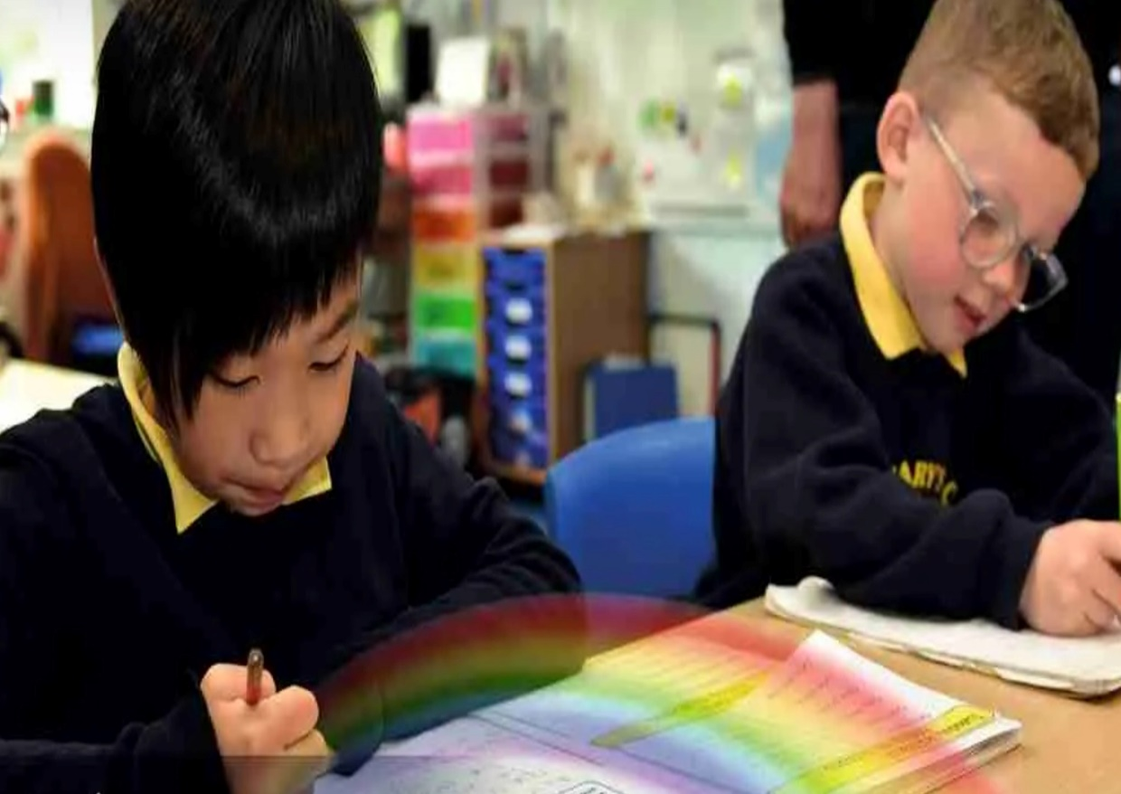

Art Curriculum Overview
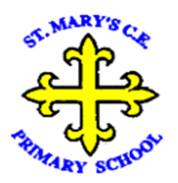
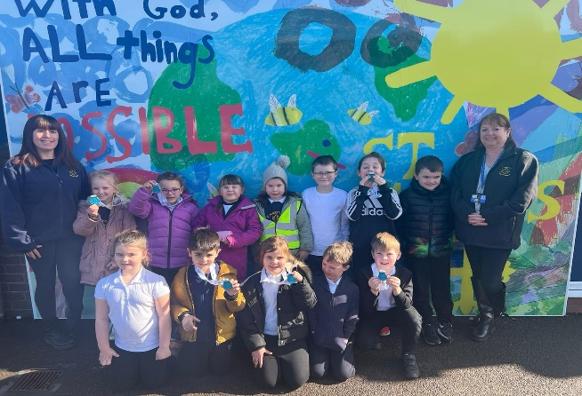
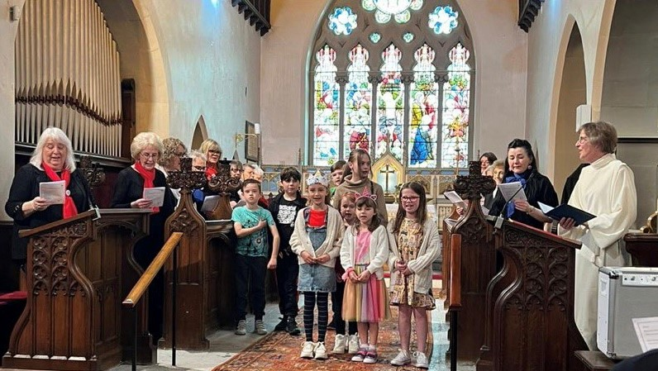
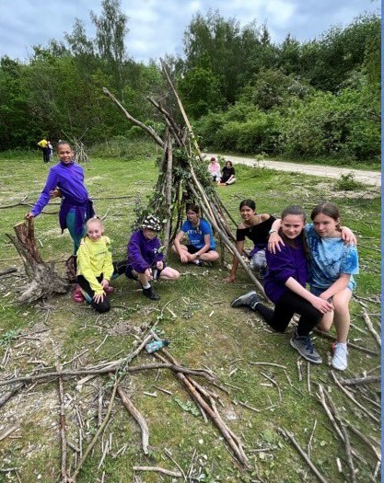
“With God, All Things are Possible.”

Our Approach

We have based our curriculum on Plan B and Access Art* materials. Our cyclical curriculum focuses on the 4 aspects below and our pupils revisit these aspects throughout their time in our school every year. Drawing and painting skills weave throughout our Sculpture/3-D and Craft & Design focused projects to embed and secure the cumulative knowledge of the different techniques looked at. Each time they revisit an aspect, it is with increasing complexity to build on their prior knowledge. Across each year group they develop a knowledge of different artists and crafts people to ensure they can compare and contrast these. Three art projects are completed across the year as a half termly block in each term as an hour a week. In addition, they use their sketch books from Y1 onwards to generate ideas, document their products and evaluate/analyse their developing skills. The whole school takes part in the Big Draw and design opportunities are taken within other subject areas such as RE, where pupils can further embed and use their developing skills. The school aims to raise pupils cultural capital through a range of planned visits across their time in school.

YR | Autumn |  | Spring | Summer
Knowledge & Skills | Drawing-All About Me  - Draw lines and circles with meaning.  - Experiment with different media for making marks.  - Study the details of the face.  - Experiment with drawing own face using a mirror.  - Create a self-portrait. | Craft & Design-Natural Materials  - Notice features in the natural world and describe the different shapes, textures and smells.  - Create representations of imaginary and real life events, people and objects.  - Safely use and explore a variety of materials, tools and techniques, experimenting with colour, design, texture, form and function.  - Share their creations, explaining the process they have used | Painting & Mixed Media-Colour mixing using primary colours  - Use colour mixing and mix black and white to colours to create the colour they want to make to express their ideas and feelings.  - Create collaboratively, sharing ideas, resources and using a range of skills.  - Create representations of imaginary and real life events, people and objects. | Sculpture & 3D  - Use hands to manipulate a range of modelling materials, including paper/card to explore how to join and fix materials in place.  - Create 3D forms to make things from their imagination or recreate things they have seen.  - Select colours, shapes and materials to suit ideas and purposes, whilst developing skills in cutting and adding decoration.
Key People | Van Gogh | Andy Goldsworthy | Monet | Michelle Reader
Vocab | Artist, bumpy, chalk, colours, drawing, hard, line, long, medium, observational drawing, oil pastel, pattern, ridged, rough, rubbing, Short, soft, texture | Bend, blades, crease, create, design, flange, fix, join, paper clip, pattern, pinch, plan, pull, push, roll, slot, snip, split pin, string, strip, sturdy, tape, thread, tie, wave | Collage, create, cut, dab, design, dot, flick, glide, glistening, glossy, landscape, permanent, rip, shiny, silky, slimy, slippery, smooth, squelchy, stick, sticky, tear, temporary, transient art, wet, wipe | 3D art, bend, clay, chop, collage, cut, evaluate, flatten, join, landscape, pinch, plan, poke, pull, push, reflect, roll, sculpture, silky, slimy, slippery, smooth, squash, Squelchy, sticky, stretch, twist, wet, tape, thread
Continuous Provision Enhancements
- Children will have access to a range of art and design activities through the continuous provision. Regular enhancements will provide opportunity for building on developing artistic skills and ensure learning is embedded.
- Children will have the opportunity to produce creative and imaginative work linked to the different projects.
- Children have the opportunity to explore their ideas and record their experiences, as well as exploring the work of others and evaluate different creative ideas.
- Children will become confident and proficient in a variety of techniques including drawing, painting, printing, collage, textiles and 3D, as well as other selected craft skills.
Y1 | Autumn |  | Spring | Summer
Knowledge & Skills | 3-D & Sculpture-Earth Art  - Describe what a sculpture is and comment on what different sculptures are made from.  - Use natural materials such as twigs and sticks to create a sculpture  - Recreate rangoli patterns using natural materials such as leaves  - Use clay to create imprints of natural materials such as leaves |  | Painting-Mark Making  - Hold a paintbrush correctly when painting and know what ‘loading’ the paintbrush is.  - Know how to create a smooth sweeping brushstroke  - Use paint to create differently shaped lines.  - Use a paintbrush to create lines of different thicknesses.  - Experiment with different ways to make marks using a paintbrush.  - Name a variety of colours and choose a favourite colour to give reasons for my choices.  - Know what primary colours are needed to mix secondary colours.  - Know how to create lighter/darker shades of colour.  - Use paint to create artwork in the style of an artist studied.  - Explore how Kandinsky used different lines in his artwork.  - Discuss how a line or a dot can be a piece of art using the story ‘The Dot’ by Peter H Reynolds.  - Discuss the artworks of Paul Klee and say what is liked and disliked about them  - Spot different mark making techniques in Klee’s work.  - Attempt to recreate some of the mark making in Klee’s artwork | Drawing-Still Life*  - Explore ways of drawing lines between two point.  - Experiment with how to hold a pencil when sketching.  - Discuss what a line is and use adjectives to describe lines.  - Experiment with pressure when drawing pencil lines.  - Comment on how different grades of sketching pencil make different marks.  - Investigate how to make different marks using sketching pencils.  - Make a choice about which pencil I need to use for a purpose.  - Experiment with different kinds of pencils and observe the different marks they make.  - Create different repeated line patterns.  - Discuss and comment on the texture in artwork.  - Apply a variety of techniques when drawing.  - Evaluate own work and the work of others to identify strengths/weaknesses.  - Comment on how drawings by different artists make them feel.  - Say what they like/dislike about different drawings.
Key People | Anthony Gormley |  | Paul Klee | LS Lowry
Vocab | Sculpture, artist, three dimensional (3D), cylinder, curve, loop, tube, concertina, overlap, spiral, zig-zag, carving, mosaic, imagine |  | Hue, shade, primary colour, secondary colour, pattern, mix, blend, print, shape, kaleidoscope, texture, space, thick | Line, vertical, horizontal, diagonal, wavy, straight, cross-hatch, optical art, 2D shape, 3D shape, abstract, narrative, printing, shade, form, continuous, mark making, observe, dots, circle, lightly, firmly, texture, shadow, charcoal, pastel, chalk, blending, thick, thin, mark making, texture
Y2 | Autumn |  | Spring | Summer
Knowledge & Skills | 3-D-& Sculpture-Installation Art  - Develop scissor/cutting skills when cutting out circles.  - Use paper art to recreate an installation piece by Yayoi Kusama.  - Comment on the shape/form of 3-D objects and sculptures.  - Use the rolling technique effectively to manipulate clay  - Recreate the form of a pumpkin, inspired by Kusama’s sculptures.  - Experiment with different materials to make marks.  - Make attempts to mimic the art of a famous artist.  - Experiment with different mediums to create a polka dot pattern.  - Follow instructions to create the basis for sketching.  - Make visual observations to inform sketches.  - Describe and make observations on a piece of artwork’s colour and pattern  - Make choices about the tools used when painting. |  | Painting-Colour Creations  - Hold a paintbrush correctly when painting and know what ‘loading’ the paintbrush is.  - Know how to create a smooth sweeping brushstroke  - Use paint to create differently shaped lines.  - Use a paintbrush to create lines of different thicknesses.  - Experiment with different ways to make marks using a paintbrush.  - Name a variety of colours and choose a favourite colour to give reasons for my choices.  - Know what primary colours are needed to mix secondary colours.  - Know how to create lighter/darker shades of colour.  - Use a paintbrush to make basic marks using paint.  - Use paint to create artwork in the style of an artist studied. | Craft & Design- Henry Rousseau  - Sketch and draw plants and flowers in the style of Rousseau  - Sketch and create a ‘portrait-landscape’  - Use imagination to generate ideas for a sketch.  - Use natural materials to create prints.  - Create prints inspired by Rousseau’s paintings.  - Say who Henri Rousseau was and recall facts about his life.  - Discuss a painting by Henri Rousseau  - Discuss and explain how they feel when looking at a Rousseau painting.  - Discuss portraits, landscapes, and Rousseau’s genre of ‘portrait-landscape’  - Use paper to create a shoebox model of one of Rousseau’s paintings  - Use paper and other materials to create a mask.  - Use glue to help attach different parts to their model.
Key People | Henri Matisse & Yayoi Kusama |  | Clarice Cliff, Piet Mondrain & Kandinsky | Henry Rousseau
Vocab | Roll, smooth, flatten, shape, cut, pinch pot, thumb pot, ceramic, glaze, score, slip, surface, join, sculpture, sculptor, plaster, casting, negative space, three dimensional, in relief, detail, impressing |  | Shade, tone, light, dark, brushstroke, texture, primary colour, secondary colour, combine, thickness, | Imaginary, inspired, landmarks, shape, texture, pattern, felt, fibre, viewfinder, abstract, composition, mosaic, overlap, gallery, curator, design, design brief, evaluate, printing, print

Y3 | Autumn | Spring | Summer
Knowledge & Skills | Drawing-Famous Buildings  - Create areas of light and dark in sketches using different shading methods such as hatching, cross-hatching, stippling and scumbling  - Vary my shading further through use of pressure.  - Comment on the patterns created in the architecture of St Basil’s Cathedral.  - Recreate patterns using oil pastels and ink.  - Spot symmetry in the designs of famous buildings.  - Use tracing to create a symmetrical piece of art.  - Create texture in artwork to reflect real-life buildings.  - Understand the role of an architect.  - Discuss the shapes and structures of famous buildings around the world.  - Say if they like or dislike the design of a building  - Explore the work of Hunndertwasser and imitate this to create own piece of Hunndertwasser inspired art. | Painting-Pointilism  - Explain what pointillism is and experiment with a range of pointillism techniques.  - Apply pointillism techniques using different mediums to create a painting.  - Evaluate techniques and mediums and say preferred.  - Identify secondary colours to create in own composition.  - Understand what tertiary colours are and identify on the colour wheel.  - Identify complementary colours on the colour wheel.  - Mix colours using the pointillism method  - Make decisions about the subjects and colours of artwork, giving reasons for choices.  - Explain who George Seurat was and why he was famous  - State feelings about a piece of artwork and justify thoughts.  - I can experiment with a range of techniques and methods for creating Pointillism  - I can state which method I prefer and why  - I can name some Pointillist artists  - I can identify Pointillism in pieces of art  - I can give reasons for my choices of colour and subject in my artwork  - I can apply what I have learnt about Pointillism to create my own piece of artwork  - I can evaluate my finished artwork and compare it to that of my peers | 3D & Sculpture-Recycled Art  - Experiment with different ways to join materials to make a 3-D piece of art.  - Select a suitable joining method when working with different materials.  - Look at different materials and make suggestions about how to use them in own artwork.  - Use a material’s existing shape to inspire own artwork.  - Create a simple animal sculpture from recycled materials.  - Select a suitable type of paint to finish own art work.  - Explore different pieces of recycled art.  - Comment on the message that a piece of art might be portraying.  - Say if they like or dislike a piece of art and why.
Key People | Hunndertwasser | Seurat & Emily Kngwarreye | Khalil Chistee & Subodh Gupta
Vocab | Stippling, hatching, cross hatching, scribbling, blending, sketch, charcoal, composition, proportion, smudging, scaled up, sketch, texture, tone | Portrait, landscape, shadow, tint, shade, texture, contrasting, vivid, muted, formal, patterned, abstract, detailed, figurative, three dimensional (3D), grid, technique, mark-making, composition, dabbing paint, stippling paint, paint wash, pointillism | Visualisation, two-dimensional (2D), three-dimensional (3D), organic shape, sculpture, tone, form, carving, model, hollow, figurative, abstract, quarry, texture, surface, join, pliers, template, secure, mesh, found objects, typography, welding, weaving
Y4 | Autumn | Spring | Summer
Knowledge & Skills | Craft & Design-Jewellery Designers  - Understand jewellery was made throughout history.  - Recognise jewellery from different ancient civilisations.  - Explain the colours and designs of ancient jewellery.  - Understand what gemstones are and where they come from.  - List some rare gems used in jewellery.  - Create their own unique gemstones using pattern and colour combinations.  - Explain what Tiffany & Co. and Bulgari are.  - Describe the appearance of some famous jewellery, including the patterns and materials used.  - Make pendants/bracelets for their own use.  - Use a range of artistic skills to design their art skills. | Painting- Wallpaper Printing  - Recreate a wallpaper pattern in the style of William Morris.  - Use careful observation skills to create a still life sketch for printing inspiration.  - Understand how shading is linked to the light source in a drawing  - Identify repeating patterns in wallpaper designs.  - Describe the process of block printing.  - Explain how different colours are achieved when using block printing to create a design.  - Design and create a relief printing tile to be used for block printing.  - Use a made printing tile to create a repeating pattern.  - Identify why a print may not have come out correctly  - Know how to create a half drop pattern with own printing.  - Find similarities and differences between the different works of William Morris.  - Analyse an existing piece of artwork using language associated with Art and Design.  - Describe what the Arts and Crafts movement was and explain why it was founded. | Drawing-Van Gogh*  - Explain what still life sketching is.  - Use soft, light sketching techniques to create a still life sketch.  - Adjust own pencil grip when sketching.  - Identify an artwork that is visually pleasing and explain why.  - Give own personal opinion of different artwork.  - Listen to others’ opinions of artworks, and try to see their point of view.  - Describe what a botanical illustration is and why they were first created.  - Discuss and respond to Van Gogh’s artwork and how he used tones and colour.  - Understand how artists create the illusion of depth in their artwork  - Design own artwork and give reasons for own choices.
Key People | Tiffany & Bulgari | William Morris | Van Gogh
Vocab | Egyptian, ancient, civilization, painting, pattern, shape, colour, convey, composition, scale, imagery, design, technique, process, material, layout, audience, inform, bend, shape, tie, cotton, glue, glass bead | Mixed media, wax-resist, highlight, collage, combine, printmaking, abstract, figurative, monoprint, block print | Contrast, observational drawing, shading, shadow, tone, gradient, three dimensional (3D), proportion, symmetry, pattern, composition, precision, parallel, hatching, cross-hatching, viewfinder, collaborate, collaboratively
Y5 | Autumn | Spring | Summer
Knowledge & Skills | Craft & Design-Digital Collage & Image Manipulation*  - Investigate self-portraits by a range of artists.  - Compare and contrast digital photographs of subjects compared to painted or drawn portraits.  - Understand how artists use digital tools and compare/contrast to traditional media/techniques.  - Take and use photographs of themselves as a starting point for developing their own unique self-portraits in mixed-media.  - Use a range of digital tools such as crop, filter, rotate and resize to manipulate digital images.  - Create photomontages/collages. | Painting-Flaunders Field*  - Understand that surrealism has 4 key characteristics and was a reaction to the atrocities of WW1.  - Know that surrealist techniques include collage, doodling and frottage and explain what these are.  - Explore the work of Paul Nash and Pablo Picasso as surrealist artists.  - Explore the use of colour within surrealist art work and collect ideas in own sketchbooks.  - Plan for a ﬁnal piece inspired by Paul Nash.  - Present what they have learnt about Paul Nash and Pablo Picasso. | Drawing-Plant Art  - Use observational skills to create a detailed sketch of part of a plant.  - Understand that constant observation and attention to detail is important when creating a detailed sketch of a plant.  - Understand that patience is important when creating a detailed sketch of a plant.  - Discuss how to represent a plant as a piece of art.  - Follow simple instructions to create a more realistic sketch of a tree.  - Compare a sketch from own imagination, and a visually informed sketch and evaluate the differences.  - Understand the difference between tints, shades and tones.  - Create and use tints, shades and tones to match a given colour in own art work.  - Understand what depth in an artwork is.  - Use colour and size to create the illusion of depth in my artwork.
Key People | Njideka Akunyili Crosby, Yinka Shonibare, Thandiwe Muriu, Mike Barret | Paul Nash & Pablo Picasso | Georgia O Keefe
Vocab | Background, portrait, self-portrait, photomontage, image, dada, composition, arrangement, layout, photography, monochrome, monochromatic, album, digital, saturation, emulate, editing, software, replacement, focus, frame, recreate, pose, prop, portrait, photorealism, photorealistic, grid, proportion, crop, resize, filter, rotate | Background, surrealism, continuous line drawing, portrait, self-portrait, paint wash, collage, texture, composition, carbon paper, transfer, printmaking, monoprint, mixed media, multimedia, justify, research, collage, doodling, frottage | Geometric, organic, shape, line, object, arrangement, light, dark, shading, tone, grip, smooth, blend, even, frottage, rubbing, surface, texture, botanist, botanical, scientific, magnified, form, scale, composition, abstract, frame, gestural, expressive, viewfinder
Y6 | Autumn | Spring | Summer
Knowledge & Skills | 3-D & Sculpture-Our Exhibition*  - Compare and contrast the work of Barbara Hepworth and Henry Moore.  - Explain what Modernism is as a movement within art and design.  - Use simple rolling and pinching techniques to manipulate salt dough.  - Form shapes to create the base of own sculpture.  - Attach two pieces of salt dough with the help of materials such as match sticks to reinforce joins.  - Add pieces of salt dough to own base to create relief details.  - Use tools to create details in own salt dough or clay model.  - Carve and manipulate a piece of clay to create the shape of own work. | Painting-Landscape Art  - Use vanishing points, horizon lines and construction lines to create perspective in own artwork.  - Sketch a landscape using linear perspective.  - Use lines and patterns to create abstract artwork.  - Experiment with different watercolor techniques to create effects.  - Paint a landscape using watercolours.  - Experiment with a variety of mediums, including watercolours and pastels, to explore how the medium changes the effect of a landscape.  - Create and use tints and shades using a variety of different mediums.  - Identify vanishing points and horizon lines in landscape paintings  - Explain how artists use linear and atmospheric perspective in their artwork.  - Comment on abstract landscapes and explain what they feel about them.  - Create a selection of lines and patterns in own sketchbook to inform own art work.  - Discuss landscape artwork by famous artists, saying what I think and feel about them  - Identify which medium has been used to create a piece of art.  - Make decisions about how to create a piece of landscape artwork based on the ideas gathered and techniques experimented with. | Drawing-Express Yourself  - I can describe the general proportions of a face  - I can use my knowledge of proportions to complete a self-portrait  - I understand that I can use light guidelines for my sketches to help structure my sketches  - I can use light sketching lines to create my portrait  - I can add paint to a sketched self-portrait to add colour and detail  - I can choose colours to express aspects of my personality  - I can choose colours to express aspects of communities I belong to  - I can describe who Frida Kahlo is and give a brief summary of her work  - I can give my opinion of a painting or artist, giving reasons for my ideas  - I can describe the differences between a portrait and a self-portrait  - I can describe aspects of Mexican folk art  - I can identify aspects of the Mexican culture in Kahlo’s artwork  - I can describe the aspects of the surrealist movement  - I can express my opinion of surrealism.  - I can apply aspects of surrealism to my own artwork.
Key People | Barbara Hepworth & Henry Moore | Nerys Levi | Frida Kahlo
Vocab | Display, installation art, mixed media, features, evaluate, analyse, location, scale, scaled down, special effects, three dimensional, art medium, performance art, stencil, atmosphere, props, influence, experience, culture, concept, elements, interact, interactive | Artist, compositions, evaluation, medium, mixed media, technique, translate, analyse, meaning, narrative, interpret, justify, inference, respond, abstract, convey, compose, thought-provoking, horizon, perspective, landscape | Imagery, mark making, expressive, character traits, interpretation, aesthetic, representative, tone, technique, commissioned, tone, tonal, composition, impact, audience

