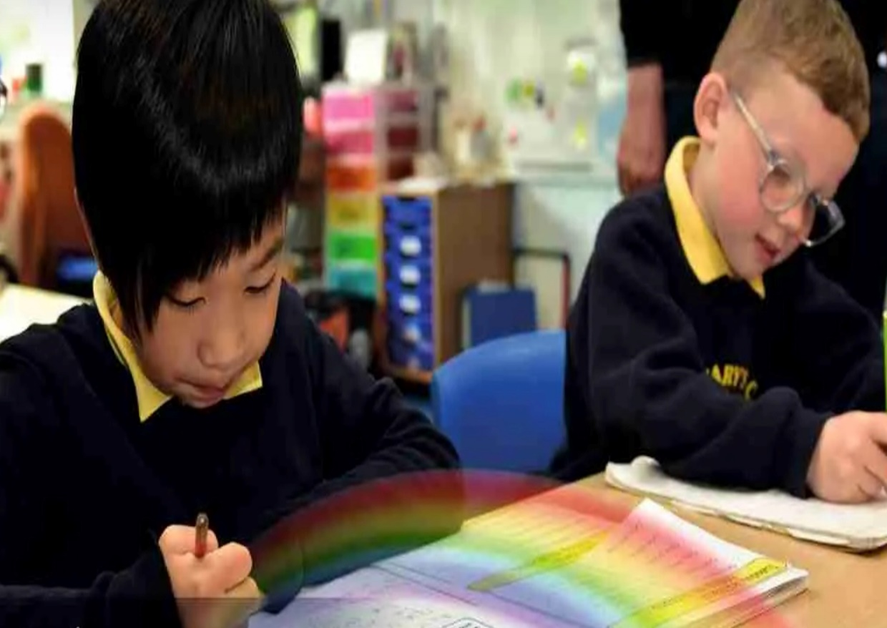

D&T Curriculum Overview

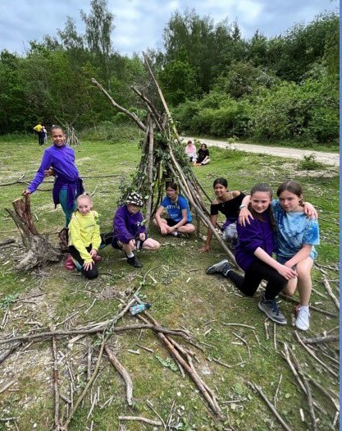
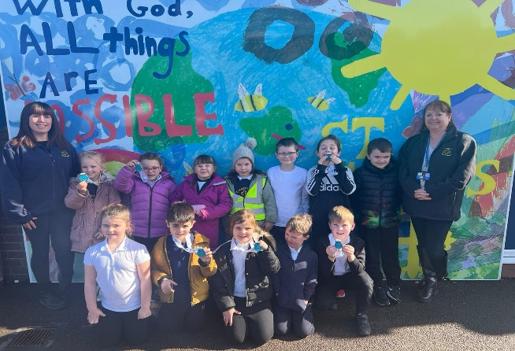

“With God, All Things are Possible.”

Our Approach

We have based out curriculum on the Plan Bee resources. Our cyclical curriculum focuses on the 6 aspects below and our pupils revisit these aspects throughout their time in our school every year, with two aspects only being introduced in KS2 (electrical systems & digital systems). Each time they revisit an aspect, it is with increasing complexity to build on their prior knowledge. Design and Technology is undertaken once a half term for an hour per week. In each of the 3 projects they complete each year they build on their ability to design, make and evaluate whilst also developing an understanding of cooking and nutrition. In addition, they are given opportunities to use their growing technical vocabulary, to talk about their products. Within each project, they will examine the work/impact of famous crafts people, designers, inventors and engineers, whilst also considering key events that have shaped the world.

YR | Autumn | Spring | Summer
Knowledge & Skills | Structures-Junk Modelling  - Safely use and explore a variety of materials, tools and techniques, experimenting with colour, design, texture, form and function  - Share their creations, explaining the process they have used. | Textiles-Weaving  - Explore how to weave with a range of materials through developing their fine and gross motor skills.  - Create collaborative large scale weaving creations.  - Explore different patterns | Mechanisms-Creating Diva Lamps & Rockets  - Safely use and explore materials and tools.  - Explore new techniques  - Talk about new creations  - Begin to return to and build upon previous learning  - Use split pins to add moving parts deciding on placement.
Cooking & Nutrition | - Name simple everyday equipment used in baking and use simple terms such as mix, ingredient, recipe and bake.  - Use small motor skills to use a range of tools such as knives and forks.  - To know and talk about how to maintain a healthy body and well-being: healthy eating and eating a range of food.  - Take part in baking bread looking at the process of how the ingredients change and understand the dangers when working around a hot oven.  - Describe how key ingredients feel and think about where they come from (caught, reared or processed).
Vocab | Join, stick, cut, bend, slot, scissors, measure, materials, fix | Weave, pattern, design, evaluate | Design, evaluation, fix, mechanic, mechanism, model, test
Continuous Provision Enhancements
- Children have access to the creative area or workshop throughout each day to “design” and “make” a variety of products with a purpose.
- Children will practice joining and combining different materials including paper, card, material, wood, string/yarn and plastic using glue, split pins, tape or loops.
- Opportunities to develop and practice cutting skills using different tools are provided.
- Large construction and small world materials in both the indoor and outdoor classroom enable pupils to develop construction skills to develop an understanding of structures, whilst experimenting with strengthening techniques and different shapes.

Y1 | Autumn | Spring | Summer
Knowledge & Skills | Food & Nutrition-Eat More Fruit & Vegetables  - Name a variety of fruits and vegetables.  - Use adjectives to describe the taste, smell and texture of a variety of fruits and vegetables.  - Know that some fruits and vegetables need to be washed, cut, cored, peeled or grated before they can be eaten.  - Understand basic food hygiene, e.g. washing hands, tying long hair back and keeping surfaces clean.  - Use a knife to cut some fruits and vegetables in different ways.  - Grate an apple/carrot and peel a banana, apple and cucumber. | Structures-Stable Structures.  - Identify the features of toy garages.  - Know what the word ‘stable’ means.  - Make changes to the design of a stable structure to make it fit for purpose.  - Explore a range of materials and evaluate the usefulness of their properties for a particular project.  - Explore how to make stable structures that hold a given object.  - Follow a design to make a stable structure.  - Know some ways to make a structure more stable.  - Evaluate a finished structure against a set of given criteria. | Mechanisms-Moving Mini beasts  - Make a sliding mechanism out of card.  - Know what a pivot and lever are.  - Use a pivot and lever mechanism using card and a split pin.  - Make a wheel mechanism using card and a split pin.  - Match a mechanism to the type of movement they produce.  - Design a moving minibeast picture to include a variety of moving mechanisms.  - Follow a design to create a moving minibeast picture for a particular purpose.  - Evaluate my finished moving minibeast picture by identifying things that worked well and things that could be improved.
Key People | Philip Harben & the first television cooking show | Gustav Eiffel & his incredible structures | Rod Campbell/David A Carter & their amazing pop up books
Vocab | Fruit, vegetables, safety, knife, blade, tool, edge, handle, chop, slice, cut, saucepan, blender, carton, healthy, ingredients, peel, peeler, recipe, slice, smoothie, stencil, template, vegetable | Client, design, evaluation, net, stable, strong, test, weak | sliders, mechanism, adapt, , design, design criteria, input, model, template, assemble, test
Y2 | Autumn | Spring | Summer
Knowledge & Skills | Food & Nutrition-Perfect Pizzas  - Name a variety of pizza toppings.  - Use the model of the balanced plate to evaluate how healthy different pizzas are.  - Explore different types of bread and evaluate which would work best for a pizza base.  - Identify which food group a variety of pizza toppings belong to.  - Sort pizza toppings into groups based on different criteria, e.g. animal vs plant products.  - Explain why each of the food groups is important for a balanced diet.  - Design and make a healthy pizza following given criteria.  - Evaluate my finished pizza, saying what I think and feel about it. | Mechanical Systems-Vehicles  - Investigate a range of vehicles, identifying and labelling their features.  - Know what an axle is.  - Know what a chassis is.  - Explore different ways of using axles, chassis and wheels to create a moving base.  - Design a vehicle with wheels, axles and chassis, as well as a body.  - Follow a design to make a moving vehicle.  - Evaluate my finished moving vehicle. | Textiles-Puppets  - Explore a variety of puppets, identifying and labelling their features.  - Cut out felt using a simple template.  - Stick pieces of felt together to make a finger puppet.  - Add pieces of felt and other materials to a finger puppet to create features, such as eyes, hats and mouths.  - Use running stitch to join two pieces of fabric together.  - Use overstitch to join two pieces of fabric together.  - Sew a button onto a piece of fabric.  - Design a glove puppet for a particular purpose.  - Follow a design to make a glove puppet by sewing two pieces of fabric together and adding decorations.  - Evaluate a finished glove puppet by identifying what went well and what could be improved.
Key People | Auguste Escoffier & his food revolution | Henry Ford & the mass manufacture of cars | Jim Henson & the evolution of puppetry
Vocab | Alternative, diet, balanced diet, evaluation, expensive, healthy, ingredients, nutrients, packaging, refrigerator, sugar, substitute | Axle, axle holder, chassis, design, evaluation, fix, mechanic, mechanism, model, test, wheel | Decorate, design, fabric, glue, model, hand puppet, safety pin, staple, stencil, template, stich, sew

Y3 | Autumn | Spring | Summer
Knowledge & Skills | Mechanisms-Storybooks  - Explore moving parts in storybooks, suggesting how they work and what purpose they serve.  - Explain what the words ‘linkage’, ‘pivot’, ‘rotate’ and ‘lever’ mean.  - Use a paper concertina to make an object pop out of a book.  - Arrange and stick paper between pages to create a pop-out.  - Use levers to create moving parts.  - Create moving wheel mechanisms to create different effects.  - Experiment with different fonts and graphic design features.  - Design pages of a storybook to include moving mechanisms and appropriate graphic features.  - Follow my designs to create a storybook with moving mechanisms.  - Evaluate how well my moving mechanisms work.  - Evaluate the overall effectiveness of my storybook. | Food & Nutrition-Seasonal Foods  - Explain what the term ‘seasonal food’ means.  - Know that different parts of the world have different seasonal food.  - Discuss the benefits and problems of unseasonal food being available in shops all year round.  - Know that some foods, like wheat, are available all year round in the UK.  - Practice cooking skills including slicing, dicing, beating, whisking, folding, sieving, rolling and grating.  - Follow a recipe to make fairy cakes.  - Describe the cycle of wheat production in the UK.  - Distinguish between fruits that are grown in the UK and those that are grown abroad.  - Know how food producers can speed up or slow down the ripening process to make fruits and vegetables available all year round.  - Follow a recipe to make fruit tarts using seasonal fruit.  - Follow a recipe to make stuffed peppers.  - Know some of the nutrients we get from fruits, vegetables, meat, fish and dairy products.  - Know when certain meats are in season in the UK and which are available all year round.  - Follow a recipe to make meatballs.  - Know some vegetarian options that provide the same nutrients as meat.  - Explain how fish are caught or reared, processed and used in healthy meals.  - Use new knowledge about seasonal food to design healthy meals and menus. | Structures-Mini Greenhouses  - Know what a greenhouse is and how they work.  - Explore a range of different greenhouses.  - Know how greenhouses are used today.  - Explain how the shape of a structure affects its stability.  - Know that the weight of the structure needs to be evenly spread on the base to make it secure.  - Know that the wider a structure’s base is, the more stable it will be.  - Use 3D nets to explore potential structures for a greenhouse, assessing their stability.  - Investigate ways of making a structure more stable, e.g. by inserting dowelling or adding triangles at the joins.  - Experiment with a range of materials to test which would be most appropriate for making the structure of a mini greenhouse.  - Design a mini greenhouse using specific design criteria.  - Select appropriate tools and materials to make a mini greenhouse.  - Follow my design to make a mini greenhouse.  - Evaluate a finished mini greenhouse for stability, effectiveness and visual appeal.
Key People | Johannes Gutenberg & the printing press | Catherine Bertini &the World Food Program | Joseph Paxton & the Great Exhibition
Vocab | Evaluation, input, lever, linear motion, linkage, mechanical, mechanism, motion, oscillating motion, output, pivot, reciprocating motion, rotary motion, survey | Climate, dry climate, exported, imported, Mediterranean climate, nationality, nutrients, polar climate, recipe, seasonal food, seasons, temperate climate, tropical climate | 2D shapes, 3D shapes, castle, design criteria, evaluate, façade, feature, flag, net, recyclable, scoring, stable, strong, structure, tab, weak
Y4 | Autumn | Spring | Summer
Knowledge & Skills | Textiles-Seasonal Stockings  - Explain the difference between the function and visual appeal of a product.  - Evaluate the function and visual appeal of a variety of Christmas stockings.  - Use pins to temporarily fasten two pieces of fabric together.  - Use running stick, back stitch, overstitch and zigzag stitch to join two pieces of fabric together.  - Hide the finishing knot.  - Identify a variety of decorative techniques that have been used to decorate Christmas stockings.  - Sew a button, bead, sequin or pipe cleaner onto a piece of fabric.  - Embroider shapes and patterns into a piece of fabric.  - Use appliqué to add decoration to a piece of fabric.  - Design a Christmas stocking incorporating a range of decorative techniques.  - Use a template to cut out front and back pattern pieces.  - Follow a design to create a Christmas stocking.  - Evaluate the function and visual appeal of my finished Christmas stocking. | Mechanical Systems-Moving Monsters Pneumatics  - Think of objects that use air to make them work.  - Examine, sketch, label and/or describe a variety of these kinds of objects.  - Learn about simple pneumatic systems.  - Make a variety of simple pneumatic systems according to given instructions using basic equipment.  - Develop ideas about the use of pneumatic systems in a moving monster toy/ model.  - Draw, annotate and describe own designs.  - Build pneumatic systems according to given instructions, or design pneumatic systems for a given toy design.  - Make a monster with a moving pneumatic part.  - Evaluate both the process and the finished product, either individually or with a partner | Electrical Systems-Light Up Signs  - Explore and analyse illuminated signs.  - Create a simple circuit with incandescent bulbs and a switch.  - Describe the difference between an LED and an incandescent light bulb.  - Create a simple circuit with an LED bulb and a resistor.  - Make a circuit with a string of LED lights.  - Design an illuminated light box against a set of design criteria.  - Select materials, tools and components to create a free-standing structure.  - Make a stable, free-standing structure to house an electrical circuit.  - Strip, twist and join wire to make permanent connections.  - Insert an electrical circuit into a free-standing structure to create an illuminated light box.  - Evaluate the effectiveness of a finished product against the design criteria.
Key People | Lucienne Day & her influence on textile patterns | George Stephenson & the first steam engine | Thomas Edison & the incandescent light bulb/Edith Clark the worlds first female electrical engineer.
Vocab | Accurate, applique, cross-stitch, cushion, decorate, detail, fabric, patch, running-stitch, seam, stencil, stuffing, target audience, target customer, template | Exploded-diagram, function, input, Lever, linkage, mechanism, motion, net, output, pivot, pneumatic system, thumbnail sketch | Battery, bulb, buzzer, cell, component, conductor, copper, design criteria, electrical item, electricity, electronic item, function, insulator, series circuit, switch, test, torch, wire
Y5 | Autumn | Spring | Summer
Knowledge & Skills | Structures-Building Bridges  - Know what beams and pillars are and how they are used in bridge construction.  - Predict which beams will be strongest from their cross-section.  - Test the strength of different beam shapes using paper and card.  - Explain what a truss is and how trusses make bridges stronger.  - Identify the three types of trusses commonly used in bridge design.  - Build a truss bridge spanning a width of 40cm using paper straws.  - Use a fair test to evaluate the strength of my truss bridge.  - Explain how arches work to make bridges stronger.  - Test the arch heights to see which can bear the most load.  - Make an arch frame.  - Explain how suspension bridges use tension forces to work.  - Design, make and evaluate a prototype suspension bridge using a scale of 1:100 according to specific design criteria. | Food & Nutrition-Burgers  - I know that most foods we buy have nutrition labels to help us make informed choices about what we eat.  - I know that calories come from fats, proteins and carbohydrates.  - I can evaluate how healthy a burger is based on its nutrition label.  - I can compare different burgers and assess which is healthiest.  - I can explain some of the different ways in which burger patties are cooked.  - I can follow a recipe to make a beef, turkey or vegetable burger patty.  - I can add ingredients to a basic burger patty to reflect global cuisine.  - I can follow a recipe to make different burger sauces, including salsa, tzatziki and barbecue sauce.  - I can design a burger menu to incorporate different patties, sides and sauces.  - I can explore, taste and assess different types of bread and their suitability for a burger bun.  - I can offer suggestions for some alternatives for bread.  - I can add mixtures of herbs and spices to a basic bread dough to make flavoured burger buns.  - I can design a burger for a particular purpose.  - I can design a burger for someone with particular dietary requirements.  - I can make and evaluate a burger, following my recipe and design. | Mechanisms-Chinese Inventions  - Explore how different transmissions create different movements.  - Use a crank to change the motion on a transmission from circular to linear motion.  - Explain how the invention of paper helped shape the world.  - Explain the traditional method for making paper.  - Test a variety of types of paper for strength, absorbency, opacity, etc.  - Make recycled paper.  - Know how gunpowder was invented.  - Explain how the invention of gunpowder helped shape the world.  - Explain how the invention of the compass changed the world.  - Make a hanging/floating compass.  - Design and label my own compass.  - Explain what water-powered machines are and how they helped change the world.  - Explain why kites were first invented and how they were made.  - Make a variety of kite prototypes and test their effectiveness.  - Design, make and evaluate a kite according to specific design criteria.
Key People | Isambard Kingdom Brunel/Santiago Calatrava & civil engineering | Henry Blair & his agricultural inventions | Leonardo Da Vinci & his robot/clock automaton designs
Vocab | Abutment, accurate, arched bridge, beam bridge, coping saw, evaluation, file, mark out, material properties, measure, predict, reinforce, research, sandpaper, set square, suspension bridge, tenon saw, test, truss bridge, wood | Beef, cross-contamination, diet, ethical issues, farm, healthy, ingredients, method, nutrients, packaging, reared, recipe, research, substitute, supermarket, vegan, vegetarian, welfare, storyboard, units of measurement | Accurate, assembly-diagram, automata, axle, bench hook, cam, clamp, component, cutting list, diagram, dowel, drill bits, exploded-diagram, finish, follower, frame, function, hand drill, jelutong, linkage mark out, measure, mechanism, model, research, right-angle, set square, tenon saw
Y6 | Autumn | Spring | Summer
Knowledge & Skills | Textiles-Fashion & Textiles  - Explain the process of turning raw cotton into cloth.  - Know that products that are woven together are called textiles.  - Know that different textiles have different properties, and can match these to their purpose.  - Identify straight stitch, zigzag stitch, whip/blanket stitch, blind stitch, buttonhole stitch and overlock stitch on a variety of ready-made garments.  - Describe what the job of a fashion designer entails.  - I can sew a basting stitch, a whip stitch, a hem and a back stitch.  - Sew an appliqué decoration.  - Use back stitch to embroider.  - Know what a pattern piece is and why they are important when designing a garment.  - Design a drawstring bag, including the necessary pattern pieces.  - Use pattern pieces to measure, mark, cut and sew fabric.  - Sew design elements according to design criteria.  - Join two pieces of fabric by hand sewing, using an appropriate stitch.  - Evaluate a finished product against a set of design criteria. | Structures-Bird House Builders  - Investigate the appearance and function of a variety of different bird houses.  - Identify what materials have been used to construct a variety of bird houses and suggest how the parts have been joined together.  - Know what a flat pack diagram is and can use it to identify each part of a structure.  - Create a flat pack diagram of a constructed bird house.  - Draw an exploded diagram.  - Identify the tools associated with basic woodwork.  - Measure, clamp, saw, sand and join wood.  - Use a hand drill to drill a hole in a piece of wood.  - Know the safety rules I need to follow when doing woodwork.  - Design a bird house for a particular bird, taking into account the bird’s needs.  - Select appropriate tools and materials to use when making a bird house.  - Create a sturdy bird house frame using wood.  - Evaluate my finished bird house, taking into account the views of others to improve my work.  - Use observation to evaluate the effectiveness of a bird house. | Digital Systems-Programming Pioneers  - Explain how computers and computer programs are used in a variety of products.  - Explain how modern memory chips work to store information.  - Write an algorithm to suggest how various appliances might work.  - Know what a computer engineer is and what they do.  - Describe some examples of how computer hardware and software specialists work together to create new products.  - Develop and build a prototype pedestrian crossing using computer programming.  - Develop, model and communicate ideas for an embedded system which monitors and controls a door, room or both.  - Describe the typical design process for computer-controlled electronic products.  - Debug errors in an algorithm.  - Suggest ways to change an algorithm to improve a system.  - Select and use electronic components to construct a prototype of an embedded computer-controlled room system.  - Evaluate my design for a computer-controlled system and consider the views of others to improve my work.
Key People | Zika Ascher & the creation of experimental fabrics | Zaha Hadid & her redefinition of contemporary architecture | Walter Braithwaite & the use of CAD/CAM technology
Vocab | Accurate, annotate, appendage, blanket-stitch, design criteria, detail, evaluation, fabric, sew, shape, stuffing, template, pattern piece, hem, blind stitch, whip stitch, button hole, fashion designer, basting stitch, garment | apparatus, design criteria, equipment, landscape features, flat pack, diagram, measure, clamp, saw, sanding, hand drill, frame, angle, wooden dowel, mark, accurate | 3D CAD, application (apps), biodegradable, Boolean, cardinal compass, client, compass, concept, convince, corrode, duplicate, environmentally friendly, equipment, feature, finite, function, functional, GPS tracker, If statement, infinite investment, lightweight, loop, manufacture, materials (wood, metal, plastic etc.), mouldable, navigation, non-recyclable, product lifecycle, product lifespan, program, recyclable, smart, sustainable,

