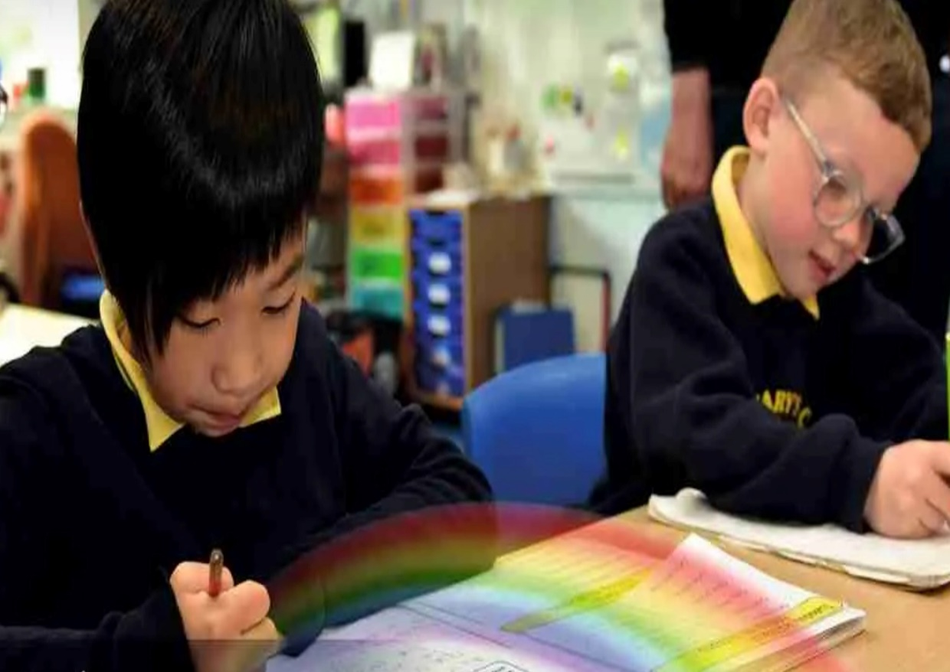

PSHE/RSE Curriculum Overview

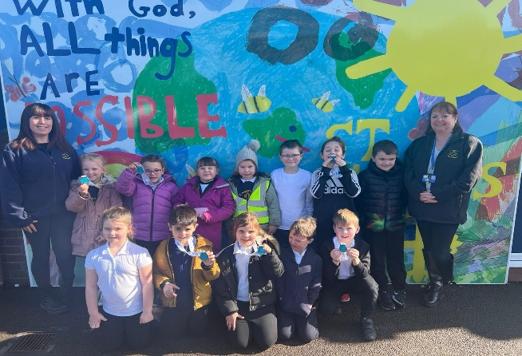
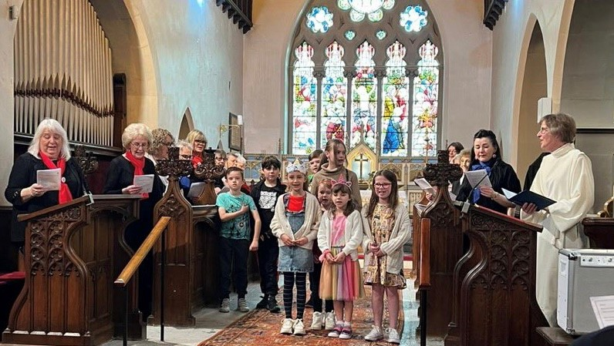
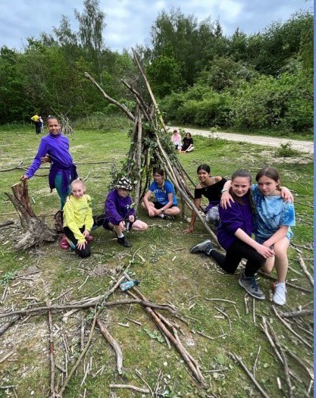
“With God, All Things are Possible.”

Our Approach

Our cyclical curriculum is built on the National Curriculum, Equality Act, Statutory RSE and Health Education Guidance from the DFE and also references to the PSHE Association Programmes of Study from Y1 onwards as a weekly 45 minute lesson. It is broken down into the 6 aspects below and our pupils revisit these aspects each year. Each time they revisit an aspect, it is with increasing complexity to build on their prior knowledge in that aspect from the year before . In EYFS we also use Jigsaw as part of our approach.

YR | Autumn |  |  | Spring |  |  | Summer
Knowledge & Skills | Being Me in My World  - Know special things about themselves  - Know that some people are different from themselves  - Know how happiness and sadness can be expressed  - Know that hands can be used kindly and unkindly  - Know that being kind is good  - Know they have a right to learn and play, safely and happily.  - Identify feelings associated with belonging  - Identify feelings of happiness and sadness  - Skills to play cooperatively with others  - Be able to consider others’ feelings  - Be responsible in the setting | Celebrating Difference  - Know what being proud means and that people can be proud of different things  - Know that people can be good at different things  - Know what being unique means  - Know that families can be different  - Know that people have different homes and why they are important to them  - Know different ways of making friends  - Know different ways to stand up for myself  - Know the names of some emotions such as happy, sad, frightened, angry  - Know that they don’t have to be ‘the same as’ to be a friend  - Know why having friends is important  - Know some qualities of a positive friendship  - Identify feelings associated with being proud  - Identify things they are good at  - Be able to vocalise success for themselves and about others successes  - Identify some ways they can be different and the same as others  - Recognise similarities and differences between their family and other families  - Identify and use skills to make a friend  - Identify and use skills to stand up for themselves  - Recognise emotions when they or someone else is upset, frightened or angry |  | Dreams & Goals  - Know what a challenge is  - Know that it is important to keep trying  - Know what a goal is  - Know how to set goals and work towards them  - Know which words are kind  - Know some jobs that they might like to do when they are older  - Know that they must work hard now in order to be able to achieve the job they want when they are older  - Know when they have achieved a goal  - Understand that challenges can be difficult  - Recognise some of the feelings linked to perseverance  - Talk about a time that they kept on trying and achieved a goal  - Be ambitious  - Resilience  - Recognise how kind words can encourage people  - Feel proud  - Celebrate success |  | Healthy Me  - Know the names for some parts of their body  - Know what the word ‘healthy’ means  - Know some things that they need to do to keep healthy  - Know that they need to exercise to keep healthy  - Know how to help themselves go to sleep and that sleep is good for them  - Know when and how to wash their hands properly  - Know what to do if they get lost  - Know how to say No to strangers  - Recognise how exercise makes them feel  - Recognise how different foods can make them feel  - Can explain what they need to do to stay healthy  - Can give examples of healthy food  - Can explain how they might feel if they don’t get enough sleep  - Can explain what to do if a stranger approaches them | Relationships  - Know what a family is  - Know that different people in a family have different responsibilities (jobs)  - Know some of the characteristics of healthy and safe friendship  - Know that friends sometimes fall out  - Know some ways to mend a friendship  - Know that unkind words can never be taken back and they can hurt  - Know how to use Jigsaw’s Calm Me to help when feeling angry  - Know some reasons why others get angry  - Can identify what jobs they do in their family and those carried out by parents/carers and siblings  - Can suggest ways to make a friend or help someone who is lonely  - Can use different ways to mend a friendship  - Can recognise what being angry feels like  - Can use Calm Me when angry or upset |  | Changing Me  - Know the names and functions of some parts of the body (see vocabulary list)  - Know that we grow from baby to adult  - Know who to talk to if they are feeling worried  - Know that sharing how they feel can help solve a worry  - Know that remembering happy times can help us move on.  - Can identify how they have changed from a baby  - Can say what might change for them they get older  - Recognise that changing class can elicit happy and/or sad emotions  - Can say how they feel about changing class/ growing up  - Can identify positive memories from the past year in school/ home
Vocab | Kind, Gentle, Friend, Similar(ity), Different, Rights, Responsibilities, Feelings, Angry, Happy, Excited, Nervous, Sharing, Taking Turns. | Different, Special, Proud, Friends, Kind, Same, Similar, Happy, Sad, Frightened, Angry, Family. |  | Dream, Goal, Challenge, Job, Ambition, Perseverance, Achievement, Happy, Kind, Encourage. |  | Healthy, Exercise, Head, Shoulders, Knees, Toes, Sleep, Wash, Clean, Stranger, Scared, Trust. | Family, Jobs, Relationship, Friend, Lonely, Argue, Fall-out, Words, Feelings, Angry, Upset, Calm me, Breathing. |  | Eye, Foot, Eyebrow, Forehead, Ear, Mouth, Arm, Leg, Chest, Knee, Nose, Tongue, Finger, Toe, Stomach, Hand, Baby, Grown-up, Adult, Change, Worry, Excited, Memories.
Continuous Provision Enhancements
- Throughout each day pupils will develop independence in self-care through getting ready for outdoor play and through learning different routines.
- Activities will regular provide children with choices to make and will also develop positive attitudes towards diet and physical activity.
- A range of books will allow pupils to discuss different families, feelings, friendship and emotions.
- Role play, small world and construction will provide opportunities for children to explore everyday scenarios and take on different roles and responsibilities.
Y1 | Autumn |  |  | Spring |  |  | Summer
Knowledge & Skills | Being Me in My World  - Understand the rights and responsibilities of a member of a class.  - Understand that their views are important  - Understand that their choices have consequences  - Understand their own rights and responsibilities with their classroom.  - Understanding that they are special and safe in their class.  - Identifying helpful behaviours to make the class a safe place.  - Identify what it’s like to feel proud of an achievement.  - Recognise feelings associated with positive and negative consequences.  Understand that they have choices |  | Celebrating Difference  - Know that people have differences and similarities  - Know what bullying means  - Know who to tell if they or someone else is being bullied or is feeling unhappy  - Know skills to make friendships  - Know that people are unique and that it is OK to be different  - Recognise ways in which they are the same as their friends and ways they are different  - Identify what is bullying and what isn’t  - Understand how being bullied might feel  - Know ways to help a person who is being bullied  - Identify emotions associated with making a new friend  •Verbalise some of the attributes that make them unique and special | Dreams & Goals  - Know how to set simple goals  - Know how to achieve a goal  - Know how to work well with a partner  - Know that tackling a challenge can stretch their learning  - Know how to identify obstacles which make achieving their goals difficult and work out how to overcome them  - Know when a goal has been achieved  - Recognise things that they do well  - Explain how they learn best  - Celebrate an achievement with a friend  - Recognise their own feelings when faced with a challenge  - Recognise their own feelings when they are faced with an obstacle  - Recognise how they feel when they overcome an obstacle  - Can store feelings of success so that they can be used in the future | Healthy Me  - Know the difference between being healthy and unhealthy  - Know some ways to keep healthy  - Know how to make healthy lifestyle choices  - Know how to keep themselves clean and healthy  - Know that germs cause disease / illness  - Know that all household products, including medicines, can be harmful if not used properly  - Know that medicines can help them if they feel poorly  - Know how to keep safe when crossing the road  - Know about people who can keep them safe.  - Feel good about themselves when they make healthy choices  - Realise that they are special  - Keep themselves safe  - Recognise ways to look after themselves if they feel poorly  - Recognise when they feel frightened and know how to ask for help  - Recognise how being healthy helps them to feel happy |  | Relationships  - Know that everyone’s family is different  - Know that there are lots of different types of families  - Know that families are founded on belonging, love and care  - Know how to make a friend  - Know the characteristics of healthy and safe friends  - Know that physical contact can be used as a greeting  - Know about the different people in the school community and how they help.  - Know who to ask for help in the school community.  - Can express how it feels to be part of a family and to care for family members  - Can say what being a good friend means  - Can show skills of friendship  - Can identify forms of physical contact they prefer  - Can say no when they receive a touch they don’t like  - Can praise themselves and others  - Can recognise some of their personal qualities.  - Can say why they appreciate a special relationship | Changing Me  - Know that animals including humans have a life cycle  - Know that changes happen when we grow up.  - Know that people grow up at different rates and that is normal.  - Know the names of male and female private body parts.  - Know that there are correct names for private body parts and nicknames, and when to use them.  - Know which parts of the body are private and that they belong to that person and that nobody has the right to hurt these.  - Know who to ask for help if they are worried or frightened.  - Know that learning brings about change.  - Understand and accepts that change is a natural part of getting older.  - Can identify some things that have changed and some things that have stayed the same since being a baby (including the body).  - Can express why they enjoy learning.  - Can suggest ways to manage change e.g. moving to a new class
Vocab | Safe, Special, Calm, Belonging, Special, Rights, Responsibilities, Learning Charter, Jigsaw Charter, Rewards, Proud, Consequences, Upset, Disappointed, Illustration |  | Similarity, Same as, Different from, Difference, Bullying, Bullying behaviour, Deliberate, On purpose, Unfair, Included, Bully, Bullied, Celebrations, Special, Unique | Proud, Success, Achievement, Goal, Treasure, Coins, Learning, Stepping-stones, Process, Working together, Team work, Celebrate, Learning, Stretchy, Challenge, Feelings, Obstacle, Overcome, Achieve, Dreams, Goals. | Healthy, Unhealthy, Balanced, Exercise, Sleep, Choices, Clean, Body parts, Keeping clean, Toiletry items (e.g. toothbrush, shampoo, soap), Hygienic, Safe Medicines, Trust, Safe, Safety, Green Cross Code, Eyes, Ears, Look, Listen, Wait. |  | Family, Belong, Same, Different, Friends, Friendship, Qualities, Caring, Sharing, Kind, Greeting, Touch, Feel, Texture, Like, Dislike, Help, Helpful, Community, Feelings, Confidence, Praise, Skills, Self-belief, Incredible, Proud, Celebrate, Relationships, Special, Appreciate. | Changes, Life cycles, Baby, Adult, Adulthood, Grown-up, Mature, Male, Female, Vagina, Penis, Testicles, Vulva, Anus, Learn, New, Grow, Feelings, Anxious, Worried, Excited, Coping.
Y2 | Autumn |  |  | Spring |  |  | Summer
Knowledge & Skills | Being Me in My World  - Identifying hopes and fears for the year ahead  - Understand the rights and responsibilities of class members  - Know that it is important to listen to other people  - Understand that their own views are valuable  - Know about rewards and consequences and that these stem from choices.  - Know that positive choices impact positively on self-learning and the learning of others.  - Recognise own feelings and know when and where to get help  - Know how to make their class a safe and fair place  - Show good listening skills  - Recognise the feeling of being worried  - Be able to work cooperatively. | Celebrating Difference  - Know there are stereotypes about boys and girls  - Know that it is OK not to conform to gender stereotypes  - Know it is good to be yourself  - Know that sometimes people get bullied because of difference  - Know the difference between right and wrong and the role that choice has to play in this  - Know that friends can be different and still be friends  - Know where to get help if being bullied  - Know the difference between a one-off incident and bullying  - Understand that boys and girls can be similar in lots of ways and that is OK  - Understand that boys and girls can be different in lots of ways and that is OK  - Explain how being bullied can make someone feel  - Can choose to be kind to someone who is being bullied  - Know how to stand up for themselves when they need to  - Recognise that they shouldn’t judge people because they are different  - Understand that everyone’s differences make them special and unique |  | Dreams & Goals  - Know how to choose a realistic goal and think about how to achieve it  - Know that it is important to persevere  - Know how to recognise what working together well looks like  - Know what good group working looks like  - Know how to share success with other people  - Be able to describe their own achievements and the feelings linked to this  - Recognise their own strengths as a learner  - Recognise how working with others can be helpful  - Be able to work effectively with a partner  - Be able to choose a partner with whom they work well  - Be able to work as part of a group  - Recognise how it feels to be part of a group that succeeds and store this feeling | Healthy Me  - Know what their body needs to stay healthy  - Know what relaxed means  - Know what makes them feel relaxed / stressed  - Know how medicines work in their bodies  - Know that it is important to use medicines safely  - Know how to make some healthy snacks  - Know why healthy snacks are good for their bodies  - Know which foods given their bodies energy.  - Desire to make healthy lifestyle choices  - Identify when a feeling is weak and when a feeling is strong  - Feel positive about caring for their bodies and keeping it healthy  - Have a healthy relationship with food  - Express how it feels to share healthy food with their friends |  | Relationships  - Know that everyone’s family is different  - Know that families function well when there is trust, respect, care, love and co-operation  - Know that there are lots of forms of physical contact within a family  - Know how to stay stop if someone is hurting them  - Know some reasons why friends have conflicts  - Know that friendships have ups and downs and sometimes change with time  - Know how to use the Mending Friendships or Solve-it-together problem-solving methods  - Know there are good secrets and worry secrets and why it is important to share worry secrets.  - Know what trust is  - Can identify the different roles and responsibilities in their family  - Can recognise the value that families can bring  - Can recognise and talk about the types of physical contact that is acceptable or unacceptable  - Can use positive problem-solving techniques (Mending Friendships or Solve-it-together) to resolve a friendship conflict  - Can identify the negative feelings associated with keeping a worry secret  - Can identify the feelings associated with trust  - Can identify who they trust in their own relationships  - Can give and receive compliments  - Can say who they would go to for help if they were worried or scared | Changing Me  - Know that life cycles exist in nature  - Know that aging is a natural process including old-age  - Know that some changes are out of an individual’s control  - Know how their bodies have changed from when they were a baby and that they will continue to change as they age  - Know the physical differences between male and female bodies  - Know the correct names for private body parts  - Know that private body parts are special and that no one has the right to hurt these  - Know who to ask for help if they are worried or frightened  - Know there are different types of touch and that some are acceptable and some are unacceptable.  - Can appreciate that changes will happen and that some can be controlled and others not  - Be able to express how they feel about changes  - Show appreciation for people who are older  - Can recognise the independence and responsibilities they have now compared to being a baby or toddler  - Can say what greater responsibilities and freedoms they may have in the future  - Can say who they would go to for help if worried or scared  - Can say what types of touch they find comfortable/ uncomfortable  - Be able to confidently ask someone to stop if they are being hurt or frightened  - Can say what they are looking forward to in the next year
Vocab | Worries, Hopes, Fears, Belonging, Rights, Responsibilities, Responsible, Actions, Praise, Reward, Consequence, Positive, Negative, Choices, Co-Operate, Learning Charter, Problem-Solving | Boys, Girls, Similarities, Assumptions, Shield, Stereotypes, Special, Differences, Bully, Purpose, Kind, Unkind, Feelings, Sad, Lonely, Help, Stand up for, Male, Female, Diversity, Fairness, Kindness, Friends, Unique, Value. |  | Realistic, Proud, Success, Celebrate, Achievement, Goal, Strength, Persevere, Challenge, Difficult, Easy, Learning Together, Partner, Team work, Product. | Healthy choices, Lifestyle, Motivation, Relax, Relaxation, Tense, Calm, Healthy, Unhealthy, Dangerous, Medicines, Safe, Body, Balanced diet, Portion, Proportion, Energy, Fuel, Nutritious. |  | Family, Different, Similarities, Special, Relationship, Important, Co-operate, Touch, Physical contact, Communication, Hugs, Like, Dislike, Acceptable, Not acceptable, Friends, Conflict, Point of view, Positive problem solving, Secret, Surprise, Good secret, Worry secret, Telling, Adult, Trust, Happy, Sad, Frightened, Trustworthy, Honesty, Reliability, Compliments, Celebrate, Appreciate. | Change, Grow, Control, Life cycle, Baby, Adult, Fully grown, Growing up, Old, Young, Change, Respect, Appearance, Physical, Baby, Toddler, Child, Teenager, Independent, Timeline, Freedom, Responsibilities, Male, Female, Vagina, Penis, Testicles, Vulva, Anus, Public, Private, Touch, Texture, Cuddle, Hug, Squeeze, Like, Dislike, Acceptable, Unacceptable, Comfortable, Uncomfortable, Looking forward, Excited, Nervous, Anxious, Happy.

Y3 | Autumn |  |  |  | Spring |  | Summer
Knowledge & Skills | Being Me in My World  - Understand that they are important  - Know what a personal goal is  - Understanding what a challenge is  - Know why rules are needed and how these relate to choices and consequences  - Know that actions can affect others’ feelings  - Know that others may hold different views  - Know that the school has a shared set of values  - Recognise self-worth  - Identify personal strengths  - Be able to set a personal goal  - Recognise feelings of happiness, sadness, worry and fear in themselves and others  - Make other people feel valued  - Develop compassion and empathy for others  - Be able to work collaboratively. |  | Celebrating Difference  - Know why families are important  - Know that everybody’s family is different  - Know that sometimes family members don’t get along and some reasons for this  - Know that conflict is a normal part of relationships  - Know what it means to be a witness to bullying and that a witness can make the situation worse or better by what they do  - Know that some words are used in hurtful ways and that this can have consequences  - Be able to show appreciation for their families, parents and carers  - Use the ‘Solve it together’ technique to calm and resolve conflicts with friends and family  - Empathise with people who are bullied  - Employ skills to support someone who is bullied  - Be able to ‘problem-solve’ a bullying situation accessing appropriate support if necessary  - Be able to recognise, accept and give compliments  - Recognise feelings associated with receiving a compliment |  | Dreams & Goals  - Know about specific people who have overcome difficult challenges to achieve success  - Know what dreams and ambitions are important to them  - Know how they can best overcome learning challenges  - Know that they are responsible for their own learning  - Know what their own strengths are as a learner  - Know what an obstacle is and how they can hinder achievement  - Know how to take steps to overcome obstacles  - Know how to evaluate their own learning progress and identify how it can be better next time.  - Recognise other people’s achievements in overcoming difficulties  - Imagine how it will feel when they achieve their dream / ambition  - Can break down a goal into small steps  - Recognise how other people can help them to achieve their goals  - Can manage feelings of frustration linked to facing obstacles  - Can share their success with others  - Can store feelings of success (in their internal treasure chest) to be used at another time | Healthy Me  - Know how exercise affects their bodies  - Know why their hearts and lungs are such important organs  - Know that the amount of calories, fat and sugar that they put into their bodies will affect their health  - Know that there are different types of drugs  - Know that there are things, places and people that can be dangerous  - Know a range of strategies to keep themselves safe  - Know when something feels safe or unsafe  - Know that their bodies are complex and need taking care of  - Able to set themselves a fitness challenge  - Recognise what it feels like to make a healthy choice  - Identify how they feel about drugs  - Can express how being anxious or scared feels  - Can take responsibility for keeping themselves and others safe  - Respect their own bodies and appreciate what they do | Relationships  - Know that different family members carry out different roles or have different responsibilities within the family  - Know that gender stereotypes can be unfair e.g. Mum is always the carer, Dad always goes to work etc  - Know some of the skills of friendship, e.g. taking turns, being a good listener  - Know some strategies for keeping themselves safe online  - Know how some of the actions and work of people around the world help and influence my life  - Know that they and all children have rights (UNCRC)  - Know the lives of children around the world can be different from their own  - Can identify the responsibilities they have within their family  - Can use Solve-it-together in a conflict scenario and find a win-win outcome  - Know how to access help if they are concerned about anything on social media or the internet  - Can empathise with people from other countries who may not have a fair job/ less fortunate  - Understand that they are connected to the global community in many different ways  - Can identify similarities in children’s rights around the world.  - Can identify their own wants and needs and how these may be similar or different from other children in school and the global community |  | Changing Me  - Know that in animals and humans lots of changes happen between conception and growing up  - Know that in nature it is usually the female that carries the baby  - Know that in humans a mother carries the baby in her uterus (womb) and this is where it develops  - Know that babies need love and care from their parents/carers  - Know some of the changes that happen between being a baby and a child  - Know that the male and female body needs to change at puberty so their bodies can make babies when they are adults  - Know some of the outside body changes that happen during puberty  - Know some of the changes on the inside that happen during puberty.  - Can express how they feel about babies  - Can describe the emotions that a new baby can bring to a family  - Can express how they feel about puberty  - Can say who they can talk to about puberty if they have any worries  - Can identify stereotypical family roles and challenge these ideas e.g. it may not always be Mum who does the laundry  - Can identify changes they are looking forward to in the next year  - Can suggest ways to help them manage feelings during changes they are more anxious about.
Vocab | Welcome, Valued, Achievements, Proud, Pleased, Personal Goal, Praise, Acknowledge, Affirm, Emotions, Feelings, Nightmare, Fears, Worries, Solutions, Support, Rights, Responsibilities, Learning Charter, Dream, Behaviour, Rewards, Consequences, Actions, Fairness, Choices, Co-Operate, Group Dynamics, Team Work, View Point, Ideal School, Belong. |  | Family, Loving, Caring, Safe, Connected, Difference, Special, Conflict, Solve It Together, Solutions, Resolve, Witness, Bystander, Bullying, Gay, Unkind, Feelings, Tell, Consequences, Hurtful, Compliment, Unique. |  | Perseverance, Challenges, Success, Obstacles, Dreams, Goals, Ambitions, Future, Aspirations, Garden, Decorate, Team work, Enterprise, Design, Cooperation, Product, Strengths, Motivated, Enthusiastic, Excited, Efficient, Responsible, Frustration, ‘Solve It Together’ Technique, Solutions, Review, Learning, Celebrate, Evaluate. | Oxygen, Energy, Calories / kilojoules, Heartbeat, Lungs, Heart, Fitness, Labels, Sugar, Fat, Saturated fat, Healthy, Drugs, Attitude, Safe, Anxious, Scared, Strategy, Advice, Harmful, Risk, Feelings, Complex, Appreciate, Body, Choice. | Men, Women, Unisex, Male, Female, Stereotype, Career, Job, Role, Responsibilities, Respect, Differences, Similarities, Conflict, Win-win, Solution, Solve-it-together, Problem-solve, Internet, Social media, Online, Risky, Gaming, Safe, Unsafe, Private messaging (pm), Direct messaging (dm), Global, Communication, Fair trade, Inequality, Food journey, Climate, Transport, Exploitation, Rights, Needs, Wants, Justice, United Nations, Equality, Deprivation, Hardship, Appreciation, Gratitude, Celebrate. |  | Changes, Birth, Animals, Babies, Mother, Growing up, Baby, Grow, Uterus, Womb, Nutrients, Survive, Love, Affection, Care, Puberty, Control, Male, Female, Testicles, Sperm, Penis, Ovaries, Egg, Ovum / ova, Womb / uterus, Vagina, Stereotypes, Task, Roles, Challenge, Looking forward, Excited, Nervous, Anxious, Happy.
Y4 | Autumn |  |  |  | Spring |  | Summer
Knowledge & Skills | Being Me in My World  - Know how individual attitudes and actions make a difference to a class  - Know about the different roles in the school community  - Know their place in the school community  - Know what democracy is (applied to pupil voice in school)  - Know that their own actions affect themselves and others  - Know how groups work together to reach a consensus  - Know that having a voice and democracy benefits the school community.  - Identify the feelings associated with being included or excluded  - Can make others feel valued and included  - Be able to take on a role in a group discussion / task and contribute to the overall outcome  - Can make others feel cared for and welcomed  - Recognise the feelings of being motivated or unmotivated  - Understand why the school community benefits from a Learning Charter  - Be able to help friends make positive choices  - Know how to regulate my emotions. |  | Celebrating Difference  - Know that sometimes people make assumptions about a person because of the way they look or act  - Know there are influences that can affect how we judge a person or situation  - Know that some forms of bullying are harder to identify e.g. tactical ignoring, cyber-bullying  - Know what to do if they think bullying is, or might be taking place  - Know the reasons why witnesses sometimes join in with bullying and don’t tell anyone  - Know that first impressions can change.  - Try to accept people for who they are  - Identify influences that have made them think or feel positively/negatively about a situation  - Identify feelings that a bystander might feel in a bullying situation  - Identify reasons why a bystander might join in with bullying  - Revisit the ‘Solve it together’ technique to practise conflict and bullying scenarios  - Identify their own uniqueness  - Be comfortable with the way they look  - Identify when a first impression they had was right or wrong  - Be non-judgemental about others who are different |  | Dreams & Goals  - Know what their own hopes and dreams are  - Know that hopes and dreams don’t always come true  - Know that reflecting on positive and happy experiences can help them to counteract disappointment  - Know how to make a new plan and set new goals even if they have been disappointed  - Know how to work out the steps they need to take to achieve a goal  - Know how to work as part of a successful group  - Know how to share in the success of a group.  - Can talk about their hopes and dreams and the feelings associated with these  - Can identify the feeling of disappointment  - Can identify a time when they have felt disappointed  - Be able to cope with disappointment  - Help others to cope with disappointment  - Can identify what resilience is  - Have a positive attitude  - Enjoy being part of a group challenge  - Can share their success with others  - Can store feelings of success (in their internal treasure chest) to be used at another time. | Healthy Me  - Know how different friendship groups are formed and how they fit into them  - Know which friends they value most  - Know that there are leaders and followers in groups  - Know that they can take on different roles according to the situation  - Know the facts about smoking and its effects on health  - Know some of the reasons some people start to smoke  - Know the facts about alcohol and its effects on health, particularly the liver  - Know some of the reasons some people drink alcohol  - Know ways to resist when people are putting pressure on them  - Know what they think is right and wrong.  - Can identify the feelings that they have about their friends and different friendship groups  - Recognise how different people and groups they interact with impact on them  - Identify which people they most want to be friends with  - Recognise negative feelings in peer pressure situations  - Can identify the feelings of anxiety and fear associated with peer pressure  - Can tap into their inner strength and know-how to be assertive. | Relationships  - Know some reasons why people feel jealousy  - Know that jealousy can be damaging to relationships  - Know that loss is a normal part of relationships  - Know that negative feelings are a normal part of loss  - Know that memories can support us when we lose a special person or animal  - Know that change is a natural part of relationships/ friendship  - Know that sometimes it is better for a friendship/ relationship to end if it is causing negative feelings or is unsafe.  - Can identify feelings and emotions that accompany jealousy  - Can suggest positive strategies for managing jealousy  - Can identify people who are special to them and express why  - Can identify the feelings and emotions that accompany loss  - Can suggest strategies for managing loss  - Can tell you about someone they no longer see  - Can suggest ways to manage relationship changes including how to negotiate. |  | Changing Me  - Know that personal characteristics are inherited from birth parents and this is brought about by an ovum joining with a sperm  - Know that babies are made by a sperm joining with an ovum  - Know the names of the different internal and external body parts that are needed to make a baby  - Know how the female and male body change at puberty  - Know that personal hygiene is important during puberty and as an adult  - Know that change is a normal part of life and that some cannot be controlled and have to be accepted  - Know that change can bring about a range of different emotions.  - Can appreciate their own uniqueness and that of others  - Can express how they feel about having children when they are grown up  - Can express any concerns they have about puberty  - Can say who they can talk to about puberty if they are worried  - Can apply the circle of change model to themselves to have strategies for managing change  - Have strategies for managing the emotions relating to change.
Vocab | Included, Excluded, Welcome, Valued, Team, Charter, Role, Job Description, School Community, Responsibility, Rights, Democracy, Democratic, Reward, Consequence, Decisions, Voting, Authority, Learning Charter, Contribution, Observer, UN Convention on Rights of Child (UNCRC). |  | Character, Assumption, Judgement, Surprised, Different, Appearance, Accept, Influence, Opinion, Attitude, Bullying, Friend, Secret, Deliberate, On purpose, Bystander, Witness, Bully, Problem solve, Cyber bullying, Text message, Website, Troll, Special, Unique, Physical features, Impression, Changed. |  | Dream, Hope, Goal, Determination, Perseverance, Resilience, Positive attitude, Disappointment, Fears, Hurts, Positive experiences, Plans, Cope, Help, Self-belief, Motivation, Commitment, Enterprise, Design, Cooperation, Success, Celebrate, Evaluate. | Friendship, Emotions, Healthy, Relationships, Friendship groups, Value, Roles, Leader, Follower, Assertive, Agree, Disagree, Smoking, Pressure, Peers, Guilt, Advice, Alcohol, Liver, Disease, Anxiety, Fear, Believe, Opinion, Right, Wrong. | Relationship, Close, Jealousy, Problem-solve, Emotions, Positive, Negative, Loss, Shock, Disbelief, Numb, Denial, Anger, Guilt, Sadness, Pain, Despair, Hope, Souvenir, Memento, Memorial, Acceptance, Relief, Remember, Negotiate, Compromise, Trust, Loyal, Empathy, Betrayal, Amicable, Appreciation, love. |  | Personal, Unique, Characteristics, Parents, Sperm, Egg / ovum, Penis, Testicles, Vagina / vulva, Womb / uterus, Ovaries, Making love, Having sex, Sexual intercourse, Fertilise, Conception, Puberty, Menstruation, Periods, Circle, Seasons, Change, Control, Emotions, Acceptance, Looking forward, Excited, Nervous, Anxious, Happy.
Y5 | Autumn |  |  |  | Spring |  | Summer
Knowledge & Skills | Being Me in My World  - Understand how to set personal goals  - Understand the rights and responsibilities associated with being a citizen in the wider community and their country  - Know how an individual’s behaviour can affect a group and the consequences of this  - Understand how democracy and having a voice benefits the school community  - Understand how to contribute towards the democratic process.  - Be able to identify what they value most about school  - Identify hopes for the school year  - Empathy for people whose lives are different from their own  - Consider their own actions and the effect they have on themselves and others  - Be able to work as part of a group, listening and contributing effectively  - Understand why the school community benefits from a Learning Charter  - Be able to help friends make positive choices  - Know how to regulate my emotions |  |  | Celebrating Difference  - Know what culture means  - Know that differences in culture can sometimes be a source of conflict  - Know what racism is and why it is unacceptable  - Know that rumour spreading is a form of bullying on and offline  - Know external forms of support in regard to bullying e.g. Childline  - Know that bullying can be direct and indirect  - Know how their life is different from the lives of children in the developing world.  - Identify their own culture and different cultures within their class community  - Identify their own attitudes about people from different faith and cultural backgrounds  - Identify a range of strategies for managing their own feelings in bullying situations  - Identify some strategies to encourage children who use bullying behaviours to make other choices  - Be able to support children who are being bullied  - Appreciate the value of happiness regardless of material wealth.  - Develop respect for cultures different from their own | Dreams & Goals  - Know that they will need money to help them to achieve some of their dreams  - Know about a range of jobs that are carried out by people I know  - Know that different jobs pay more money than others  - Know the types of job they might like to do when they are older  - Know that young people from different cultures may have different dreams and goals  - Know that communicating with someone from a different culture means that they can learn from them and vice versa  - Know ways that they can support young people in their own culture and abroad.  - Verbalise what they would like their life to be like when they are grown up  - Appreciate the contributions made by people in different jobs  - Appreciate the opportunities learning and education can give them  - Reflect on the differences between their own learning goals and those of someone from a different culture  - Appreciate the differences between themselves and someone from a different culture  - Understand why they are motivated to make a positive contribution to supporting others | Healthy Me  - Know the health risks of smoking  - Know how smoking tobacco affects the lungs, liver and heart  - Know some of the risks linked to misusing alcohol, including antisocial behaviour  - Know basic emergency procedures including the recovery position  - Know how to get help in emergency situations  - Know that the media, social media and celebrity culture promotes certain body types  - Know the different roles food can play in people’s lives and know that people can develop eating problems / disorders related to body image pressure  - Know what makes a healthy lifestyle  - Can make informed decisions about whether or not they choose to smoke when they are older  - Can make informed decisions about whether they choose to drink alcohol when they are older  - Recognise strategies for resisting pressure  - Can identify ways to keep themselves calm in an emergency  - Can reflect on their own body image and know how important it is that this is positive  - Accept and respect themselves for who they are  - Respect and value their own bodies.  - Be motivated to keep themselves healthy and happy | Relationships  - Know that a personality is made up of many different characteristics, qualities and attributes  - Know that belonging to an online community can have positive and negative consequences  - Know that there are rights and responsibilities in an online community or social network  - Know that there are rights and responsibilities when playing a game online  - Know that too much screen time isn’t healthy  - Know how to stay safe when using technology to communicate with friends.  - Can suggest strategies for building self-esteem of themselves and others  - Can identify when an online community / social media group feels risky, uncomfortable, or unsafe  - Can suggest strategies for staying safe online/ social media  - Can say how to report unsafe online / social network activity  - Can identify when an online game is safe or unsafe  - Can suggest ways to monitor and reduce screen time.  - Can suggest strategies for managing unhelpful pressures online or in social networks. | Changing Me  - Know what perception means and that perceptions can be right or wrong  - Know how girls’ and boys’ bodies change during puberty and understand the importance of looking after themselves physically and emotionally  - Know that sexual intercourse can lead to conception  - Know that some people need help to conceive and might use IVF  - Know that becoming a teenager involves various changes and also brings growing responsibility.  - Can celebrate what they like about their own and others’ self- image and body-image  - Can suggest ways to boost self-esteem of self and others  - Recognise that puberty is a natural process that happens to everybody and that it will be OK for them  - Can ask questions about puberty to seek clarification  - Can express how they feel about having a romantic relationship when they are an adult  - Can express how they feel about having children when they are an adult  - Can express how they feel about becoming a teenager  - Can say who they can talk to if concerned about puberty or becoming a teenager/adult.
Vocab | Challenge, Goal, Attitude, Actions, Rights and Responsibilities, United Nations Convention on The Rights of the Child, Citizen, Choices, Consequences, Views, Opinion, Collaboration, Collective Decision, Democracy. |  |  | Culture, Conflict, Difference, Similarity, Belong, Culture Wheel, Racism, Colour, Race, Discrimination, Ribbon, Bullying, Rumour, Name-calling, Racist, Homophobic, Cyber bullying, Texting, Problem solving, Indirect, Direct, Happiness, Developing World, Celebration, Artefacts, Display, Presentation. | Dream, Hope, Goal, Feeling, Achievement, Money, Grown Up, Adult, Lifestyle, Job, Career, Profession, Money, Salary, Contribution, Society, Determination, Perseverance, Motivation, Aspiration, Culture, Country, Sponsorship, Communication, Support, Rallying, Team Work, Cooperation, Difference. | Choices, Healthy behaviour, Unhealthy behaviour, Informed decision, Pressure, Media, Influence, Emergency, Procedure, Recovery position, Calm, Level-headed, Body image, Media, Social media, Celebrity, Altered, Self-respect, Comparison, Eating problem, Eating disorder, Respect, Debate, Opinion, Fact, Motivation. | Personal attributes, Qualities, Characteristics, Self-esteem, Unique, Comparison, Negative self-talk, Social media, Online, Community, Risky, Positive, Negative, Safe, Unsafe, Rights, Responsibilities, Social network, Gaming, Violence, Grooming, Troll, Gambling, Betting, Trustworthy, Appropriate, Screen time, Physical health, Mental health, Off-line, Social, Peer pressure, Influences, Personal information, Passwords, Privacy, Settings, Profile, SMARRT rules. | Body-image, Self-image, Characteristics, Looks, Personality, Perception, Self-esteem, Affirmation, Comparison, Uterus, Womb, Oestrogen, Fallopian Tube, Cervix, Develops, Puberty, Breasts, Vagina, Vulva, Hips, Penis, Testicles, Adam’s Apple, Scrotum, Genitals, Hair, Broader, Wider, Sperm, Semen, Erection, Ejaculation, Urethra, Wet dream, Growth spurt, Larynx, Facial hair, Pubic hair, Hormones, Scrotum, Testosterone, Circumcised,
Y6 | Autumn |  |  |  | Spring |  | Summer
Knowledge & Skills | Being Me in My World  - Know how to set goals for the year ahead  - Understand what fears and worries are  - Know about children’s universal rights (United Nations Convention on the Rights of the Child)  - Know about the lives of children in other parts of the world  - Know that personal choices can affect others locally and globally  - Understand that their own choices result in different consequences and rewards  - Understand how democracy and having a voice benefits the school community  - Understand how to contribute towards the democratic process.  - Be able to make others feel welcomed and valued  - Know own wants and needs  - Be able to compare their life with the lives of those less fortunate  - Demonstrate empathy and understanding towards others  - Can demonstrate attributes of a positive role-model  - Can take positive action to help others  - Be able to contribute towards a group task  - Know what effective group work is  - Know how to regulate my emotions | Celebrating Difference  - Know that there are different perceptions of ‘being normal’ and where these might come from  - Know that being different could affect someone’s life  - Know that power can play a part in a bullying or conflict situation  - Know that people can hold power over others individually or in a group  - Know why some people choose to bully others  - Know that people with disabilities can lead amazing lives  - Know that difference can be a source of celebration as well as conflict.  - Empathise with people who are different and be aware of my own feelings towards them  - Identify feelings associated with being excluded  - Be able to recognise when someone is exerting power negatively in a relationship  - Use a range of strategies when involved in a bullying situation or in situations where difference is a source of conflict  - Identify different feelings of the bully, bullied and bystanders in a bullying scenario  - Be able to vocalise their thoughts and feelings about prejudice and discrimination and why it happens  - Appreciate people for who they are  Show empathy |  |  | Dreams & Goals  - Know their own learning strengths  - Know how to set realistic and challenging goals  - Know what the learning steps are they need to take to achieve their goal  - Know a variety of problems that the world is facing  - Know how to work with other people to make the world a better place  - Know some ways in which they could work with others to make the world a better place  - Know what their classmates like and admire about them  - Understand why it is important to stretch the boundaries of their current learning  - Set success criteria so that they know when they have achieved their goal  - Recognise the emotions they experience when they consider people in the world who are suffering or living in difficult circumstances  - Empathise with people who are suffering or living in difficult situations  - Be able to give praise and compliments to other people when they recognise that person’s achievements | Healthy Me  - Know how to take responsibility for their own health  - Know how to make choices that benefit their own health and well-being  - Know about different types of drugs and their uses  - Know how these different types of drugs can affect people’s bodies, especially their liver and heart  - Know that some people can be exploited and made to do things that are against the law  - Know why some people join gangs and the risk that this can involve  - Know what it means to be emotionally well  - Know that stress can be triggered by a range of things  - Know that being stressed can cause drug and alcohol misuse  - Are motivated to care for their own physical and emotional health  - Are motivated to find ways to be happy and cope with life’s situations without using drugs  - Identify ways that someone who is being exploited could help themselves  - Suggest strategies someone could use to avoid being pressured  - Recognise that people have different attitudes towards mental health / illness  - Can use different strategies to manage stress and pressure | Relationships  - Know that it is important to take care of their own mental health  - Know ways that they can take care of their own mental health  - Know the stages of grief and that there are different types of loss that cause people to grieve  - Know that sometimes people can try to gain power or control them  - Know some of the dangers of being ‘online’  - Know how to use technology safely and positively to communicate with their friends and family  - Recognise that people can get problems with their mental health and that it is nothing to be ashamed of  - Can help themselves and others when worried about a mental health problem  - Recognise when they are feeling grief and have strategies to manage them  - Demonstrate ways they could stand up for themselves and their friends in situations where others are trying to gain power or control  - Can resist pressure to do something online that might hurt themselves or others  - Can take responsibility for their own safety and well-being |  | Changing Me  - Know how girls’ and boys’ bodies change during puberty and understand the importance of looking after themselves physically and emotionally  - Know how a baby develops from conception through the nine months of pregnancy and how it is born  - Know how being physically attracted to someone changes the nature of the relationship  - Know the importance of self-esteem and what they can do to develop it  - Know what they are looking forward to and what they are worried about when thinking about transition to secondary school / moving to their next class  - Recognise ways they can develop their own self-esteem  - Can express how they feel about the changes that will happen to them during puberty  - Recognise how they feel when they reflect on the development and birth of a baby  - Understand that mutual respect is essential in a boyfriend / girlfriend relationship and that they shouldn’t feel pressured into doing something that they don’t want to  - Can celebrate what they like about their own and others’ self- image and body-image  - Use strategies to prepare themselves emotionally for the transition (changes) to secondary school
Vocab | Goals, Worries, Fears, Value, Welcome, Choice, Ghana, West Africa, Cocoa Plantation, Cocoa Pods, Machete, Rights, Community, Education, Wants, Needs, Maslow, Empathy, Comparison, Opportunities, Education, Choices, Behaviour, Responsibilities, Rewards, Consequences, Empathise, Learning Charter, Obstacles, Cooperation, Collaboration, Legal, Illegal, Lawful, Laws, Participation, Motivation, Democracy, Decision, Proud. | Normal, Ability, Disability, Visual impairment, Empathy, Perception, Medication, Vision, Blind, Male, Female, Diversity, Transgender, Gender Diversity, Courage, Fairness, Rights, Responsibilities, Power, Struggle, Imbalance, Harassment, Bullying, Bullying behaviour, Direct, Indirect, Argument, Recipient, Para-Olympian, Achievement, Accolade, Perseverance, Sport, Admiration, Stamina, Celebration, Conflict. |  |  | Dream, Hope, Goal, Learning, strengths, Stretch, Achievement, Personal, Realistic, Unrealistic, Feeling, Success, Criteria, Learning steps, Money, Global issue, Suffering, Concern, Hardship, Sponsorship, Empathy, Motivation, Admire, Respect, Praise, Compliment, Contribution, Recognition. | Responsibility, Choice, Immunisation, Prevention, Drugs, Effects, Motivation, Prescribed, Unrestricted, Over-the-counter, Restricted, Illegal, Volatile substances, ‘Legal highs’, Exploited, Vulnerable, Criminal, Gangs, Pressure, Strategies, Reputation, Anti-social behaviour, Crime, Mental health, Emotional health, Mental illness, Symptoms, Stress, Triggers, Strategies, Managing stress. | Mental health, Ashamed, Stigma, Stress, Anxiety, Support, Worried, Signs, Warning, Self-harm, Emotions, Feelings, Sadness, Loss, Grief, Denial, Despair, Guilt, Shock, Hopelessness, Anger, Acceptance, Bereavement, Coping strategies, Power, Control, Authority, Bullying, Script, Assertive, Risks, Pressure, Influences, Self-control, Real / fake, True / untrue, Assertiveness, Judgement, Communication, Technology, Power, Cyber-bullying, Abuse, Safety. |  | Body-image, Self-image, Characteristics, Looks, Personality, Perception, Self-esteem, Affirmation, Comparison, negative body-talk, mental health, Uterus, Womb, Oestrogen, Fallopian Tube, Cervix, Develops, Puberty, Breasts, Vagina, Vulva, Hips, Penis, Testicles, Adam’s Apple, Scrotum, Genitals, Hair, Broader, Wider, Sperm, Semen, Erection, Ejaculation, Urethra, Wet dream, Growth spurt, Larynx, Facial hair, Pubic hair, Hormones, Scrotum, Testosterone, Circumcised, Uncircumcised, Foreskin, Epididymis, Ovaries, Egg (Ovum), Period, Fertilised, Unfertilised, Conception, Having sex, Sexual intercourse, Making love, Embryo, Umbilical cord, IVF, Foetus, Contraception, Pregnancy, midwife, labour, Menstruation, Sanitary products, Tampon, Pad, Towel, Liner, Hygiene, Age appropriateness, Legal, Laws, Responsible, Teenager, Responsibilities, Rights, opportunities, freedoms, responsibilities, attraction, relationship, love, sexting, transition, secondary, looking forward, journey, worries, anxiety, excitement .

